**The Principles of Motivational Interviewing**

There are 4 Principals of Motivational Interviewing

R.U.L.E.

**Resist – telling job seekers what to do.**

You want to avoid telling a jobseeker what YOU think they should do. Instead, guide them on the path of self-discovery

**Understand- their motives.**

Through conversation and relationship building, pay close attention to the Jobseeker's values, needs, motivations, potential barriers, and behaviors that can be changed.

**Listen- and empathize.**

Connect with your Jobseeker by building trust. This is done by feeling what your jobseekers feels and being able to relate their personal experiences. Even if you cannot personally relate, acknowledge what they are saying and allow them a safe platform to speak freely.

**Empower- them.**

Collaborate with your Jobseeker to develop attainable goals, and identify the strategies you will put into place to help them overcome barriers.

**Helping the Job Seekers to overcome these:**

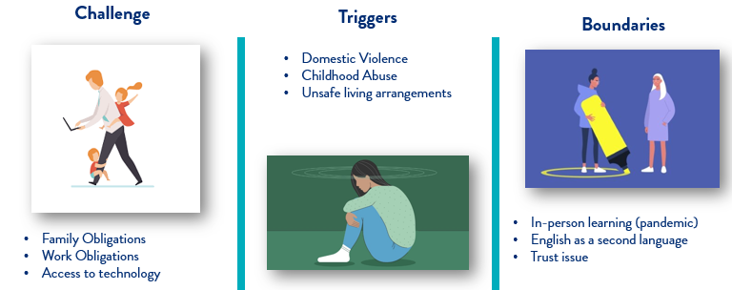

Combine these with the best practices of Motivational Interviewing for maximum results!