My Workday New Supplier Request Guide

Your guide to requesting New Suppliers in Workday

TABLE OF CONTENTS
Requesting a New Supplier Overview 3
Request a Supplier 4

REQUESTING A NEW SUPPLIER: OVERVIEW

All users should submit a supplier request prior to engaging in any business with the potential supplier.

Suppliers must:

Provide a W-9 with information and an address that matches the what is shown with the Secretary of State or Chamber of Commerce they are registered with, i.e. address, business name, etc.

Provide a certificate of limited liability insurance if they will be on any GCNA sites. This includes, deliveries, repairs, trainings, pickups, etc.

Complete the GCNA New Supplier Application Form GCNA New Supplier Application Form.pdf

If a potential supplier is researched by the Purchasing department and found to be debarred from doing business with the Federal Government, or not in good standing, GCNA cannot do business with that supplier.

REQUESTING A NEW SUPPLIER: GETTING STARTED

- Provide the prospective supplier the GCNA New Supplier Application Form GCNA New Supplier Application Form.pdf

- Once the prospective supplier fills out the form in its entirety, they should return it to the requestor, to be attached to the supplier request in Workday.

- Click the Purchases application, on your Home page.

Note: If the Purchases application is not visible on your Home page, you may add the application. See the My Workday manual, Customize Your Homepage section for instructions
to add a Workday application.

- Click More in the Actions section to expand the list of available Actions.
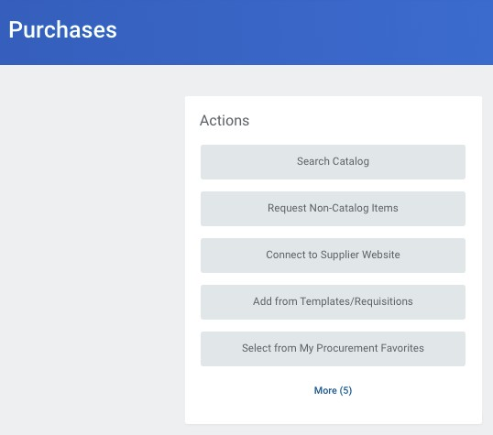

- Click Create Supplier Request.
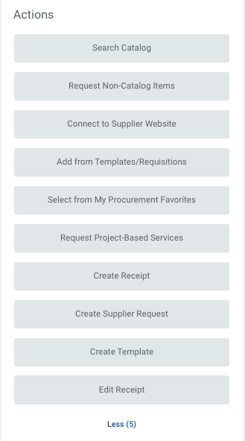

- The Create Supplier Request page appears (see below).

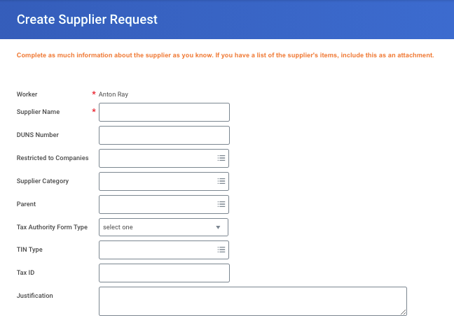
- Include the following required
Information for the supplier:

- Supplier Name
- Supplier Category
- Justification for why
This supplier should be
added.

- Click the Contact Information link, enter the following required pieces of information:

- Supplier Phone Number
- Supplier Address
- Supplier Email

Note: When entering phone numbers, emails address, and addresses, one must be marked as Primary.

- Click on the Classification link and select the Spend Category (required)

- Click the Attachments (required) link to upload files necessary for documentation.

- Completed GCNA New Supplier Application Form

- W-9 signed and dated within the last 2 years, that reflects an address and name that matches what shows on file with the Secretary of State’s website where they are registered to do business

- Certificate of Insurance, if Supplier will be on any GCNA sites

- Any other documentation i.e. ACH Form, Contract, etc.

- Add the Supplier Contact (required)

- Click OK
STOP

- Purchase will review the supplier request, and notify the requestor via email if additional information is required, or if the supplier is approved.

- Once Purchasing has approved the Supplier Request, you may proceed with creating a requisition for goods and/or services.

