TEAM MEMBER
1 7/16/2020

My Workday Procurement

Guide

Your guide to purchasing, approving and receiving goods and services using Workday

TABLE OF CONTENTS
Procurement Overview 3
Getting Started 4
Create a Requisition for goods/services related to Federal Funds…………………………………...5
Create a Punch Out Requisition for ODP Items 6
Create a Requisition for Catalog Items 9
Create a Requisition for Non-Catalog Items 14
View and Find the status of your Requisitions 19
View and Find the status of your Purchase Orders……………………………………………………..21
Approve a Requisition 25
Create a Receipt - All Items Fully Received. 27
Create a Receipt When Not All Items Received 29
How to look up Purchase Orders by Store that needs receipts created……………………………..32
Post Inventory to Dynamics 35
Note: Approval authority in Workday is aligned with the Purchasing Policy as outlined in FIN-PUR-104. For details, refer to the policy which can be found on the Policy and Procedure website.

PROCUREMENT: OVERVIEW

PURCHASES
The Workday Purchases application contains links to purchasing-related tasks and information. The application allows you to perform the following tasks:

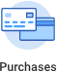
- Create a Requisition
- View Status of a Requisition
- Approve a Requisition
- Create a Receipt

The procurement process involves many steps and several different groups of people. Below is an illustration of the procurement process from shopping for goods and services all the way through to payment.

The process steps highlighted in teal represent the steps that you will take and are responsible for as part of the overall procurement process.

Shop for Goods/ Services
Explore and Select Vendor(s)
Submit Purchase Requisition

Authorization

Approval(s)

Do not continue to next step until ordered product has been delivered. *
Create Purchase Order

Create Receipt
Post to Dynamics Inventory
STOP

Invoice (AP)
Prepare payment voucher
Receipt (record keeping)

Payments made

Note: For Shamrock and Frito Lay, please see Special Instructions located on page 25.

PROCUREMENT: GETTING STARTED

GETTING STARTED
To purchase items, you begin with a requisition. A requisition is a request that lists the items (e.g., goods/services) you want to purchase. To get started, review the decision tree below and follow the steps.

Requisition Decision Tree

- Will the purchase be charged (capitalized) to a new or existing project?
  - If yes, have the project information available. This information will be required in order to create the requisition. Continue to question #2 when ready.
  - If no, continue to question #2.

- Will the purchase be associated with a new or existing Grant?
  - If yes, have the grant information available. This information will be required in order to create the requisition. Continue to question #3 when ready.
  - If no, continue to question #3.

- Are you attempting to create a requisition to purchase Goods and/or Services from a new Supplier?
  - If yes, refer to Workday Request a New Supplier Guide. Continue with Question #4 after the New Supplier is added.
  - If no, proceed to question #4.

- Are you attempting to create a Punch Out Requisition to purchase Goods from ODP?
  - If yes, see page 8.
  - If no, proceed to question #5

- Can the Goods and/or Services be found in the Workday catalog?
  - If yes, see page 11 for steps to Create a Requisition for a Catalog Items.
  - If no, see page 16 for steps to Create a Requisition for Non-Catalog Items.

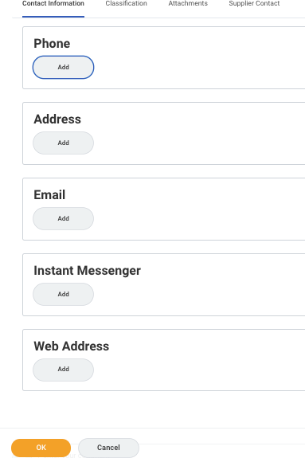
Create a Requisition for goods and/or services related to Federal Funds

- When Federal Funds will be used to make purchases, the requisitioner must follow FIN-PUR-294 Federal Funds Purchasing Policy.

CREATE A PUNCH OUT REQUISITION FOR ODP ITEMS

- Click the Purchases application, on your Workday Home page.
- Click Connect to Supplier Website from the Purchases page.
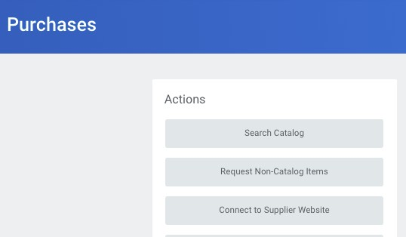
- The Connect to Supplier Website page will appear (see below). Review, verify and/or complete the following fields as needed:

FIELD | ACTION REQUIRED
Company Requester Currency | Auto populated Auto populated  Auto populated (USD)
Requisition Type | Select from: Capital Expenditure, Goods, Services Only
Deliver-To Ship-To | Auto populated. Update as needed. Auto populated. Update as needed.
Cost Center  Grant  Project Task | Auto populated. If the cost should be applied to a Cost Center  other than your own, click the Prompt icon, locate and select the appropriate Cost Center.  If purchase is associated with a grant, click the Prompt  icon, locate and select the appropriate grant.  If the purchase is associated with a project and will be  capitalized, click the Prompt icon, locate and select the appropriate project.
Additional Worktags | Auto populated

- Click OK.

(continued)

CREATE A PUNCH OUT REQUISITION FOR ODP ITEMS (continued)
- A list of supplier websites will appear (see below).
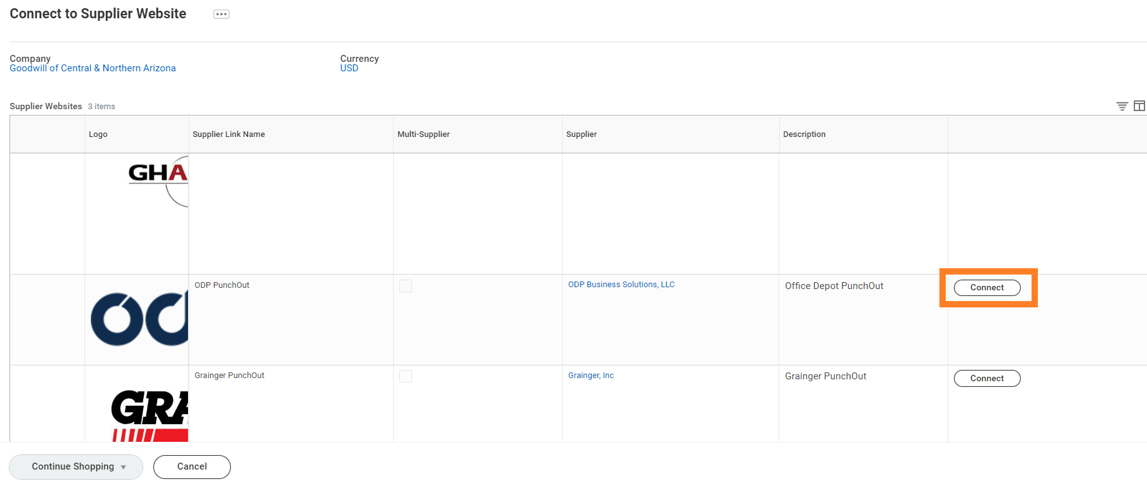
- Locate the ODP Punchout row, click Connect.
- The external ODP website page will appear (see below).
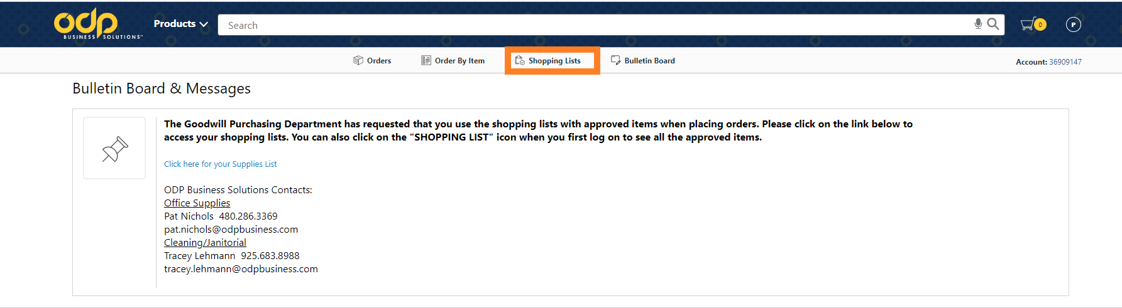
- Click the Shopping Lists link located at the top of the page.
- The My Lists page will appear, click Shopping List to continue.
- The Shopping List page will appear.

(continued)

CREATE A PUNCH OUT REQUISITION FOR ODP ITEMS (continued)
- To select an item for purchase,
  - Click the checkbox to the left of the desired item.

  - Adjust the Quantity (Qty) 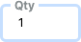 to the desired amount.
  - Click Add to Cart to add the item to your shopping cart.
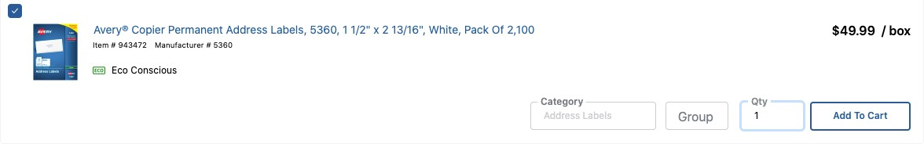
- Once you have added all the desired items to your cart, move your mouse over the Shopping Cart
icon to view your Cart Summary and/or to Checkout.

Note: Disregard the Summary section on the right-side of the page. Do not use the Add Selected To Cart or Add All To Cart buttons found in the Summary section.
- Verify the order.
Note: To make changes to the order from the Cart Summary window, click View Cart.
- Click the Checkout button.
Note: After checking out, you will automatically return to Workday.

- From the Workday View Cart page, click the Checkout button.
- Verify the order, click Submit.

CREATE A REQUISITION FOR CATALOG ITEMS

- Click the Purchases application, on your Workday Home page.
- Click Search Catalog from the Purchases page.
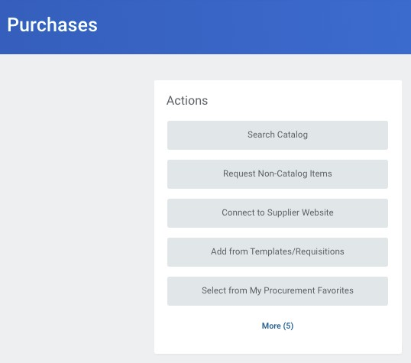
- The Search Catalog page will appear (see below). Search options include:
  - Search by Item Name (e.g., twin mattress). To search by Item Name, type the name in the Search field and Click Search.
  - Search by Category (e.g., New Mattresses). To Search by Category, click the box to the left of the Category Names listed to filter your search.
  - Search by Supplier (e.g., Quality Bedding). To Search by Supplier, click the box to the left of the Supplier Names listed to filter your search.
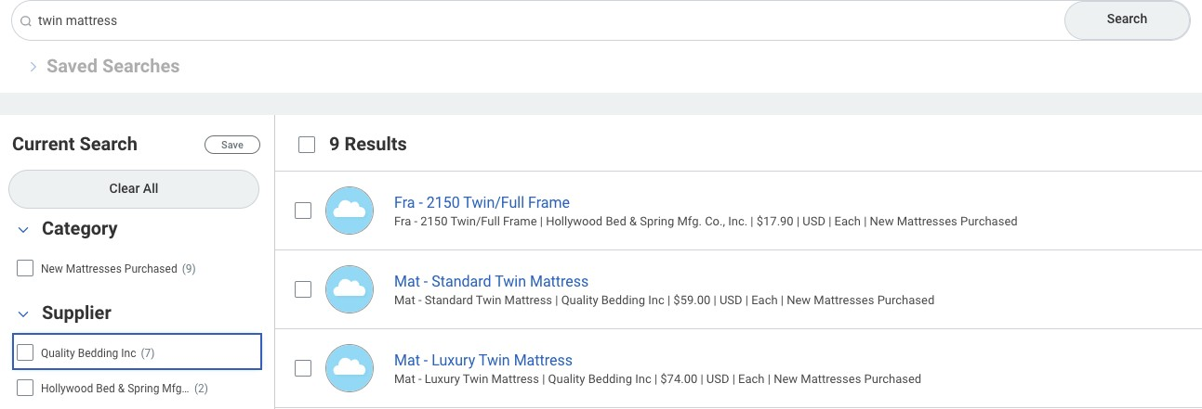

- Click the box(es) to the left of the items you want to purchase.
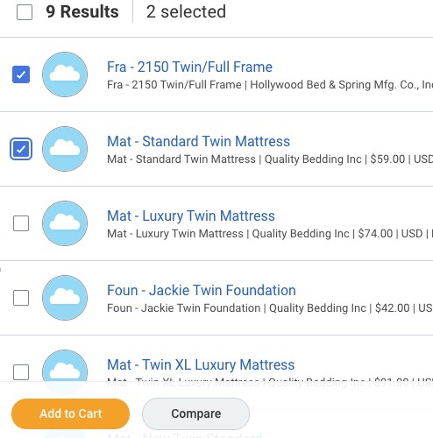

Note: If you cannot find the item you wish to purchase in the catalog, return to the Home page and refer to the instructions on page 13 to Create a Requisition for Non-Catalog Items.

- Click Add to Cart to add the items to your purchase.
- Click the Shopping Cart icon, found in the upper-right portion of your page.
- Click View Cart to adjust item quantities as needed.
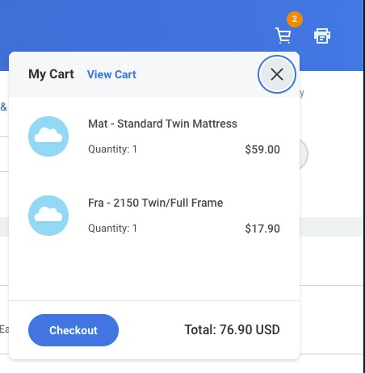

- An item list will appear on the left side of the page. To adjust quantities for each item, select an item from the item list on the left side of the page, then adjust item quantity on the right side of the page.
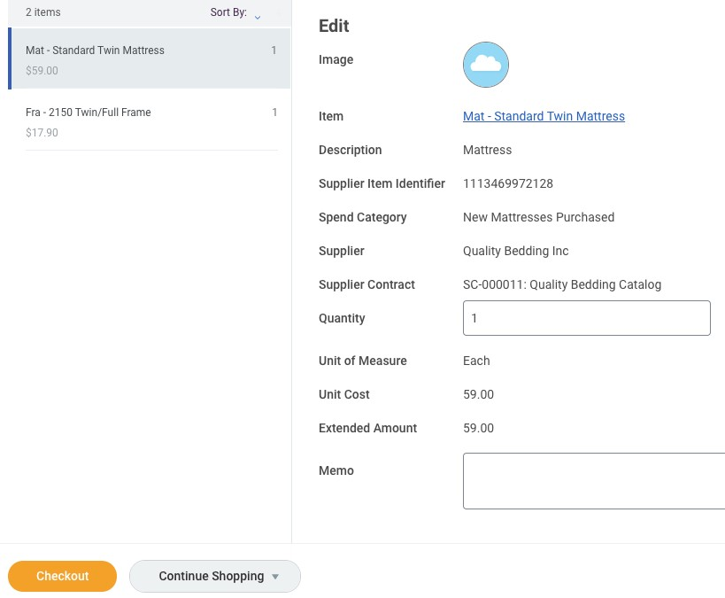
- Verify quantity amounts are correct, then click Checkout .
- The Checkout page appears, displaying the following information:

  - Shipping Address
  - Requisition Information
  - Goods
  - Services
  - Attachments

Note: See the following page for help completing the Checkout process.

- Review Shipping Address section. Perform any necessary changes in the Goods section.
- Review Requisition Information section. Select the Requisition Type (Capital Expenditure, Goods, or Services Only). Provide any additional information you have available.
- Review Goods section. Review, verify and/or complete the following fields as needed:

FIELD | ACTION REQUIRED
Item  Item Description Spend Category | Auto populated Auto populated  Auto populated
Quantity | Verify and/or update quantity amounts as needed
Unit Cost | Auto populated
Extended Amount | Auto populated
Deliver-To Address | Auto populated. Update as needed.
Ship-To Address | Auto populated. Update as needed.
Ship-To Contact | Auto populated. Update as needed.
Requested Delivery Date | Optional
Supplier  Supplier Contract Supplier Item Identifier | Auto populated Auto populated  Auto populated
Memo  Cost Center  Grant  Project Task | Optional  If the cost should be applied to a Cost Center other than your  own, click the Prompt icon, locate and select the appropriate Cost Center.  If purchase is associated with a grant, click the Prompt  icon, locate and select the appropriate grant.  If the purchase is associated with a project and will be  capitalized, click the Prompt icon, locate and select the appropriate project.
Additional Worktags  Splits | Auto populated  N/A

- Review Services section. Review, verify and/or complete the following fields as needed:

FIELD | ACTION REQUIRED
Item  Item Description Spend Category | Auto populated Auto populated Auto populated
Start Date | N/A
End Date | N/A
Deliver-To Address | Auto populated. Update as needed.
Ship-To Address | Auto populated. Update as needed.
Ship-To Contact | Auto populated. Update as needed.
Supplier | Auto populated
Supplier Contact | Auto populated
RFQ Required | N/A
Memo | Optional
Cost Center | If the cost should be applied to a Cost Center other than your
 | own, click the Prompt icon, locate and select the
 | appropriate Cost Center.
Grant | If purchase is associated with a grant, click the Prompt
 | icon, locate and select the appropriate grant.
Project Task | If the purchase is associated with a project and will be
 | capitalized, click the Prompt icon, locate and select the
 | appropriate project.
Additional Worktags Splits | N/A N/A

- Add Attachments. Add all Sales Orders, Quotes, Estimates, etc.
- After all information has been reviewed and verified for accuracy, click Submit.

CREATE A REQUISITION FOR NON-CATALOG ITEMS

- Click the Purchases application, on your Workday Home page.
- Click Request Non-Catalog Items from the Purchases page.
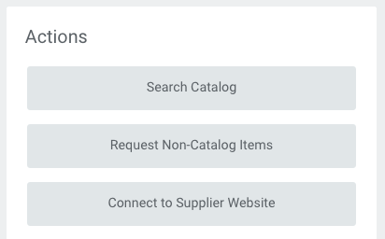
- The Request Non-Catalog Items page appears.
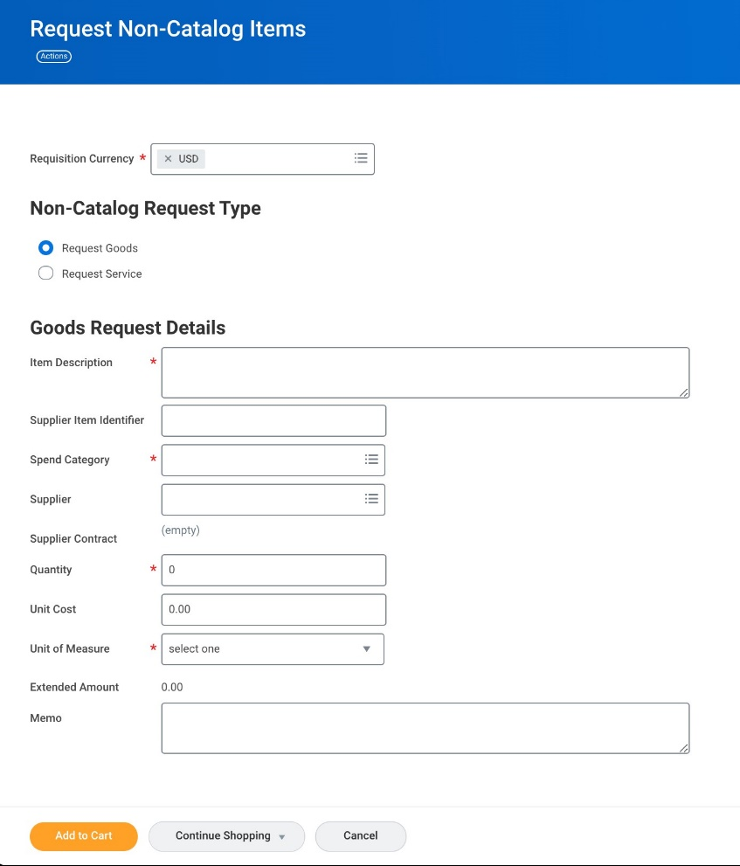

(continued)

11. From the Request Non-Catalog Items page, complete the following fields:

FIELD | ACTION REQUIRED
Non-Catalog Request Type Item Description | Select either Goods or Services  Provide description of the Good or Service
Supplier Item Identifier | N/A
Spend Category | Click the Prompt icon, locate and select the Spend
 | Category that best describes the purchase.
Supplier | Click the Prompt icon, locate and select the Supplier from
 | the list. If the Supplier is not known, leave the field blank.
Quantity | Input the desired quantity.
Unit Cost | Input dollar amount.
Unit of Measure | Click the Prompt icon, locate and select the Unit of
 | Measure that best describes the purchase.

- Click Add to Cart to add the items to your purchase.
- Click the Shopping Cart icon, found in the upper-right portion of your page.
- Click View Cart to adjust item quantities as needed.

- An item list will appear on the left side of the page. To adjust quantities for each item, select an item from the item list on the left side of the page, then adjust item quantity on the right side of the page.
- Verify quantity amounts are correct, then click Checkout .
- The Checkout page appears, displaying the following information:

  - Shipping Address
  - Requisition Information
  - Goods
  - Services
  - Attachments

Note: See the following page for help completing the Checkout process.

- Review Shipping Address section. Perform any necessary changes in the Goods section.
- Review Requisition Information section. Select the Requisition Type (Capital Expenditure, Goods, or Services Only). Provide any additional information you have available.
- Review Goods section. Review, verify and/or complete the following fields as needed:

FIELD | ACTION REQUIRED
Item  Item Description Spend Category | Blank  Auto populated Auto populated
Quantity | Verify and/or update quantity amounts as needed
Unit of Measure | Auto populated
Unit Cost | Auto populated
Extended Amount | Auto populated
Deliver-To Address | Auto populated. Update as needed.
Ship-To Address | Auto populated. Update as needed.
Ship-To Contact | Auto populated. Update as needed.
Requested Delivery Date | Optional
Supplier Supplier Contact  Supplier Item Identifier | Auto populated Auto populated Auto populated
Memo  Cost Center  Grant  Project Task | Optional  If the cost should be applied to a Cost Center other than your  own, click the Prompt icon, locate and select the appropriate Cost Center.  If purchase is associated with a grant, click the Prompt  icon, locate and select the appropriate grant.  If the purchase is associated with a project and will be  capitalized, click the Prompt icon, locate and select the appropriate project.
Additional Worktags Splits | Auto populated N/A

(continued)

- Review Services section. Review, verify and/or complete the following fields as needed:

FIELD | ACTION REQUIRED
Item  Item Description Spend Category | Auto populated Auto populated Auto populated
Start Date End Date | N/A N/A
Deliver-To Address | Auto populated. Update as needed.
Ship-To Address | Auto populated. Update as needed.
Ship-To Contact | Auto populated. Update as needed.
Supplier | Auto populated
Supplier Contact | Auto populated
RFQ Required Memo  Cost Center  Grant  Project Task | N/A Optional  If the cost should be applied to a Cost Center other than your  own, click the Prompt icon, locate and select the appropriate Cost Center.  If purchase is associated with a grant, click the Prompt  icon, locate and select the appropriate grant.  If the purchase is associated with a project and will be  capitalized, click the Prompt icon, locate and select the appropriate project.
Additional Worktags Splits | N/A N/A

- Add Attachments. Add all Sales Orders, Quotes, Estimates, etc.
- After all information has been reviewed and verified for accuracy, click Submit.

View and find the status of your Requisitions

Click the My Requisitions application, on your Workday home page.

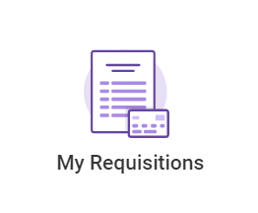

Your recent requisitions will populate

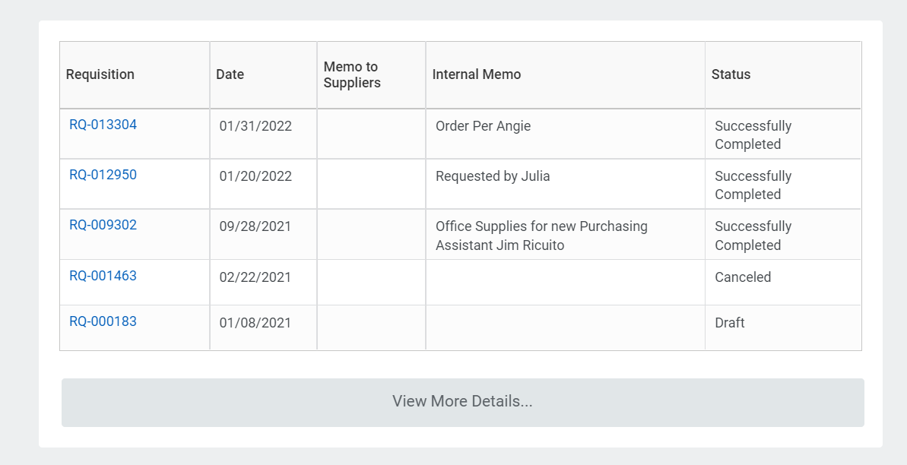

If you need to search for requisitions created earlier that what is displayed, click ‘view more details’
- The My Requisitions page will appear. Workday offers multiple ways to narrow your search. Use the fields to set your search criteria and click OK.

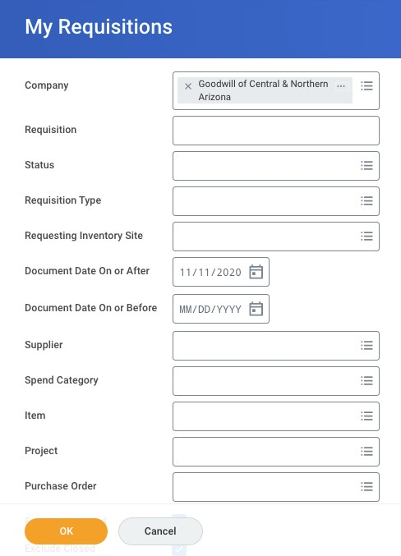
To set search criteria, type data directly into the fields, or click the Prompt icon located within each field and select accordingly.

Frequently used search criteria:
  - Requisition (number) if known
  - Status
  - Document Date (range)
  - Supplier
  - Item

Note: To cast a wide net, click OK to view all requisitions associated with you.

Your requisitions from the search criteria will display on the next page.

VIEW STATUS OF A REQUISITION (continued)

- The Procurement Requisitions list will appear, displaying the Request Status.
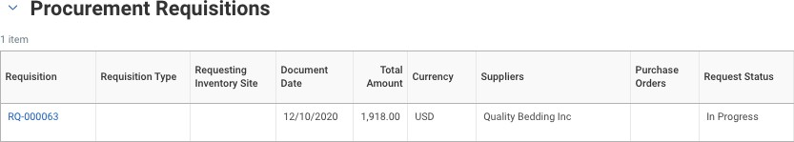

- To view the details of a requisition and determine which step in the business process the requisition it is at,
- Click on the requisition number
- Scroll down to Process History
- Click on Process History
- Review the Process List of events to determine if an event is Awaiting Action or if it shows
Step Completed.

- To cancel a requisition which has not been approved,
- Click the Related Actions icon (appears when hovering over the requisition number)
- Click Requisition
- Click Cancel

View and Find the Status of your Purchase Orders

Click the My Recent Purchase Orders application, on your Workday home page.

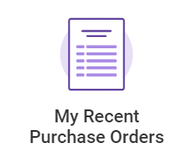

- Your Recent Purchase Orders will display on the page
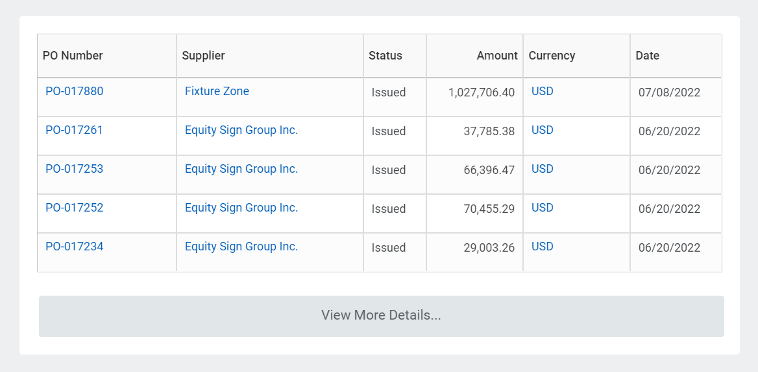

- If you need to search for purchase orders created earlier that what is displayed, click ‘view more details’
- The Find Purchase Orders page will appear. Workday offers multiple ways to narrow your search. Use the fields to set your search criteria and click OK.

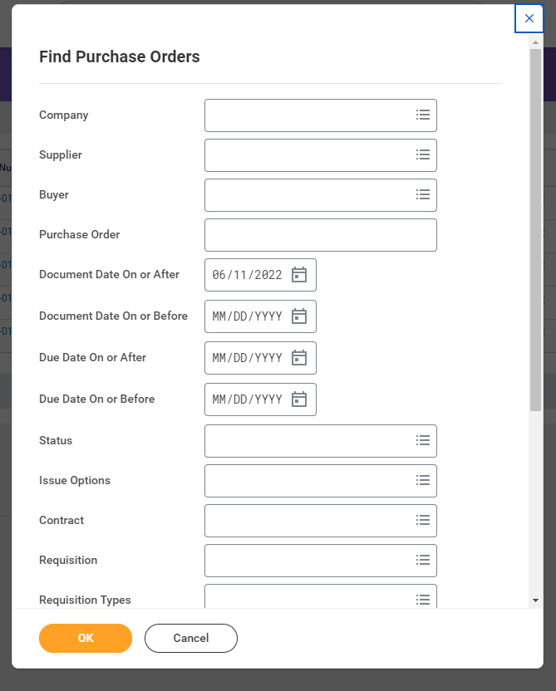
To set search criteria, type data directly into the fields, or click the Prompt icon located within each field and select accordingly.

Frequently used search criteria:
  - Requisition (number) if known
  - Status
  - Document Date (range)
  - Supplier
  - Item

Note: To cast a wide net, click OK to view all purchase orders associated with you.

Your Purchase Orders from the search criteria will display on the next page.

*Note – If you need to create a receipt for any of the PO’s shown, you can quickly access the receipt function from this page by accessing the actions menu next to the PO, and go to receipt – create.

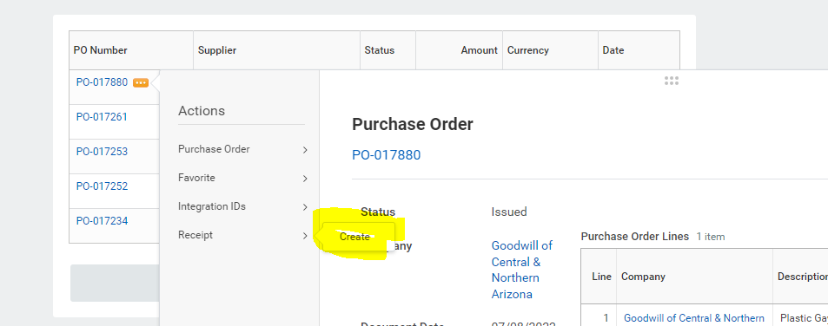

APPROVE A REQUISITION

Note: Approval authority in Workday is aligned with the Purchasing Policy as outlined in FIN-PUR-
104. For details, refer to the policy which can be found on the Policy and Procedure website.

- Click on your Workday inbox located on your Home page.
- Click on the requisition task, review and verify all details.

  - If you approve the request, click Approve.
  - If you do not approve the request, click Send Back and include a reason. (e.g., incorrect item, quantity, etc.)

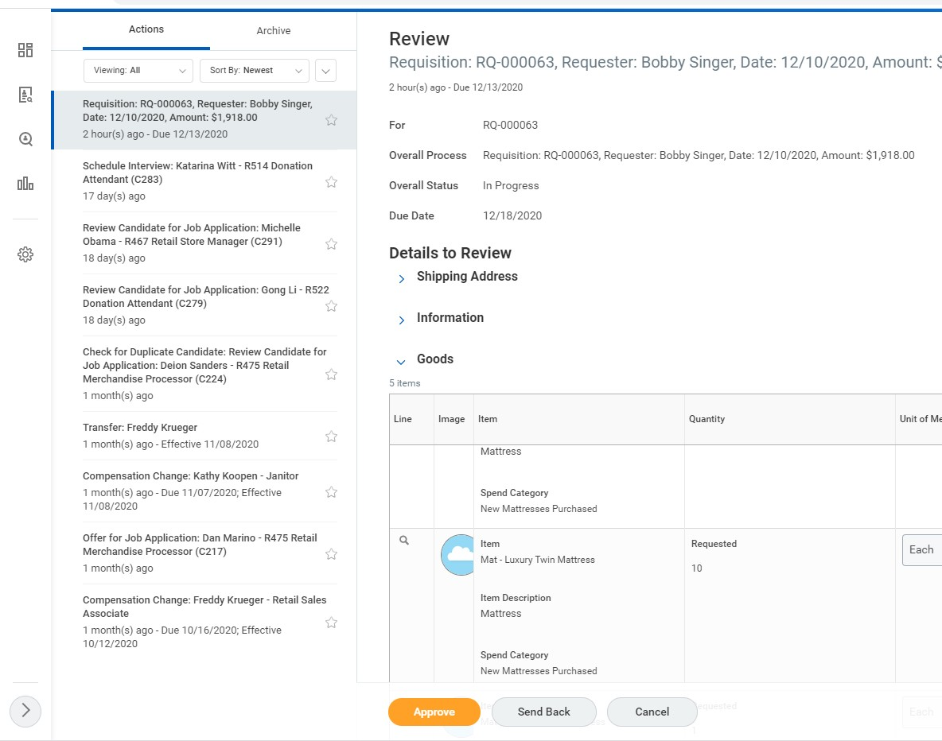

(continued)

APPROVE A REQUISITION (continued)

- After approving the requisition, the following page will appear, indicating the next step in the business process.
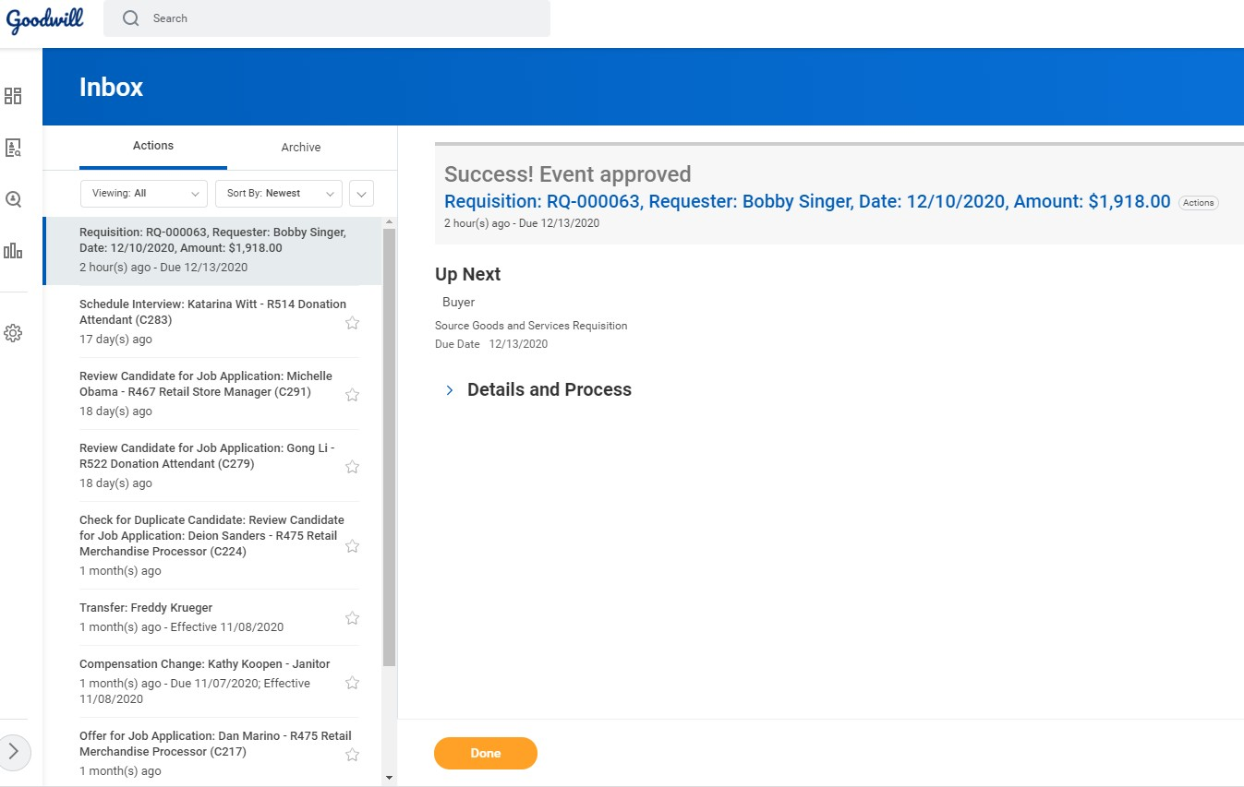

- For more information on the remaining business processes, click the Details and Process link.
- To complete the approval, click Done.

(continued)

PROCUREMENT: RECEIVING

CREATE A RECEIPT - All Items Fully Received

Note: Do NOT use this process if your store was short shipped or are missing items from your order, use the process on page 27.

Once the vendor has delivered the ordered products, the next step in the process is to create a receipt in Workday. Follow the steps 1- 8 below to create a receipt.
Note: Shamrock and Frito-Lay products follow a different process. See special instructions below.
Shamrock and Frito-Lay Special Instructions
Once the product has been replaced by the vendor:

- Create a Requisition in Workday for the items received.
- Wait 24-28 hours for the approval process to be completed.
- Create a Receipt in Workday (follow steps 1-8 below)
CREATE A RECEIPT

- Click the Purchases application, on your Workday Home page.
- Click the More link to expand the Actions menu.
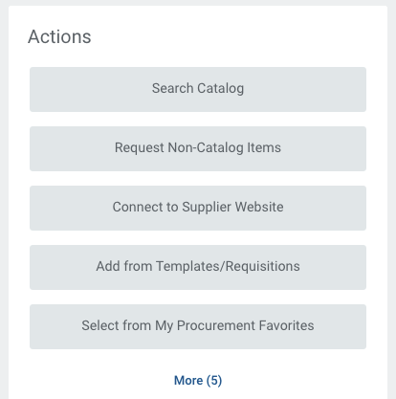

- Click Create Receipt.
- The Create Receipt page appears.

(continued)

PROCUREMENT: RECEIVING

CREATE A RECEIPT (continued)

- From the Create Receipt page:

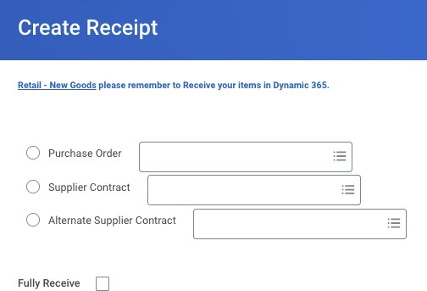
In the Purchase Order field, click the Prompt icon, locate and select the desired
Purchase Order.

Note: To view the details for the Purchase Order, Click the Related
Actions icon.

- To receive all goods, check the Fully Receive box.

Note: If you did not receive all items as expected, notate the quantity actually received in the
Quantity to Receive field. (e.g., If you expected 10 items and received 8 items, enter 8 in the
Quantity to Receive field).

- Click OK.
- Click Submit.

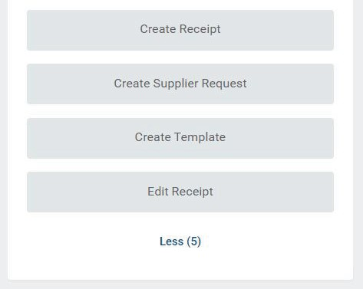
PROCUREMENT: RECEIVING

CREATE A RECEIPT – WHEN YOUR STORE WAS SHORT SHIPPED PRODUCT

- Log in to the Workday system.
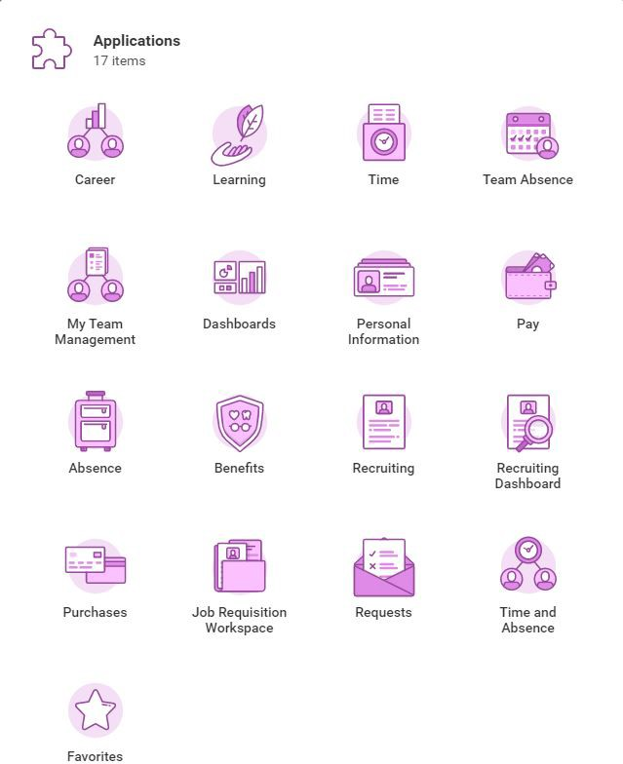
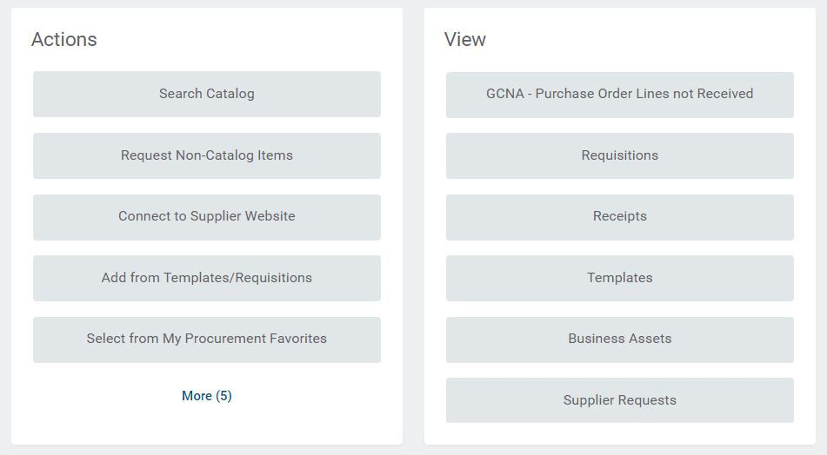
- Go to your purchases app - and on the left side click More and then create receipt.

- Click on Purchase Order, then Purchase Orders by Suppliers. In this example, we will select Dahdoul.
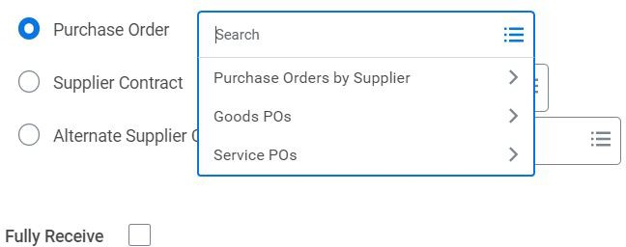

- Scroll down until you find the PO Number you need to receive, then select it
Note: If you do not know your PO#, you can type in the top left search bar ‘find purchase orders’ and use the search criteria to locate your PO#.
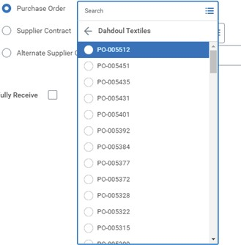

- After you select the PO Number you want to receive, click OK. Do NOT click Fully Receive unless you physically got everything you ordered.
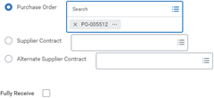

- Enter the quantity in each line of what you physically received from the vendor. In this example, we are going to receive all the goods except for 5 of the 10 Disney beach towels.
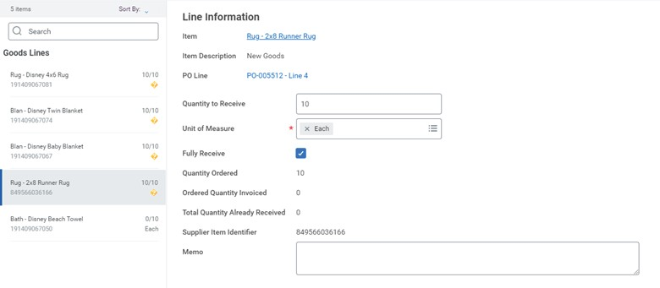
- For the beach towels, we are going to enter 5 in the ‘quantity to receive’ field, and then click submit.

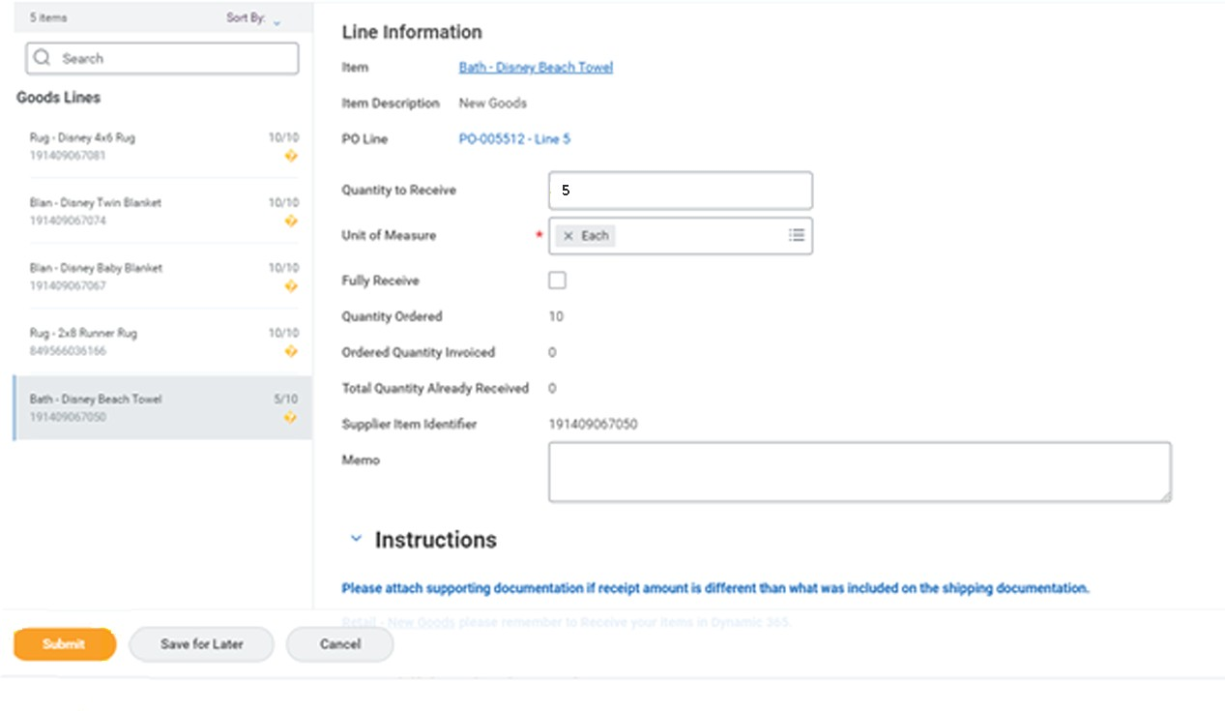

PROCUREMENT: RECEIVING

HOW TO LOOK UP PURCHASE ORDERS FOR YOUR STORE THAT NEED TO BE RECEIVED
These instructions can be used to find Purchase Orders that need receipts created, even if you were not the requisitioner.
- Click on the Purchases App
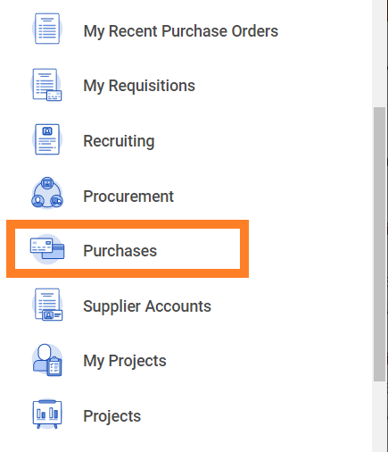

- Click on ‘GCNA – Purchase Order Lines not Received’
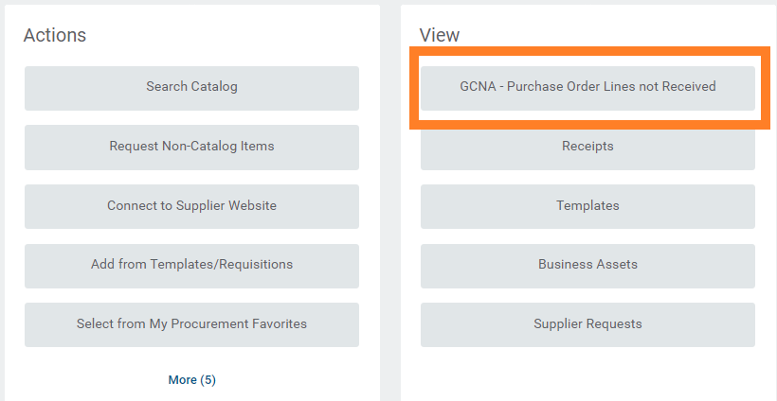

PROCUREMENT: RECEIVING

HOW TO FIND PURCHASE ORDERS FOR YOUR STORE THAT NEED TO BE RECEIVED
(continued)

- Click on Cost Center, and select the appropriate store
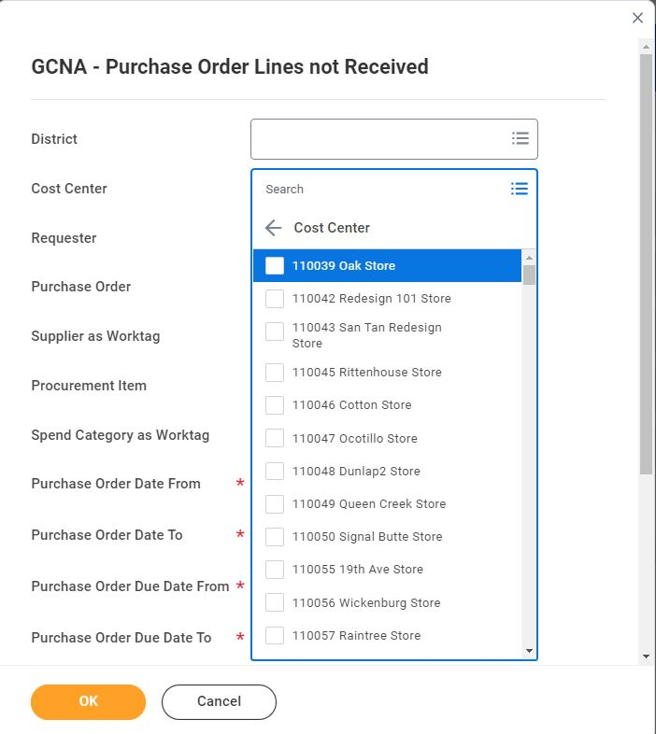

- If necessary, select the date range that you would like to search by selecting dates from the ‘Purchase Order Date From’ field, and the ‘Purchase Order Date To’ field, and click OK
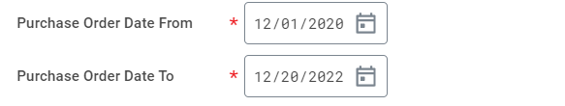

PROCUREMENT: RECEIVING

HOW TO FIND PURCHASE ORDERS FOR YOUR STORE THAT NEED TO BE RECEIVED
(continued)

- The report will populate each line of a PO that does not have a receipt. Hover over the 3 dots next to the PO you need to create the receipt for, and access the actions menu, and then click receipt, create.
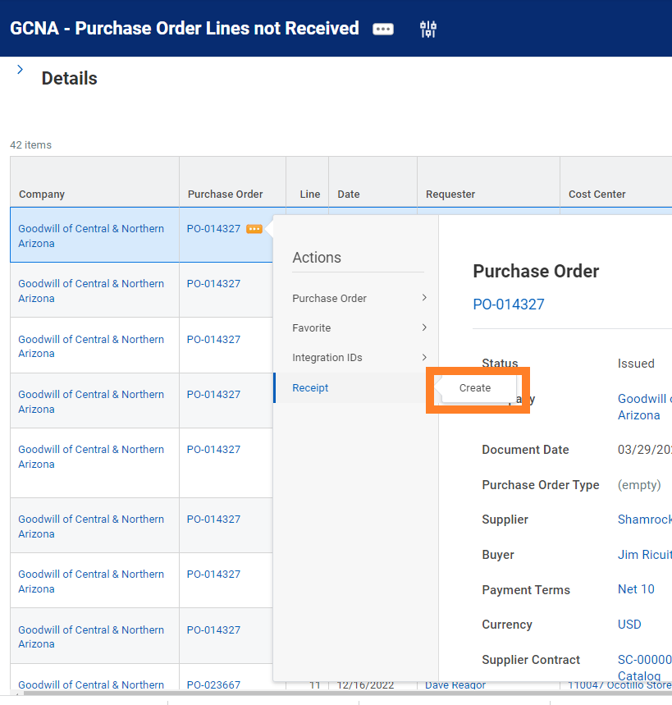
- If your store received everything that was ordered, finish out the receipt creation process from the instructions on page 30. If you were short shipped, finish out the receipt process listed on page 32.

PROCUREMENT: RECEIVING

POST INVENTORY TO DYNAMICS
The final step in the Procurement process requires receiving Workday items into Dynamics’ inventory. To receive and post inventory to Dynamics, continue with the following steps:

- Create the receipt in Workday.

Note: An integration will automatically run in the background to transfer the Workday received items to Dynamics to receive into inventory. This integration takes approximately 10 minutes to
complete.

- Log into Dynamics.
- Go to Inventory Adjustment.
- View the list of Workday INV journals (Workday Inventory Adjustment Journal).
- Click on a INV Journal file to view the details of the journal file.
- A list of Journal Lines will appear displaying the Workday items received into Dynamics.
- From the Dynamics menu (located at the top of the page), click Post to add the items to your Dynamics inventory.

