**Mission Services Core Skills Training**

**High-impact Questions**

**INSTRUCTOR GUIDE**

**Goodwill of Central and Northern Arizona**

**Purpose**

The purpose of this course is to introduce learners to the topic: High-impact Questions . Topics to be covered include; what are High-impact Questions, the difference between open and closed ended questions, how to leverage High-impact Question techniques and best practices. At the conclusion of this course, learners will gain a better understanding of their High-impact questioning skillset and how to leverage these skills with our colleagues and jobseekers.

**How to Use This Guide**

This instructor guide is designed to help you deliver the High-impact Questions course. Explanations of what to say, what to do, and how to conduct activities, if applicable are provided within this guide; however, you can use the left side of each page to enter your own notes to help you train this workshop.

You will also see PG referenced throughout this material, it stands for Participant Guide. References will only be provided when relevant to the training.

Durations, if provided, are estimates only and may not reflect the final training.

**Materials Needed**

Use the following materials as you train this course**:**

* Core Skills High-impact Questions PPT
* Core Skills High-impact Questions Participant Guide
* Core Skills High-impact questions, Best Practices Handout
* Core Skills High-impact questions, Types of Questions Handout
* Core Skills High-impact questions, Types of Responses Handout

Header/Topic: **Welcome Slide**

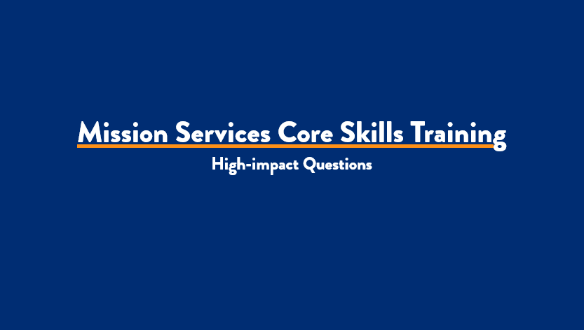

***Slide 1: Title Slide***

***Estimated duration:***

***Participant Guide Page:***

***Notes:***

**Say:**

Welcome to Mission Service’s Core Skills Training. This course will focus on the topic: High-impact Questions. Keep in mind that the Core Skills Training will encompass numerous courses developed specifically to meet your unique needs as a member of the Missions Services team. You will continue to receive updates from your respective leaders once additional courses are released and available for you to complete.

**Explain:**

This is a self-paced course designed for you to complete at your own pace. Before you get started, make sure you have the following items to ensure successful completion of this course:

•Something to write with- Pen/Pencil

•Your Participant Guide- This can be accessed via the L&D Learning Portal

•A quiet place to complete your training that is free from any distractions

•And a headset, if needed.

**Say:**

 I am very excited to walk you through this topic today.

Header/Topic: **Course Objectives**

**Say:**

One of the important aspects of a training course is the course objective. The objectives provide insight into what you will learn from the content presented to you today. For the HIQ course, the objectives we will cover include:

•Define High-impact questions

•Differentiate open and closed-ended questioning

•Discuss how to leverage High-impact questions

**Explain:**

This course will provide you with the basic foundations of High-impact Questions and leverage them in the workplace, and with the people we serve.

**Discuss:**

High-impact questions are an essential part of your role as a member of the Mission Services Team. When working with our Job Seekers, you'll be presented with opportunities to help them dive deeper within themselves to find answers to questions about their career and educational growth.

**Say:**

Now, let's review our course rules.

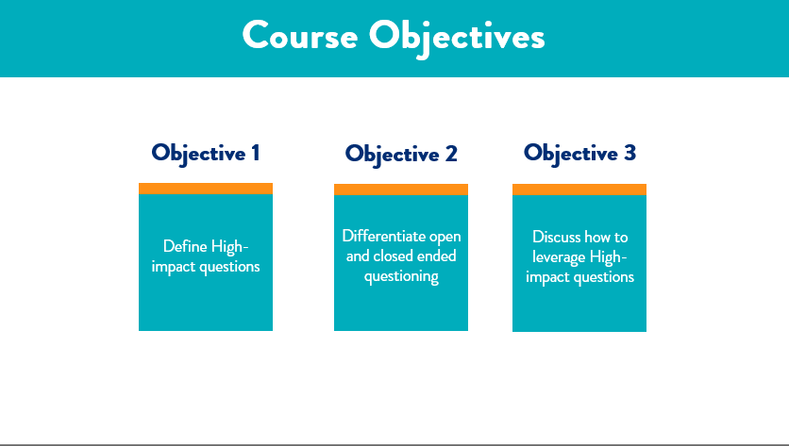

***Slide 2: Course Objectives***

***Estimated duration:***

***Participant Guide Page:***

***Notes:***

Header/Topic: **Course Rules**

**Say:**

The rules for this course will look a little different as you are completing this session in a self-paced modality. So let's talk a little about the course rules now:

•Make sure you're in a learning environment free from distractions.

•Feel free to pause this course at any time if you need to step away or take a break

•Write down any questions you have for your leaders and send your questions to them after the completion of this course

•Write down any feedback you have for L&D and forward that to your respective leader

**Say:**

Let's move right into our first topic, where we will define high-impact questioning.

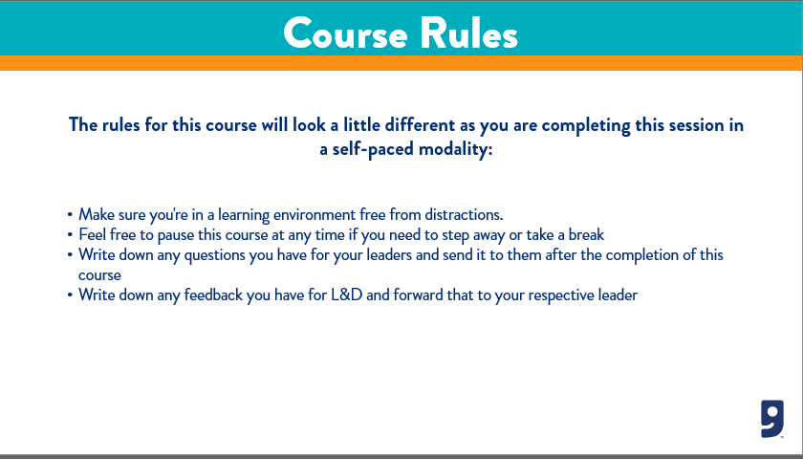

***Slide 3: Course Rules***

***Estimated duration:***

***Participant Guide Page:***

***Notes:***

Header/Topic: **High-impact Questions**

**Say:**

Let's begin by defining what High-impact questions are. High-impact questions are those that open the door for robust conversation. These are questions that provide direction and structure within a conversation. The way these questions are positioned helps empower the person you communicate with to explore thoughts, emotions, and feelings through more profound, more meaningful conversation.

**Explain:**

This may look like you are meeting with a jobseeker for the first time and speaking with them to get to know who they are and how invested they are in receiving services. You may want to start by asking questions such as "what problem you are trying to solve?" and exploring solutions. You may also request a job seeker to consider how their lives might be impacted by receiving service with us. When interacting with our jobseeker, the first thing we always want to do is determine what their actual ask is and how we can help them.

**Discuss:**

So, why do we ask high-impact questions? By asking questions using this structure, we move beyond transactional conversations towards a new level of questioning, which encourages the jobseeker to think deeply about an issue because the answers they discover have an impact on them. Essentially, you are communicating with influence when you ask high-impact questions at the right time.

**Say:**

Next, let's talk about how we can develop high-impact questions to leverage with our job seekers.

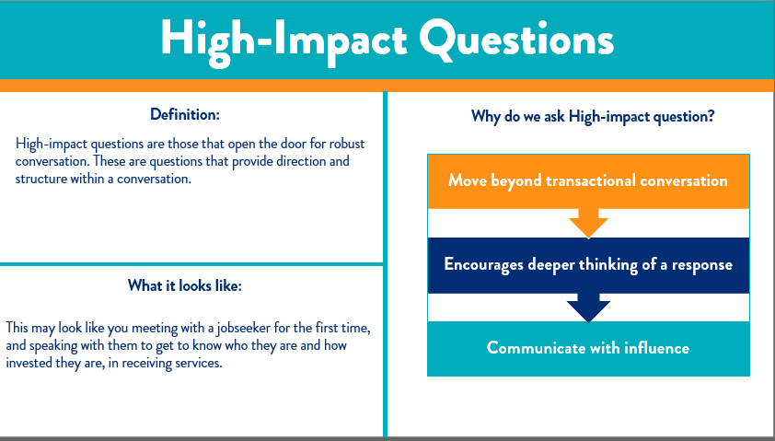

***Slide 4: High-impact Questions***

***Estimated duration:***

***Participant Guide Page:***

***Notes:***

Header/Topic **High-Impact questions examples**

**Say:**

High-impact questions are open-ended and EMPOWER the person responding to choose the direction THEY WANT TO TAKE.   They are curious and non-judgmental questions and they seek to further learning and connection.

I'd recommend jotting down the part of the statement that says, "EMPOWER the person responding to choose the direction THEY WANT TO TAKE." If you ever doubt why high-impact questions are essential, this can be your go-to reminder!

**Explain:**

These questions show that you want to learn from the person you're conversing with. It gives them a chance to contemplate what THEY want, making it a judgment-free zone, in other words, no one is telling them what to do, what to think, or how to think; it's an honest inquisitive question asking for information that will help you learn more about your job seeker.

**Say:**

Now that we have a better understanding of what high-impact questions are, I want to share with you some examples of high-impact questions. I encourage you to write these down in your workbook for future reference.

**Examples:**

I want to be sure that I provide you with solid examples of what your high-impact question may look like. Remember, we want to guide the jobseeker to provide us with as many details as possible on their terms. Some high-impact question examples might include:

***Continued on next page***

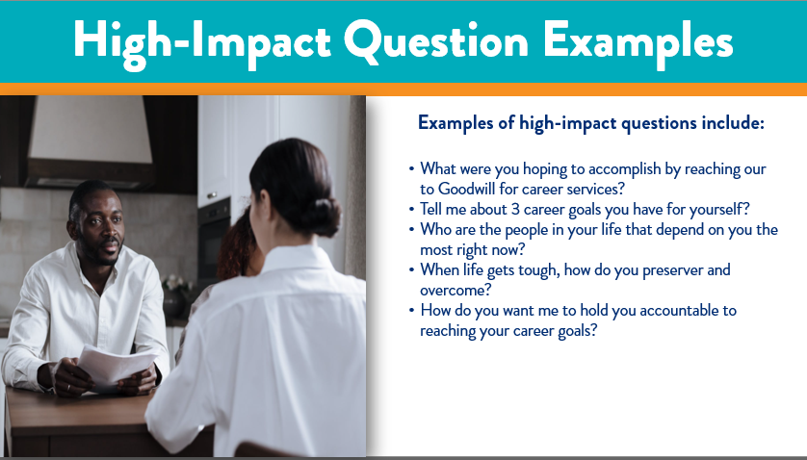

***Slide 5: High-Impact questions examples***

***Estimated duration:***

***Participant Guide Page:***

***Notes:***

* What were you hoping to accomplish by reaching out to Goodwill for career services?
* Tell me about 3 career goals you have for yourself?
* Who are the people in your life that depend on you the most right now?
* When life gets tough, how do you preserver and overcome?
* How do you want me to hold you accountable to reaching your career goals?
* How do you want me to hold you accountable for reaching your career goals?
* What are your career goals in 3-5 years from now?

**Explain**:

As you can see from the examples, these questions are thought-provoking and require the jobseeker to open up and be vulnerable. This is one of the beautiful things about helping those in our community to better themselves. That is, being the person, they feel safe opening up to and allowing them to guide the conversation without them knowing that you are the one doing the guiding.

**Next:**

let's move on to the next slide, where we will discuss how to develop high-impact questions.

Header/Topic **Developing high-impact questions**

**Say:**

An important part of your role is to meet with our job seekers and help them along their career path. When you interact with them, it is important that you build trust and create a relationship with them where they look to you for guidance and direction. We achieve this by conducting a fact-finding conversation with them to learn who they are and how we can help them. We use high-impact questions to determine what strategies will work best for each jobseeker. I want to talk more about how you can accomplish this through conversation and high-impact questions.

**Say:**

There are six guidelines you want to think about when developing your questions. I’m going to ask that you pause this video and in your Participant Guide, fill in the blanks in your guide, from this slide. When you’ve filled in the blanks for this slide, please come back.

***Continued on next page***

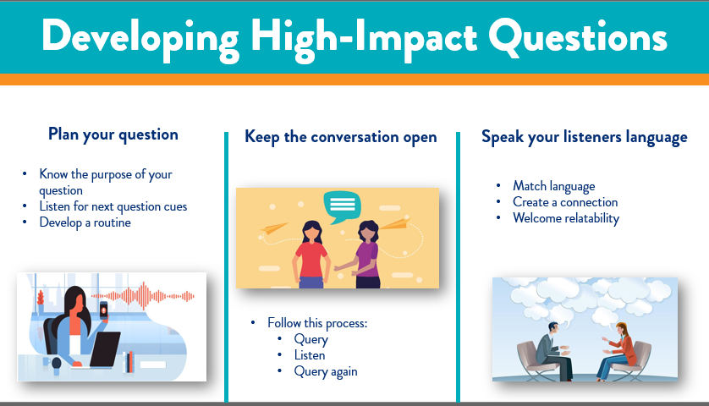

***Slide 6: Developing high-impact questions***

***Estimated duration:***

***Participant Guide Page:***

***Notes:***

**Explain:**

Welcome back. This information is important because these are the types of question that will garner you the information you need to help your job seeker succeed on their journey!

•Plan your questions- To plan your questions, you need to know the purpose of your question. Now, in some questions, you may be able to prepare some questions in advance. These may be questions that you can use on a routine basis but with different Job Seekers.

For instance, if a Job Seeker is new to you and they have determined a specific job they would like to perform, you might ask something like, *"What type of research have you done for the needed education or experience required for this career"?*

However, in general, your "planning" is just some forward-thinking you might do while working with the jobseeker. By listening to your Job Seeker, you can learn the purpose of your next question so that you can dive deeper into the subject.

•Keep the conversation open- By asking High-impact Questions, you continue to query and then listen and query again, keeping the flow of the conversation moving forward.

•Speak your listeners' language- When you can, match your language to that of your jobseekers. This will create connection and relatedness and keep the conversation open and friendly.

**Say**:

I have three additional guidelines to review with you on the next screen.

Header/Topic: **Developing high-impact questions**

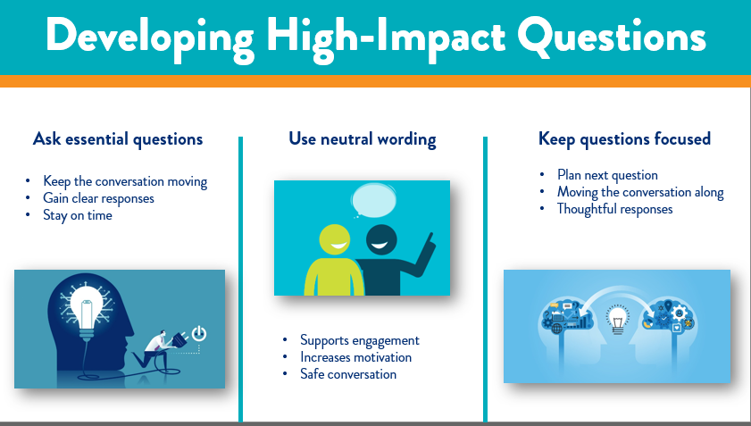

***Slide 7*: Developing high-impact questions**

***Estimated duration:***

***Participant Guide Page:***

***Notes:***

**Say**

Again, I’m going to ask you to pause this video and in your Participant Guide, fill in the blanks in your guide, from this slide. When you’ve filled in the blanks for this slide, please come back.

Welcome back! The next guideline I would like to cover with you is:

•Ask essential questions- This helps keep the conversation moving forward and helps remove side chatting that can take up valuable time. Remember, your task is to lead the jobseeker into giving clear responses to the questions you ask. Keeping your questions to the essential topics at hand will help you glean more information and stay timely with your appointments.

•Using neutral wording helps keep the Job Seeker engaged while feeling motivated to do the necessary work. Neutral wording means keeping your language positive, supportive, and impartial. Remember, we want to know what the Job Seeker has to say; using neutral working keeps the conversation safe for them to be honest and forthcoming.

***Continued on next page***

•Keep your questions focused. Take a moment to plan your next question to move the conversation forward and guide the Job Seeker. Giving them the space and time to dig for an honest answer and not just an off-the-cuff answer creates a sense of safety, support, and, more than anything, setting a tone that we are here to help.

**Say:**

Now that we have a clear understanding of high-impact questions and how we should structure them in conversation with our job seekers, let's move forward and talk a little about open-ended and closed-ended questions.

Header/Topic: **Open and Closed-Ended Questions**

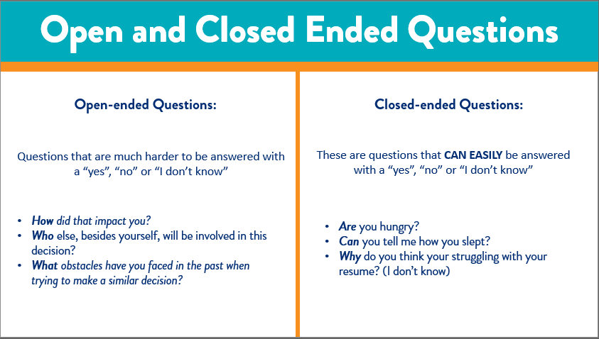

***Slide 8: Open and Closed-Ended Questions***

***Estimated duration:***

***Participant Guide Page:***

***Notes:***

**Say**:

When it comes to high-impact questions, it's important for us to know the difference between Open and Closed-ended questions. This is important because it will help us develop and frame the high-impact questions we want to deliver to the jobseeker. Therefore, I want to take some time to discuss this topic in more detail.

**Say**:

Open-ended questions are questions that cannot be answered with a "yes," "no," or "I don't know" response. Instead, open-ended questions are positioned in such a way that it requires your jobseeker to provide a thoughtful response. An example of an open-ended question might be; "Tell me about your job experience?" or "Where do you see your career journey in the next five years?" These types of questions prompt your jobseeker to provide detail and context to understand better who they are and what goals they want to achieve through the services we provide.

Closed-ended questions are phrased so that job seekers can respond with a "yes" or "no" or "I don't know" response. Closed-ended questions do not require or prompt for additional context. An example of a closed-ended question might be; "Are you 25 years old?" or "Were you satisfied with the service you received today?" These questions serve only to get a very directed and specific response, and there is no room for interpretation. These questions generally work in gathering demographic data; however, if you are trying to develop a career plan for your jobseeker, you may not get the information you need to create that plan.

***Continued on next page***

**Say**:

In general, a closed-ended question is excellent if you need a clear and concise, simple answer. A general open-ended question is good to gather some basics but leaves the conversation open to moving forward. Lastly, High-impact questions will take your discussion to new depths, giving the person you're asking the question time to contemplate, imagine, and discover their answer.

**Explain**:

So now that we have a better understanding of the differences between the two types of questions, you may be thinking, "How do I leverage these when I am working with job seekers?" Let's talk about that on the next slide.

Header/Topic: **Types of questions**

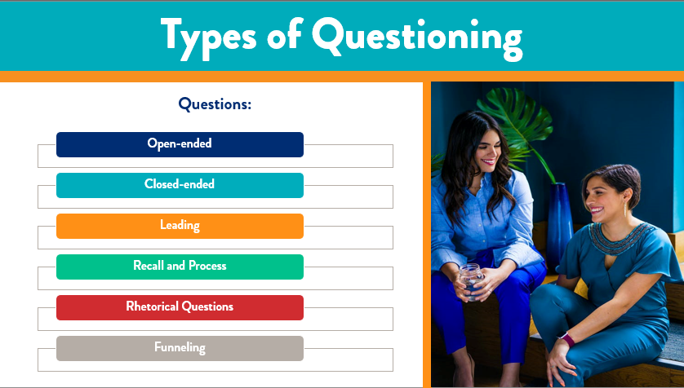

***Slide 9: Types of questions***

***Estimated duration:***

***Participant Guide Page:***

***Notes:***

**Say**:

We now understand the more familiar types of questions, specifically open and closed-ended questions. However, were you aware that there are additional types of questioning? Let's talk about those:

•Open-ended- Questions that cannot be answered with a simple yes or no (example: What type of work you are looking for?)

•Closed-ended questions can be answered with a simple yes or no (example: Is your goal to find a new job?)

•Leading- These are questions that lead or guide a person to answer in a directive way. (example: Did you have a GOOD day today? Is leading, instead, try, "How was your day today?"

•Recall and Process- These are questions that require the answer to be recalled. These questions may also require a person to engage in deep thought or analysis of their answer. (example: What skills do you bring to the organization that other candidates don't?"

Rhetorical Questions- These are often funny or sarcastic questions and do not necessarily require a response. (example: You are teaching an interviewing skills course, and you ask the group, "So who is here to get a job today?")

***Continued on next page***

•Funneling- This is a unique type of question where you ask a series of questions that become progressively restrictive each question. Typically, you start with an open-ended question and end with a closed-ended question in the series.

(example: Tell me about yourself, What types of services would you like to receive, Were there any classes you're interested in, Did you complete Northstar, did you get an interview?)

**Explain:**

How we question our job seekers is important because we want to gather the most important details about them to help them along on their career journey. Therefore, it is important for you to know these different questioning techniques to understand how to position your high-impact questions when engaging with them.

**Next:**

Let's move to the next slide, where we will discuss types of responses.

Header/Topic: **Types of Responses**

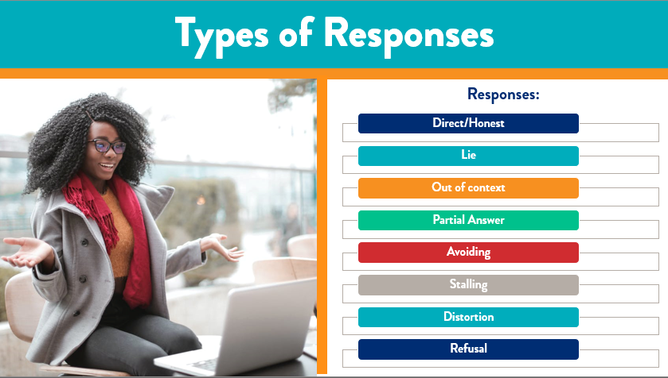

***Slide 10: Types of Responses***

***Estimated duration:***

***Participant Guide Page:***

***Notes:***

**Say**:

Now that we understand the various types of questioning let's talk a little about the response. When communicating with our jobseeker, it's not just about the questions we ask. Still, it is also about the responses we receive. When communicating using High-impact questions, be prepared to recognize and redirect the following responses:

•Direct/Honest- Ideally, this is always the type of response we strive for when engaging our jobseeker

•Lie- Be mindful of your knowledge of the jobseeker and non-verbal cues that may signal a lie. Move on to the next question and keep focused on body language; if you continue to sense something is off, move on to different questions.

•Out of context- This type of response will display a change of topic or an answer that has nothing to do with the question. Be sure to re-word your question if you feel the initial message wasn't delivered adequately.

•Partial Responses- Sometimes, responses may only

answer some parts of your question. Pay attention to this and redirect with follow-up

•Avoiding- This response is typically generated from a difficult question. Also, if the response is negative, your job seeker may want to avoid answering altogether. You may also catch the jobseeker answering this question with a question. This is a sign of moving on with a different question.

***Continued on next page***

Stalling- This is relative to avoiding; however, you can hear active stalling and see it when it's happening. This looks like your jobseeker taking a long time to formulate an acceptable response or buying more time to develop an acceptable response by answering a question with another question.

•Distortion- These are responses that are influenced by bias. An example of this might be a jobseeker exaggerating about their salary. The societal need to fit within a specific salary range to be "accepted" into certain social situations or groups might lead someone to exaggerate their salary.

•Refusal- This means your jobseeker completely refuses to answer a question. They might remain silent or shut down completely. Often, this may manifest by the job seeker specifically saying, "I will not answer that question.“

**Say:**

Why is it important for us to know the different styles of questioning and responses? When we have a conversation with a job seeker, we want to go into it with our fact-finding questions prepared and a mitigation strategy ready if we anticipate any of the responses discussed that will not give us a direct answer. Let's go into our conversations confident and ready for push-back. We can ensure that we get the information we need to provide service to the job seeker.

**Say**:

Next, I would like to take some time to review how we leverage high-impact questions with our jobseekers.

Header/Topic: **Leveraging High-impact questions with jobseekers**

**Say:**

Now that we have a thorough understanding of high-impact questions and the difference between open and closed-ended questions, let's discuss how we can leverage these types of questions with our jobseekers.

**Explain:**

Imagine you have a jobseeker come to you and show their interest in receiving services. You welcome them in, and you sit down and begin a conversation with them. First, you need to gather basic information, and then you move into a space where you want to talk about their goals and motivations. This is where your high-impact questions will come in.

**Say:**

The information we want to seek first is their goals for receiving service.

Open-ended question- If we position this question open-ended, we might say, "What specific goal would you like to reach by receiving services with us? This prompts your jobseeker to provide a response that requires more than a yes or no answer.

Close-ended question- If we position this question closed-ended, we might say, "Do you want to achieve any goals by receiving services with us?" When the question is framed this way, it allows your jobseeker to provide you a quick "yes or no" response that makes it harder to engage your jobseeker and learn about their "why."

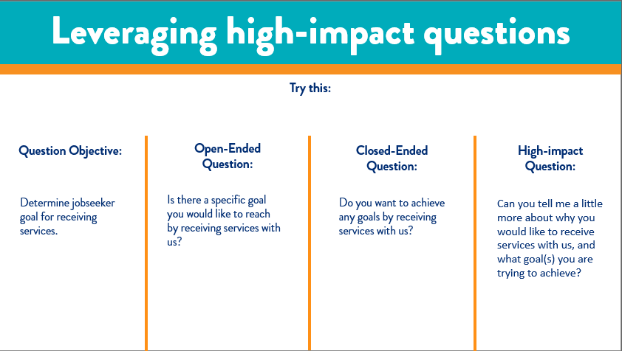

***Slide 11:* Leveraging High-impact questions with jobseeker**

***Estimated duration:***

***Participant Guide Page:***

***Notes:***

***Continued on next page***

High-impact question- If we were to position the question in a high-impact frame, we would say something like, "Tell me a little more about why you would like to receive services with us, and what goal(s) you are trying to achieve?" We challenged the job seeker to provide a thoughtful and robust response when we positioned the question in this way. This is important because we want to help the jobseeker discover their goals, motivations, and ultimate "Why." Also, questions positioned this way will always get you context and additional information, which you need to develop a unique learning plan with your jobseeker.

**Say:**

Did you enjoy that example? You need to become familiar with how to frame your questions to job seekers to build trust and rapport with them. I want to take a moment and have you complete an activity. Pause the video here and take about 5 minutes to complete the Framing Questions Activity. Once you are finished, resume the video, and we will move forward.

**Say:**

Welcome Back! I hope you enjoyed that activity. Now we are going to move forward and discuss best practices for high-impact questions.

Header/Topic **Leveraging High-impact questions with jobseekers**

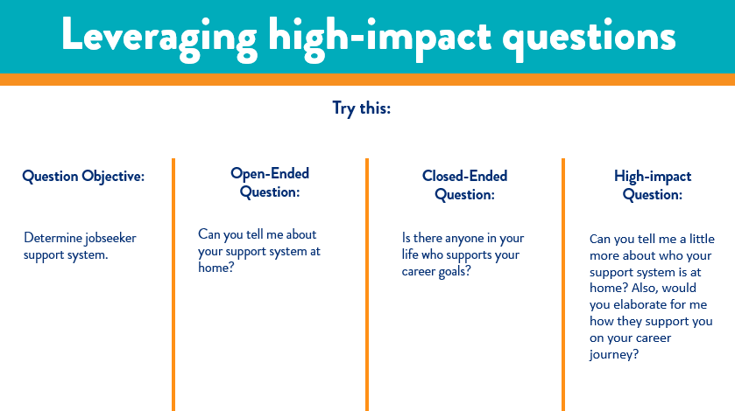

***Slide 12: Leveraging High-impact questions with jobseekers***

***Estimated duration:***

***Participant Guide Page:***

***Notes:***

**Say:**

Let's try another example of leveraging high-impact questions together.

**Explain:**

•Our goal for this example will be to determine the jobseeker support system.

•Open-ended question- How will we position this in an open-ended question? Can you tell me about your support system at home? When we leverage the question this way, we prompt the jobseeker to give us a thoughtful response.

•Closed-ended questions- When we position the question in this way, "Is there anyone who supports your career goals?" we are setting ourselves up for the need to ask multiple follow-up questions. We want to avoid this at all costs.

•High-impact question- We get the best response results when we position our question in a high-impact structure. Set this way, we guide the jobseeker to give us full details without follow-up questions or losing the jobseekers' investment in the interview.

**Say:**

To gain the best response possible and help you create a solid career success plan, you always want to strategically leverage those high-impact questions. You will not only build trust with your jobseeker, but you will foster an environment where they feel safe to be vulnerable with you. This is key to their career success.

**Next:**

Let's move to the next slide, where we will discuss high-impact questioning best practices.

Header/Topic: **High-impact question best practices**

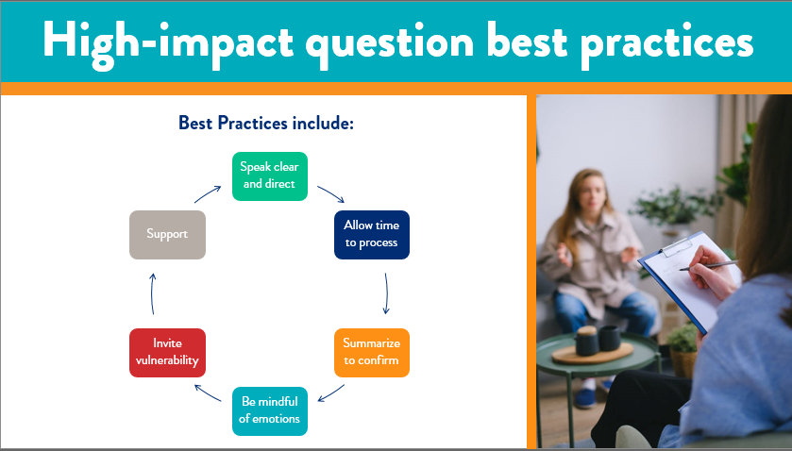

***Slide 13: High-impact question best practices***

***Estimated duration:***

***Participant Guide Page:***

***Notes:***

**Say:**

One very important thing to remember when we are engaging our jobseeker is to be respectful with our questioning and conversation. I would like to discuss some questioning best practices with you, so that you begin to go engage in robust, respectful and thought-provoking conversations with jobseekers. Here are some questioning best practices for you to review and remember:

**Say:**

One significant thing to remember when engaging our jobseeker is to be respectful with our questioning and conversation. I want to discuss some questioning best practices with you so that you begin to engage in robust, respectful, and thought-provoking discussions with job seekers. Here are some best practices for you to review and remember:

•Speak clear and direct- Make eye contact and annunciate your words. You want to ensure your jobseekers fully understands the question you are asking

•Allow time to process- Some questions may be easier to respond to than others. Be sure that you are mindful of silence and potential cues your jobseeker may be giving off that indicate they are processing their response. Let a few seconds pass and ask them if they need more time to respond or if they would like to move on to another question and come back to the question at a later time.

•Summarize to confirm- It is always a best practice to summarize what your jobseeker is saying to ensure your understanding. This makes the jobseeker feel respected and shows them you are invested in their success.

***Continued on next page-***

•Be mindful of emotions- If you ask a question that starts to cause your job seeker to show signs of an emotional response, make sure you ask them if they are okay and if they would like a moment to gather their thoughts. For example, if your job seekers begin to have tears well up in their eyes, that is an indicator that they may not be ready to respond to such a question, and you can immediately offer them more time or move on.

•Invite vulnerability- Be sure to communicate to your jobseeker that it is okay and safe to be vulnerable with you. Remind them that your conversation is a safe zone and that they can feel free from judgment. This is your esteemed opportunity to build trust within your relationship.

•Support- Always ask your jobseeker how they would like you to support them. It is one thing to offer general support, but if you position this in a question, you will get a personalized response that provides you direction on how to support them. This is what you want to gain from these conversations to help them along their career path.

**Say:**

These are just a few best practices that I have shared with you today. I encourage you to test these out, and maybe even others, and see how they work for you. I also challenge you to share your best practices with your colleagues to begin to cultivate an environment rich in strategic approaches for engaging our jobseekers.

**Next:**

Now that we have covered all of today

Header/Topic**: Knowledge Check**

**Say:**

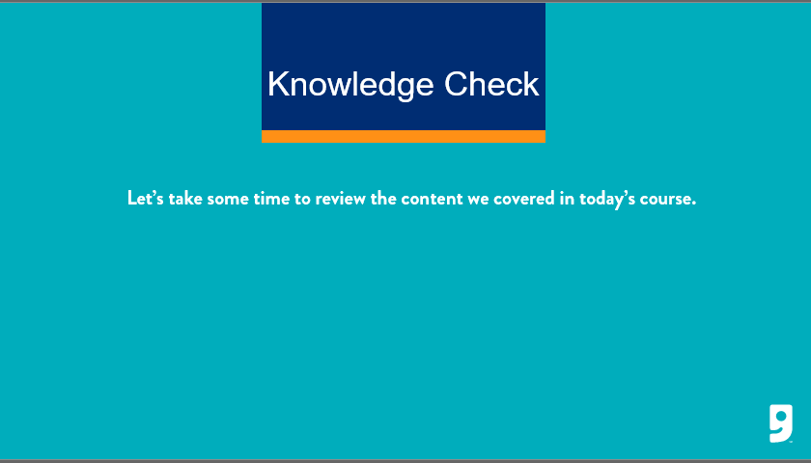

***Slide 14:*  *Knowledge Check***

***Estimated duration:***

***Participant Guide Page:***

***Notes:***

The next part of this course is to designed to check your understanding of the content that was presented today. In your workbook, you will find a knowledge check worksheet. Pause this video when I give you the prompt, and I want you to take about 10 minutes to review and answer your knowledge check questions. Once you are completed, you can click play on the video and finish the session.

**Say:**

Remember, when you are finished with the course, provide your leader with your knowledge check worksheet, as this will ensure you are given credit for participating and completing the Growth Mindset course today. If you have any further questions, please be sure to speak with your leader.

**Say:**

Alright, go ahead and pause the video now and begin your knowledge check.

Return:

**Say:**

Welcome back! I hope you enjoyed completing your knowledge check. Lets move forward and discuss next steps as we wrap up this session.

Header/Topic: **Next Steps**

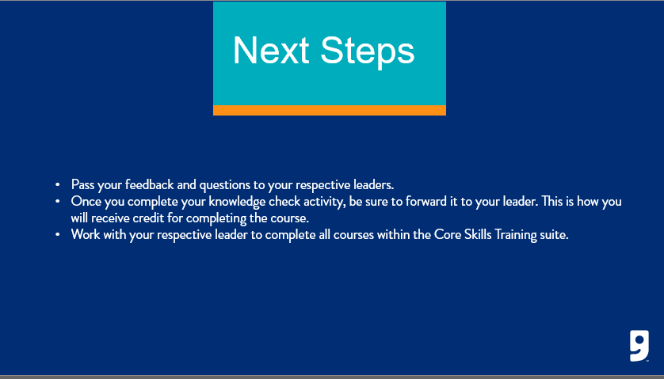

***Slide 15: Next Steps***

***Estimated duration:***

***Participant Guide Page:***

***Notes:***

Some next steps I want to cover include:

* Be sure to pass your feedback and questions to your respective leaders.
* Make sure you pass on your knowledge check activity from this course to your leader as this is what will confirm your completion of this course.
* And lastly, work with your manager to schedule time to complete the other Core Courses that have been released this quarter.

**Say:**

It is important to keep your upskilling and training at the forefront of everything you do.

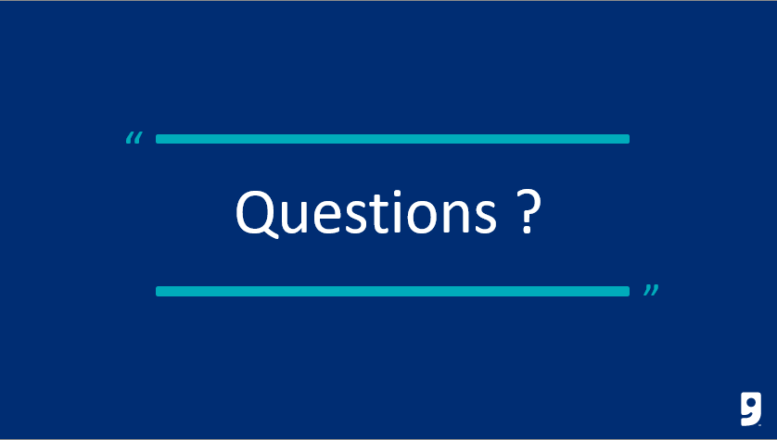

***Slide 16:*** *Questions*

***Estimated duration:***

***Participant Guide Page:***

***Notes:***

Header/Topic: **Questions**

**Say:**

In the beginning of this course, I asked you to write down questions as you moved through the session. If you have any questions written down, or if you have questions that have crossed your mind now, I encourage you to write those down and schedule time with your leader to work through them and get answers.

**Say**:

If you have feedback for the Learning and Development team on this training, we encourage you to reach out to LearningandDevelopment@goodwillaz.org. I am always happy to jump in and help when I can. Please be sure to forward your feedback to your leader first, then you can send it to the team.

**Close:**

I want to take the opportunity to thank you for completing this course today. As a member of this team, I want to thank you for all the hard work and dedication you provide our jobseekers and community every day. It is because of you, we were able to provide career and employment services to our communities and help strengthen families in the communities we serve. Thank you for all you do! I appreciate your time today and I hope you gained a little more knowledge on an unfamiliar topic. I encourage you to continue to ask questions and take the information you have learned and leverage it with your colleagues and jobseekers. Have a wonderful day!

Header/Topic: **References**

**Say**:

In an effort to give credit when credit is due, we have included a reference page to call out the resources used to create this content here for you today.

* Self Determination Theory-Ryan/Deci
* Sixdegreesexecutive.com.au
* How to Ask Great Questions-Harvard Business Review

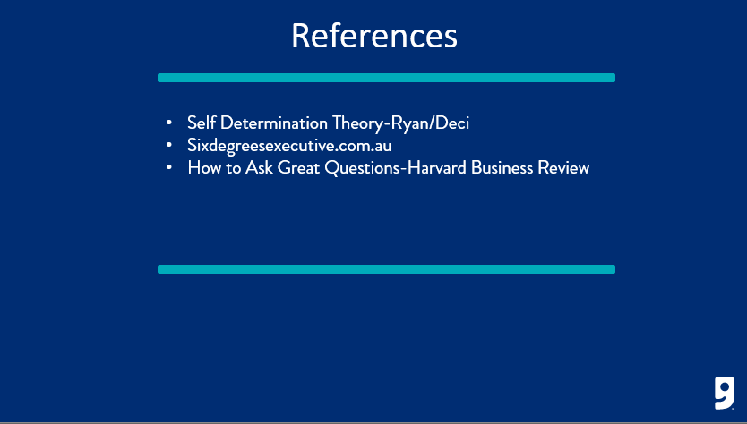

***Slide 17: References***

***Estimated duration:***

***Participant Guide Page:***

***Notes:***

**Knowledge Check**

Directions: Review the questions below and respond accordingly. When finished, return to the training video and provide your knowledge check to your leader.

1. **Question:** There are three reasons we ask High-impact questions. Circle the correct three reasons:
   1. **Move beyond transactional conversations**
   2. To shorten the conversation
   3. **Encourages deeper thinking of a response**
   4. Makes a job seekers response easier
   5. **Communicate with influence**
   6. To tell the job seeker what to do.
2. **True**/False: In order to create questions that drive the job seeker deeper in order to respond with more information, you should take time, sometimes just a moment, to plan your question.
3. True/**False**: To get an in-depth answer from the job seeker, you want to ask a lot of closed ended questions.
4. **Question:** Using the example below, circle the correct “*Type of Questioning*” that is being used. **Example:** “Tell me about yourself, What types of services would you like to receive, were there any classes you're interested in, did you complete Northstar, did you get an interview?” Is it:

|  |  |  |
| --- | --- | --- |
|  |  |  |
| Recall and Process | **Funneling** | Rhetorical |
|  |  |  |

1. **Question:** Using the example below, circle the correct “*Type of Questioning*” that is being used. **Example:** “Was your breakfast delicious, today?” Is it:

|  |  |  |
| --- | --- | --- |
|  |  |  |
| **Leading** | Open-ended | Rhetorical |
|  |  |  |

1. **Question:** Circle the question below that is most likely to get a yes/no, single word answer. (closed-ended question)
   1. What specific goal would you like to reach by receiving services with us?
   2. **Do you want to achieve any goals by receiving services with us?**
   3. Tell me a little more about why you would like to receive services with us, and what goal(s) you are trying to achieve?
2. **Question:** Which of the three questions below will get you the maximum amount of information from the job seeker?
   1. **Can you tell me a little more about who your support system is at home? Also, would you elaborate for me how they support you on your career journey?**
   2. Can you tell me about your support system at home?
   3. Is there anyone in your life who supports your career goals?
3. **Question:** With the three questions above, which is the “High-impact question”? Circle the correct answer. **a.** b. c.
4. **Question:** Which of the following is *NOT* a “best practice”? (circle the correct answer)
   1. Speak clear and direct
   2. Allow time to process
   3. **Tell the job seeker what is best for them**
   4. Summarize to confirm
   5. Be mindful of emotions
   6. Invite vulnerability
   7. Support