AccuTime

Time Clock Guide

TABLE OF CONTENTS

Overview………………………………………………………… page 2
Punch In…………………………………………………………. page 3
Punch Out……………………………………………………….. page 5
Punch Out for Meal…………………………………………….. page 7
Punch In for Meal………………………………………………. page 9
Employee Transfer ……………………………………………. page
Employee Options ……………………………………………... page 11
View Schedules …………………………………………. page 12
Review Punches ………………………………………… page 13
View Accruals ……………………………………………. page 14
Manager Options ……………………………………………….. page 15

Overview
The following document provides step-by-step instruction on how to use and access features of the AccuTime Clock using the touchscreen or keypad.

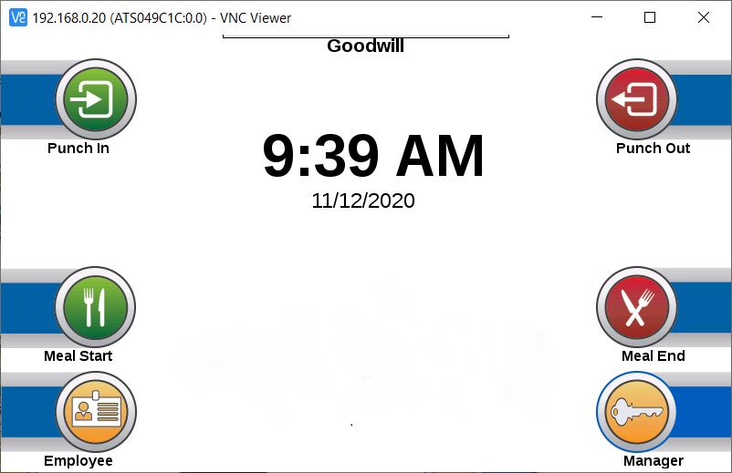
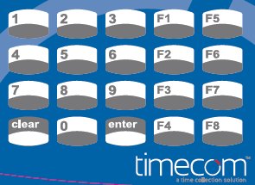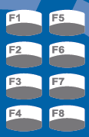

Punch In
When you perform a punch, the Time Clock Device records the current time and the function key or touchscreen button pressed. Please use the following steps to Punch IN.
- Press the “Punch In” icon on the touchscreen or the F1 button on the keypad
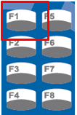
- The employee will be prompted to enter their employee number:

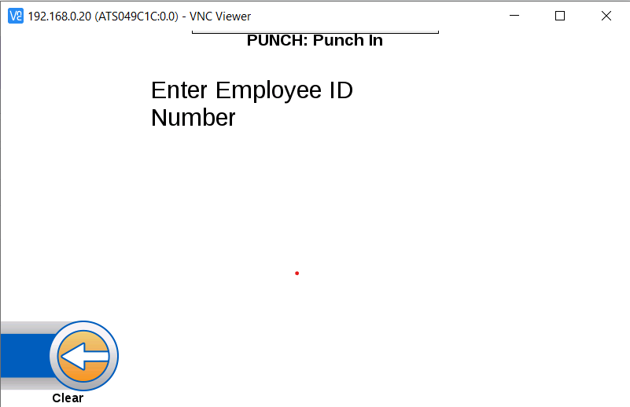

- The employee will get a message stating they have successfully punched in:

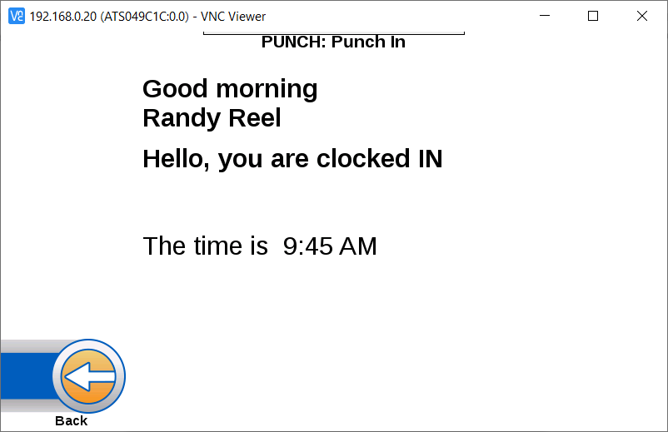

Punch Out
When you perform a punch on the Time Clock Device, it records the current time and the function key or touchscreen button pressed. Please use the following steps to Punch OUT:
- Press the “Punch Out” icon on the touchscreen or the F5 button on the keypad:
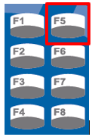

- The employee will be prompted to enter their Employee ID:
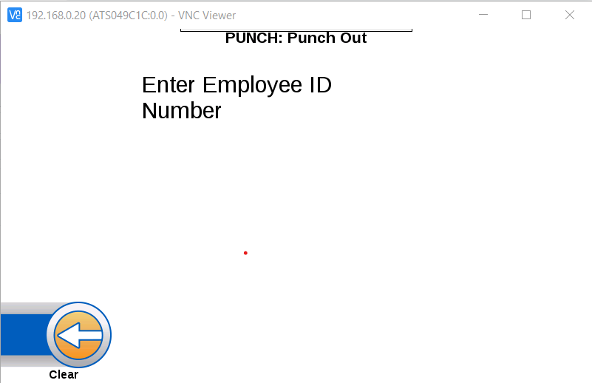

- The employee will get a message stating they have successfully Punched Out:

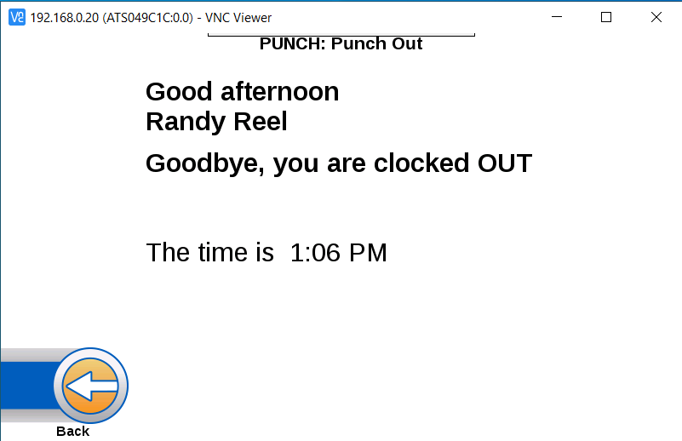

Punch Out For Meal
When you perform a punch on the Time Clock Device, it records the current time and the function key or touchscreen button pressed. Please use the following steps to punch OUT FOR MEAL.
- Press the “Meal Start” touchscreen icon or the F3 key on the keypad:
- 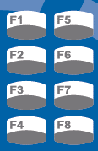

- The employee will be prompted to enter their employee Id:

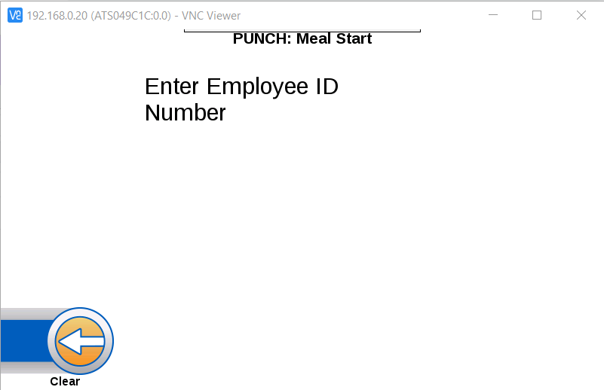

- The employee will get a message stating they have successfully punched Out for Meal:

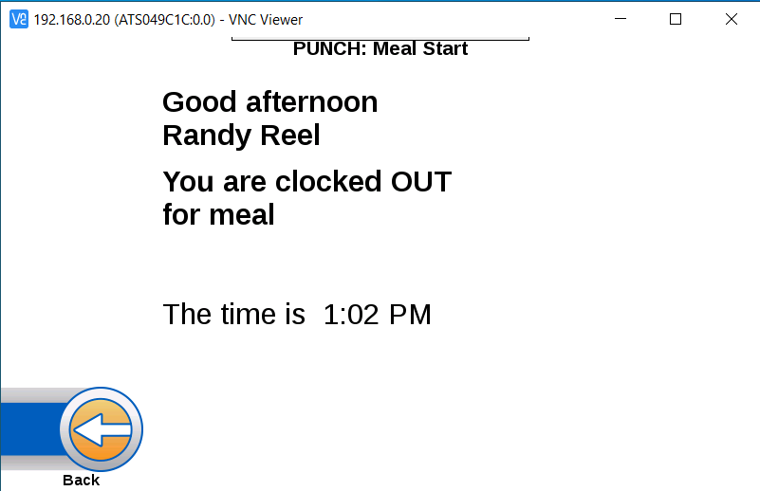

Punch In From Meal
When you perform a punch on the Time Clock Device, it records the current time and the function key or touchscreen button pressed. Please use the following steps to punch IN FROM MEAL:
- Press the “Meal End” on the touchscreen or the F7 button on the keypad:

- The employee will be prompted to enter their Employee ID:

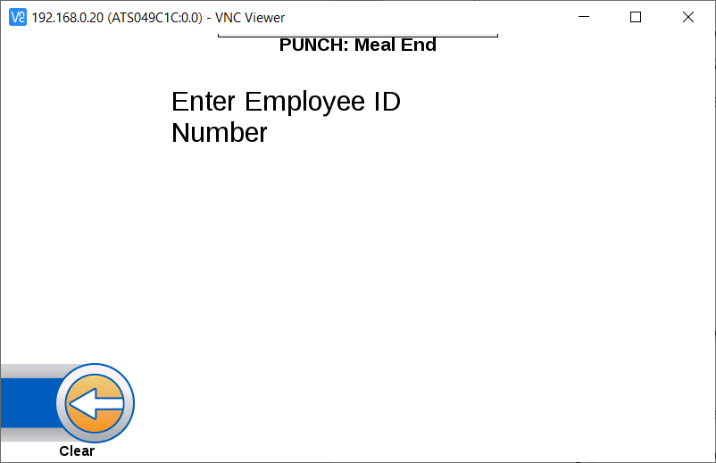

- The employee will get a message stating they have successfully punched In for Meal:

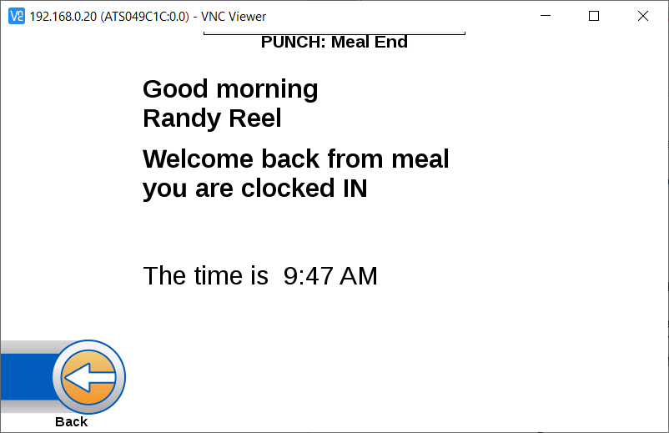

Employee Options
The clock will allow employees to to View Schedule, Review Punch, View Accruals and Tranfer. To view the employee menu, press the Employee icon on the clock touchscreen or F4 button on the keypad:
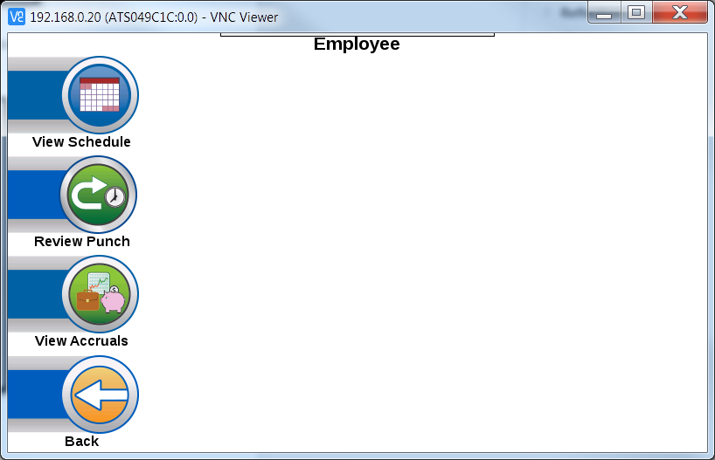

Viewing Schedules
To view a Schedule, press the Employee icon on the touchscreen. Press the View Schedule icon on the touchscreen:
- The clock will then prompt the employee to enter their Employe ID Number:

- The clock will display the employee’s schedule:
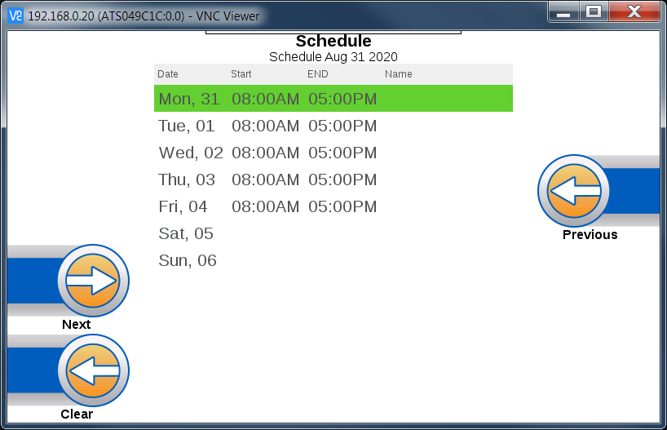
- The Previous and Next icons can be used to scroll through the previous and next week schedules:
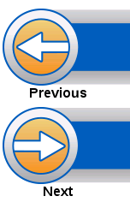

Reviewing Punches
To review punches, first press the Employee button on the main screen to access the employee options. Press the Review Punch icon on the touchscreen:
- The clock will prompt the employee to enter their Employee ID Number:

- The clock will then display the employee’s last punch details, including date, time and punch type:
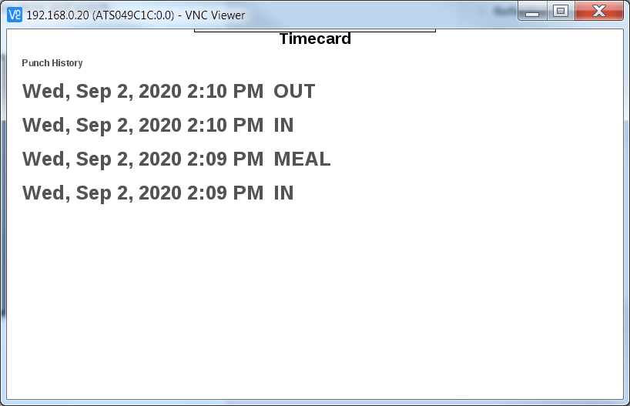

Viewing Accruals
To view accruals, first press the Employee button on the main screen to access the employee options. Press the View Accruals Punch icon on the touchscreen:
- The clock will prompt the employee to enter their Employee ID Number:

- The clock will then display the employee’s balances type, floating holiday, sick time, vacation, voulenter day and available hours:

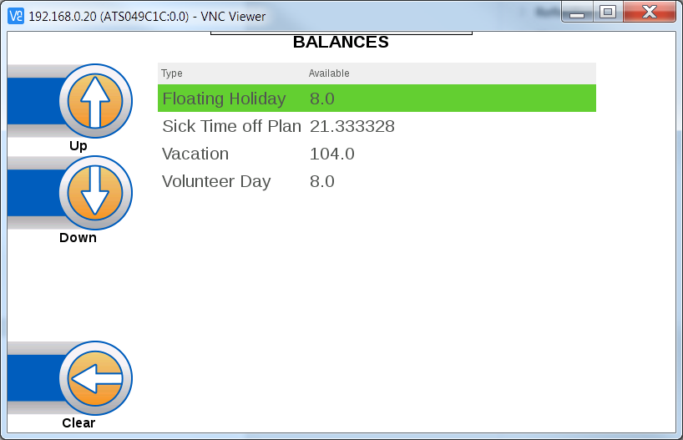

Manager Options
When troubleshooting the clock, customer service may ask for information about the clock. In order to promptly assist, you can find general clock information by pressing the following buttons on the keypad:
- F8 F8 F7
- Alternatively, you can press the Manager icon on the touchscreen:
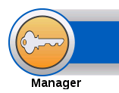
- Press the System icon:
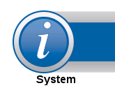

- Press the Info icon:

- The information screen will show the current IP address of the clock, the clock’s MAC address, as well as other information about the terminal:
