**Mission Services Core Skills Training**

**Time Management**

**Instructor Guide**

**Goodwill of Central and Northern Arizona**

**Purpose**

The purpose of this course is to introduce learners to the topic: Time Management. Topics to be covered include; what is time management, how to implement time management strategies and time-management tools, and healthy habits. Learners will gain a better understanding of the positive impact time-management can have on daily work priorities. At the completion of this course, learners will be prepared to identify what time-management is and how to leverage multiple tools and strategies to ensure project deadlines are consistently met.

**How to Use This Guide**

This instructor guide is designed to help you deliver the Time Management course. Explanations of what to say, what to do, and how to conduct activities, if applicable are provided within this guide; however, you can use the left side of each page to enter your own notes to help you train this workshop.

You will also see PG referenced throughout this material, it stands for Participant Guide. References will only be provided when relevant to the training.

Durations, if provided, are estimates only and may not reflect the final training.

**Materials Needed**

Use the following materials as you train this course**:**

* Core Skills_Time Management PPT
* Core Skills_Time Management Participant Guide

**Say:** Welcome to Mission Service’s Core Skills Training. This course will focus on the topic: Time Management. Keep in mind that the Core Skills Training will encompass numerous courses that are developed specifically to meet your unique needs as a member of the Missions Services team. You will continue to receive updates from your respective leaders once additional courses have been released, and are available for you to complete.

**Explain:** This is a self-paced course designed for you to complete at your own pace. Before you get started, make sure you have the following items to ensure successful completion of this course:

* Something to write with – pen or pencil
* Your participant guide- This can be access via the L&D Learning Portal
* A quiet place to complete your training that is free from any distractions
* And, a headset, if needed

**Say:** I am very excited to walk you through this topic today. Let’s move to the next slide and discuss the course overview.

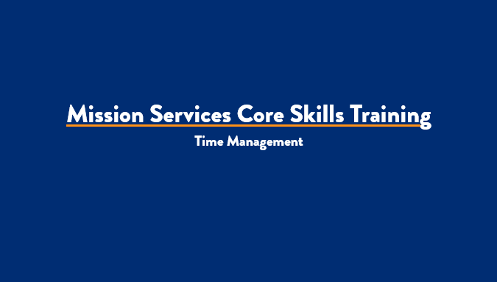

***Slide 1: Title Slide***

***Estimated duration:***

***Participant Guide Page:***

***Notes:***

**Slide Title: Course Overview**

**Say:** This course will introduce learners to Time Management. Topics to be covered include; what is time management, how to implement time management strategies and time-management tools, and healthy habits. Learners will gain a better understanding of the positive impact time-management can have on daily work priorities. At the completion of this course, learners will be prepared to identify what time-management is and how to leverage multiple tools and strategies to ensure project deadlines are consistently met.

**Explain:** As we move through this course, I encourage you to write down any questions you may have, that you would like addressed by a member of your leadership team or Learning and Development. There is a note section provided to you within your participant guide, so be sure to write down those questions so that we can provide you with a prompt response.

**Say:** Now that we have a high-level overview of the course and what it entails, let’s talk a little more about the course objectives.

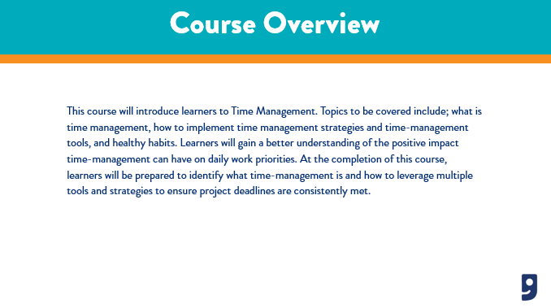

***Slide 2: Course Overview***

***Estimated duration:***

***Participant Guide Page:***

***Notes:***

**Slide Title: Course Objectives**

**Say:** One of the important aspects of a training course are the course objectives. The objectives provide insight into what you will learn from the content presented to you today. For the Time Management course, the objectives we will cover include:

* Define time management
* Discuss goal setting, prioritizing tasks, and organizing your day
* Examine time management tools and best practices

**Explain:** This course will provide you the basic foundations of how to develop best practices for time management allowing you to perform your daily duties seamlessly.

**Discuss:** Time management is an important part of your role as a member of the Mission Services Team. At times, you will be presented with opportunities to flex your knowledge and skillset in identifying what time management means and how to prioritize your day. This will position you to be better equipped to complete your daily tasks while serving our jobseekers every day.

**Say:** Next, I would like to review with you the topics we will cover in today’s course.

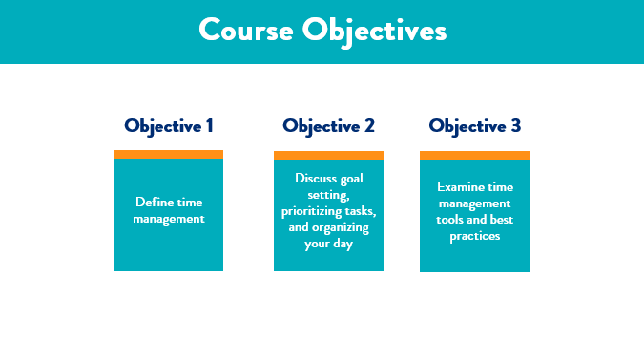

***Slide 3: Course Objectives***

***Estimated duration:***

***Participant Guide Page:***

***Notes:***

**Slide Title: Course Topics**

**Say:** Another important aspect of a training course is the course topics. The course topics give us insight into what we will be learning in the session.

For the Time Management course you are currently taking, the topics we will cover in today’s session include:

* Time Management
* Goal Setting
* Prioritizing
* Healthy Work Habits
* Time Management Tools
* Knowledge check
* Next steps

**Explain:** Next, I want to take a moment to cover some course rules with you before we jump right in to the content we are set to cover today.

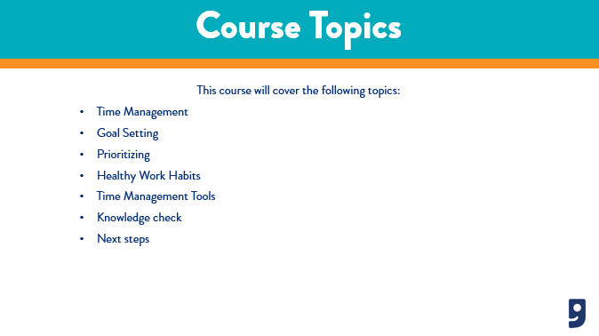

***Slide 4: Course Topics***

***Estimated duration:***

***Participant Guide Page:***

***Notes:***

**Slide Title: Course Rules**

**Say:** The rules for this course will look a little different as you are completing this session in a self-paced modality. Let’s talk a little about the course rules now:

* Make sure you are in a learning environment free from distractions.
* Feel free to pause this course at any time if you need to step away or take a break.
* Write down any questions you have for your leaders and send it to them after the completion of this course.
* Write down any feedback you have for L&D and forward that to your respective leader.

**Say:** Now that we have covered the course rules, let’s jump right in to our first topic which is, Time Management.

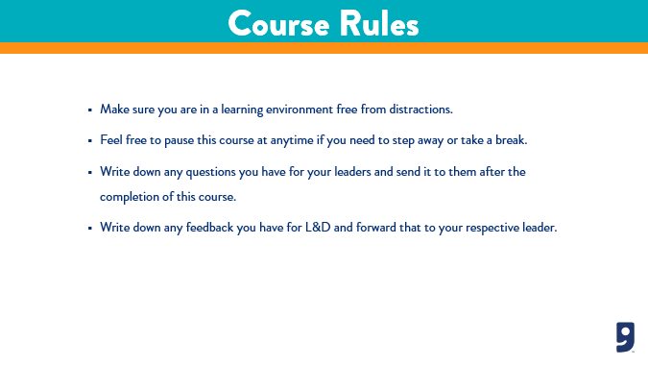

***Slide 5: Course Rules***

***Estimated duration:***

***Participant Guide Page:***

***Notes:***

**Slide Title: Time Management**

What is time management and why is it important to my success?

**Say:** In today’s workplace, most people may feel as though they can’t be successful at work, or accomplish all the things their work day entails because, they simply don’t have enough time. There is a quote by Alex Carrel that says, “The most efficient way to live reasonably is every morning to make a plan of one’s day and every night to examine the results obtained.” This is a great quote to live by when thinking of time management.

**Say:** Time management is the effective use of your time that allows you to plan your days in such a way that you finish your work with less effort and make the most of the limited time you’ve got. Do you ever start your day in a panic because you know the day before you left work with what seems like a million things still left to check off on your to do list? I have felt this way many times and I can tell you, it’s a pretty normal feeling among most professionals, so don’t feel like you're alone. The good news is, there are strategies and techniques you can implement starting today, that will help you manage your time more effectively.

**Say:** Why is time management important to your success? I’d like to take a moment to talk to you a little about that now. Some key reasons I want to cover with you include:

* **Helps meet your deadlines, meetings, and appointments:** These are all daily tasks you will encounter in your role. They are also all tasks that are easy to lose track of if you’re not on top of your daily priorities. Time management strategies help you start work on time, stay on task, and meet your daily work goals.
* **Break procrastination habits:** You do this by pivoting your mindset from procrastination to focus. When you know you’re working on a fixed schedule with assigned tasks, it’ll be easier for you to focus. This is because you’ll know you have personal deadlines to meet for each task.
* **Prevent stress:** Trying to beat a deadline is stressful, because you don’t know whether you’ll meet it or miss it. However, good time management helps you visualize your workday, not as a whole, but as a set of tasks you need to go through.
* **Maintain a professional presence:** In order to ensure that missed deadlines, meetings, or rushing projects don’t mess up your work reputation, you want to make sure you develop good time management habits and maintain your professional presence in the workplace.
* **Improves work-life balance:** Time management strategies help you meet your daily work tasks and goals. When this happens, you can leave work for the day without any lingering thoughts around your productivity and if you did enough. This allows you to go home and truly unplug from work and focus on your personal life. Work life balance is important to you, your family, and your profession.

**Say:** I hope you now have a better understanding of what time management is and how it is important to you. Let’s move on to the next slide where we will talk about daily goal setting..

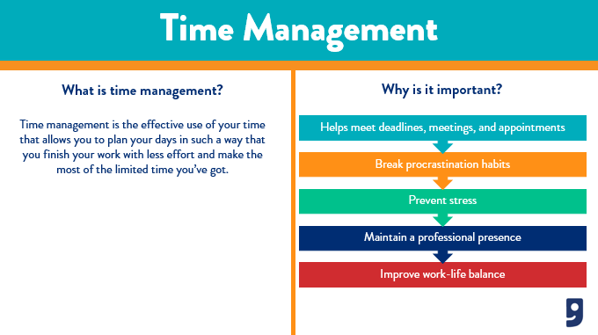

***Slide 6: Time Management***

***Estimated duration:***

***Participant Guide Page:***

***Notes:***

**Slide Title: Goal Setting**

What is goal setting and how do I set goals for success?

**Say:** Let’s talk a little about goal setting. Goal setting is a very important part of time management and what makes it so effective. There are many types of goal setting practices in the workplace. You may set goals for how many jobseekers you help or for how many calls you will take or make? Or maybe you even set goals for how many resumes you will review and provide feedback for. Whatever the reason for your goals, it’s important that we also set goals when managing our time.

**Say:** There is definitely a right and wrong way to go about goal setting. If you don’t set your goals the right way, then you'll most likely miss something, which will force you to go back and redo things or otherwise veer off-track. Having goals trains our brain in a way that provides us the motivation to actually work toward achieving those goals. A goal can trigger positive behavior and a positive mentality. Here are some things to consider when setting time management goals:

**Understand how you currently spend your time:** This will take some time in the beginning, but trust me, this will help you in the long run. First, for a couple weeks, you want to track how you spend your time throughout your day. Be sure to track things like; what you’re working on and what you accomplished. Where is the majority of your time spent in your day? Was your time wasted or well spent based on if you completed your task? And lastly, did the activities you spend your time on help you achieve your goals? Do this to help you gain a better understanding of where you allocate your time. You can then begin to strategically plan your day to ensure time management success.

**Plan ahead:** Making a to do list daily is a great way to stay on top of your work tasks, leading you to meeting your goals. A good way to begin making to do lists is to plan ahead. A couple ways to accomplish this include taking time at the end of your day you think of any tasks you didn’t meet, and consider the tasks youhave for the following day, and write down which are the most important to accomplish. You could also make a to do list first thing in the morning when you arrive to work, start your day a few minutes earlier and assemble a prioritized list of things to do. Aim to list about five tasks you want to accomplish in a day, organize them according to their priority, and schedule them in blocks on your calendar. Avoid multitasking by only working on one activity at a time. Be sure to cross off your tasks as you complete them. This practice is not only rewarding, but motivating and helps to keep you focused on your goals.

**Know your goals:** Be sure to consider and always be mindful of your work goals. A good way to do this might be on a weekly basis. Set some attainable goals that you want to focus on when you week begins. At the end of the week you can review those goals and mark off the ones you were able to accomplish. If you accomplish them all, that’s great! If not, don’t be discouraged. You can take the missed goals and move them to the following week! This practice fosters good time management habits that you can easily being to implement in your workday.

**Declutter and Organize:** Studies have shown that unnecessary clutter in our environments can force us to lose focus and derail us from tasks at hand. Conversely, those same studies show that keeping your work space organized helps increase productivity and it also helps you remain focused because when we lose focus, we lose valuable time. Take a few minutes each day to tidy your space. Clear your desk, put your pens back in your drawer, and throw away old post-it notes. You can even go as far as to establish a dedicated workspace used only for work where personal interruptions are not allowed. This is particularly helpful if you are working from home.

**Protect your time:** Do you ever find yourself saying “Yes” to everything and everyone? Do you ever find yourself falling victim to not meeting deadlines because you can’t say no? I will tell you something I learned years ago from a college professor, that is, it’s ok to say, “No”. You own your work. If you have a deadline, something urgent at hand, or need to prioritize your own work, it is ok to decline a request. At times, it may be more important to attend to tasks you absolutely need to accomplish in order to move toward your own goals rather than focus on the needs of others. Be sure focus your efforts accordingly.

**Say:** Goal setting is just a small step in the right direction of implementing time management strategies into your day, let’s move on to the next topic where we will cover prioritizing your day.

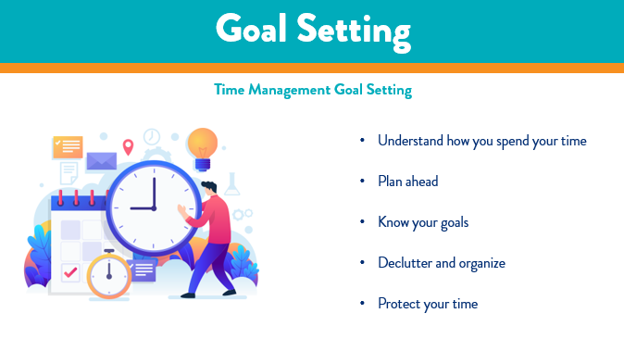

***Slide 7: Goal Setting***

***Estimated duration:***

***Participant Guide Page:***

***Notes:***

**Slide Title: Prioritizing**

What is prioritizing and how do I prioritize my day and tasks?

**Say:** So, we talked a little about goals setting, and with that, we also talked about prioritizing and to do lists. You might be thinking to yourself, “How does one even begin to prioritize their day?” Well, I am going to share some steps you can take to help you prioritize your work tasks and cerate those solid to do lists that will help you meet your work deliverables and goals. Let’s talk about those steps now.

* **Create a master list:** Write down every task you need to complete daily, whether it is critical or routine. Be sure to include your regular, often times mundane tasks. Failure to encompass all your daily tasks can throw off your intended time-block schedule.
* **Determine your top tasks:** Label your most important task as priorities or “Type A’ tasks. These are tasks that one might consider, “must do, can’t fail.” Maybe you have a schedule meeting with your leader. That would be considered a type A task.
* **Categorize your tasks:** Just as we label certain tasks type A, you also want to label your other tasks accordingly. This is what will help you create a solid to do list and accomplish the most important tasks while meeting your work goals.
  + So, type A tasks are tasks that come with a huge consequence if not met.
  + Type B tasks will carry mildly negative consequences if not met.
  + Type C tasks will not carry a consequence if it is not accomplished today.
  + Type D tasks represent tasks you can delegate or ask someone else to do.
* **Put your to do list into action:** Once you have completely prioritized your daily tasks, and have created your to do list, put it into action. Be mindful of how the to do lists help or hinder you from meeting your goals. If you find that you are still struggling to manage your time, you can always re-categorize your list and try again.

**Say:** Prioritizing daily tasks is key to successful time management. When you prioritize, you make sure to accomplish the most important tasks first. Make time management a habit and your overall success and work-life balance will thank you.

**Say:** Now that we have reviewed prioritizing your day, let’s talk about healthy work habits to help keep your time management momentum going.

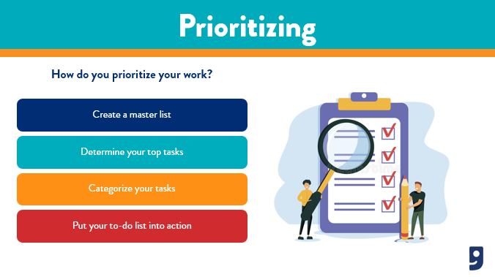

***Slide 8: Prioritizing***

***Estimated duration:***

***Participant Guide Page:***

***Notes:***

**Slide Title: Healthy Work Habits**

What are healthy work habits and how can I implement them into my day?

**Say:** One thing I want to point out is that time management is not about completing all of your daily tasks; it’s about adequately allocating enough time for the things that matter most to you. Time management can also be seen as “personal management” which is a skill necessary for improving your work-life balance. By managing your time in a more efficient way, you get things done right, can relax at the end of your day, and foster those feelings of accomplishment. Implementing good time management strategies comes with many benefits for your overall well-being. Let’s talk a little about some of those benefits.

* **Improves workplace productivity:** Time management improves workplace productivity because it ensures you are completing your tasks, and when your colleagues see that you have implemented a strategy that works, they also become motivated to do the same, leading to a domino effect of fostering workplace productivity.
* **Increases work success:** Your work successes will be notable and you will begin to see them more frequently. Time management allows you meet workplace goals, and brings a level of visibility to your ability to meet your deadlines. Leaders and colleagues will see this and be sure to commend you on your progress.
* **Improves work relationships:** Time management allows you to take on your day and tasks effectively. This puts you in a unique position to offer help to others, and at times, you may be able to take on additional work. This is the gateway to building trust and a good rapport with your team, ultimately, giving them a resource to look to when accomplishing our goals as a whole.
* **Increases self-awareness:** Time management allows you to foster a foundation of being self-aware. You are able to say “No” when you lack the capacity to take on additional projects, but also, when you do take on additional work, you know for certain when you can say, “Yes.” Being self-aware positions you to effectively manage time and share those tips with others, fostering a culture of team success.

**Say:** Healthy work habits help us maintain a productive workplace and help us with our work life balance. On the next slide, I want to take some time to talk to you about time management tools you can use to help you accomplish your work goals.

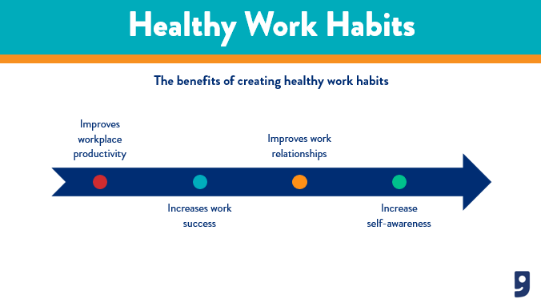

***Slide 9: Healthy Work Habits***

***Estimated duration:***

***Participant Guide Page:***

***Notes:***

**Slide Title: Time Management Tools**

**Say:** There are many tools you can use that will help you start your time management journey. I want to review a few with you, that are inexpensive and can be easily implemented, as soon as you finish this course. Whichever tool you decide to use, it’s important to remember that this is your unique journey, so be sure to implement the strategies you feel fit your needs best. Some of the tools I want to cover with you might be familiar, but also, you may notice you already use them, every day. These include:

* **To do list:** We have been talking about these throughout this course. A to-do list is a popular tool that professionals use to manage their time effectively. I personally, will write my to do list on an electronic sticky note and pin it to my desktop; however, you can use physical sticky notes or even a journal. Maybe you are in a role where your daily tasks remain the same each day. You could print up a Word document and put it up in your workspace so you always have visibility of your list. Make sure your list is easily accessible and that you mark off your accomplished tasks along the way.
* **Calendars:** As you may know, you have access to your company email and there is a calendar you can use to schedule meetings, plan out your day in blocks, and even associate time blocks to your tasks. Be sure to take advantage of the various ways you can leverage your email calendar to become a time management master.
* **Note taking (journaling):** Note taking is closely related to your to do list. When you are in meetings or meeting with a jobseeker, be sure to write down the commitments you make so that you can schedule those on your to do list.
* **Project trackers:** Have you ever heard of Monday.com? There are many project tracking tools out there. Some you pay for, some offer free basic memberships, and others you already have access to like Microsoft Project or Microsoft Excel. Whichever you choose to leverage, be sure to find one that is easy to use and fits your unique need.

**Say:** Now that we have covered the last topic of our training today, let’s move on to the next slide where we will review our knowledge check for this course.

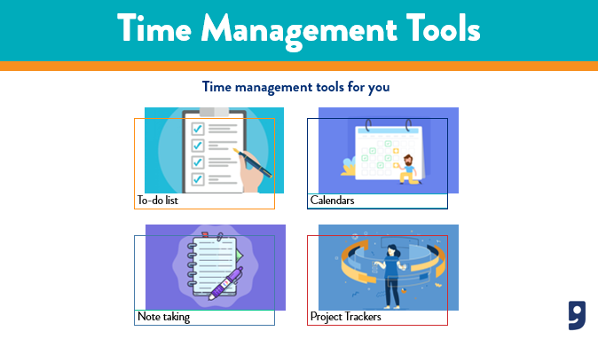

***Slide 10: Time Management Tools***

***Estimated duration:***

***Participant Guide Page:***

***Notes:***

**Slide Title: Knowledge Check**

**Say:** The next part of this course is to designed to check your understanding of the content that was presented today. In your participant guide, you will find a knowledge check worksheet. Pause this video when I give you the prompt. I want you to take about 10 minutes to review and answer these knowledge check questions. Once you are finished, click Play on the video to finish the session.

**Say:** Remember, when you are finished with the course, provide your leader with your knowledge check worksheet, as this will ensure you are given credit for participating and completing the Time Management course today. If you have any further questions, please be sure to speak with your leader.

**Say:** Alright, go ahead and pause the video now and begin your knowledge check.

**Return:**

**Say:** Welcome back! I hope you enjoyed completing your knowledge check. Let’s move forward and discuss next steps as we wrap up this session.

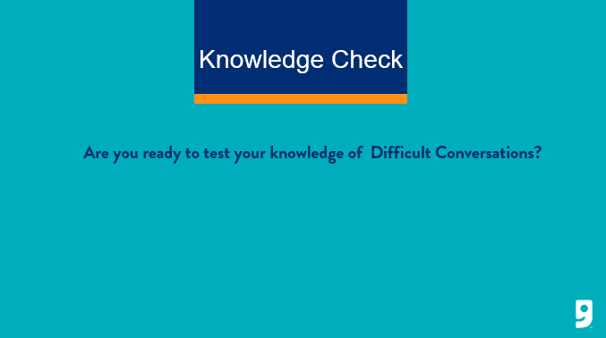

***Slide 11: Knowledge Check***

***Estimated duration:***

***Participant Guide Page:***

***Notes:***

**Slide Title: Next Steps**

**Say:** Some next steps I want to cover include:

* Be sure to pass your feedback and questions to your respective leaders.
* Make sure you pass on your knowledge check activity from this course to your leader as this is what will confirm your completion of this course.
* And lastly, work with your manager to schedule time to complete the other Core Courses that have been released this quarter.

**Say:** It is important to keep your upskilling and training at the forefront of everything you do.

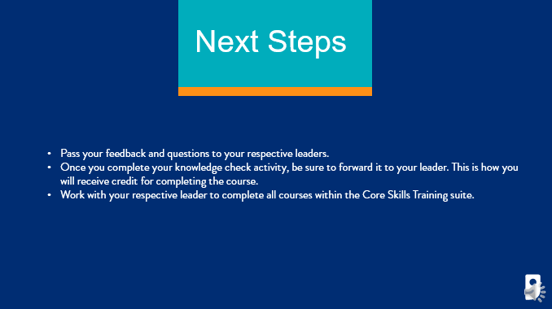

***Slide 12: Next Steps***

***Estimated duration:***

***Participant Guide Page:***

***Notes:***

**Slide Title: Questions**

**Say:** In the beginning of this course, I asked you to write down questions as you moved through the session. If you have any questions written down, or if you have questions that have crossed your mind now, I encourage you to write those down and schedule time with your leader to work through them and get answers.

**Say:** If you have feedback for the Learning and Development team on this training, we encourage you to reach out to LearningandDevelopment@goodwillaz.org. I am always happy to jump in and help when I can. Please be sure to forward your feedback to your leader first, then you can send it to the team.

**Close:** I want to take the opportunity to thank you for completing this course today. As a member of this team, I want to thank you for all the hard work and dedication you provide our jobseekers and community every day. It is because of you, we were able to provide career and employment services to our communities and help strengthen families in the communities we serve. Thank you for all you do! I appreciate your time today and I hope you gained a little more knowledge on an unfamiliar topic. I encourage you to continue to ask questions and take the information you have learned and leverage it with your colleagues and jobseekers. Have a wonderful day!

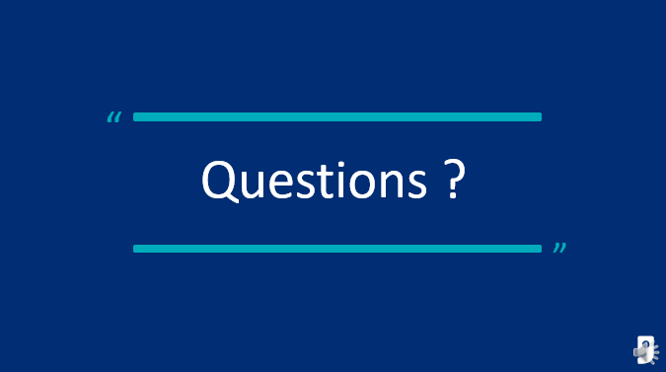

***Slide 13: Questions***

***Estimated duration:***

***Participant Guide Page:***

***Notes:***

**Slide Title: References**

**Say:** In an effort to give credit when credit is due, we have included a reference page to call out the resources used to create this content here for you today.

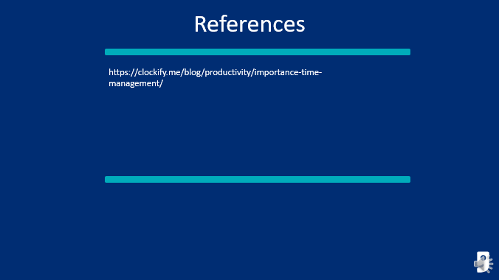

***Slide 14: References***

***Estimated duration:***

***Participant Guide Page:***

***Notes:***

Prioritizing Activity Answer Key

**Directions:** Answer the questions below regarding task categories

|  |  |  |  |
| --- | --- | --- | --- |
| These tasks will carry mildly negative consequences if not met. | These tasks you can delegate or ask someone else to do. | These tasks will not carry a consequence if it is not accomplished today. | These tasks come with a huge consequence if not met |
| Answer:  Type B | Answer:  Type D | Answer:  Type C | Answer:  Type A |

**Directions:** Categorize your tasks by the correct type.

|  |  |  |  |
| --- | --- | --- | --- |
| Type A  Attend a meeting  Lock up when you leave  Meet with a jobseeker | Type B  Check your emails  Return phone calls  Run a report | Type C    File your daily paperwork  Print out materials for next day  Set up for a training class | Type D  Take out trash  Clean breakroom  Turn off computers |

|  |  |  |  |
| --- | --- | --- | --- |
| Take out trash | Attend a meeting | File your paperwork | Set up for a training class |
| Check your emails | Clean breakroom | Lock up when you leave | Run a report |
| Print out materials for next day | Return phone calls | Turn off computers | Meet with a jobseeker |

Knowledge Check Answer Key

**Question:** *What is time management?*

1. When your leader watches your time
2. Effective use of your time
3. Managing the time on your smart device

**Question:** *Why is time management important?*

1. You want to make sure you receive a good annual review
2. It’s an important skill to know
3. Prevent stress, improve work-life balance, and break procrastination habits

**Question:** *True or false. Goal setting helps you understand how you spend money, know your goals, plan ahead, protect your time, and declutter and organize.*

**Question:** *Prioritizing your tasks includes creating a master list, determining your top tasks, making a to do list, and…*

1. Scheduling your meetings in the morning
2. Categorizing your tasks
3. Project managing your tasks

**Question:** *True or false. Healthy work habits increase productivity, work success, work relationships, and self-awareness.*

**Question:** *Which time management tools do you have access to right now that can help you manage your time effectively?*

1. Calendar, notes, to-do lists, and project trackers
2. A personal assistant
3. Internal work application accessible via Workday

**Question:** *Cleaning the breakroom and taking out the trash are both examples of what type of task?*

1. Type A
2. Type D
3. Type C

**Question:** *Locking up at night and attending a meeting are both examples of what type of task?*

1. Type C
2. Type B
3. Type A

**Question:** *True or false. The first step to time management goal setting is to just make a list and follow it.* *False. Understand how you spend your time.*

**Question:** *Outlook calendar, Microsoft Project, and a notebook are all examples of what?*

1. Time management strategies
2. Time management tools
3. Time management goals