**Mission Services Core Skills Training**

**Growth Mindset**

**Instructor Guide**

**Goodwill of Central and Northern Arizona**

**Purpose**

The purpose of this course is to introduce the subject: Growth Mindset. Topics to be covered include; what is a growth mindset, what is a fixed mindset, overcoming fixed mindset barriers and pivoting. Learners will gain a better understanding of why growth mindset is important to their success. At the completion of this course, learners will be prepared to identify the difference between growth and fixed mindset and how to leverage their understanding with the people we serve in the community.

**How to Use This Guide**

This instructor guide is designed to help you deliver the Growth Mindset course. Explanations of what to say, what to do, and how to conduct activities, if applicable are provided within this guide; however, you can use the left side of each page to enter your own notes to help you train this workshop.

You will also see PG referenced throughout this material, it stands for Participant Guide. References will only be provided when relevant to the training.

Durations, if provided, are estimates only and may not reflect the final training.

**Materials Needed**

Use the following materials as you train this course**:**

* Core Skills_Growth Mindset PPT
* Core Skills_Growth Mindset Participant Guide

**Say:** Welcome to Mission Service’s Core Skills Training. This course will focus on the topic: Growth Mindset. Keep in mind that the Core Skills Training will encompass numerous courses that are developed specifically to meet your unique needs as a member of the Missions Services team. You will continue to receive updates from your respective leaders once additional courses have been released, and are available for you to complete.

**Explain:** This is a self-paced course designed for you to complete at your own pace. Before you get started, make sure you have the following items to ensure successful completion of this course:

* Something to write with – pen or pencil
* Your participant guide- This can be access via the L&D Learning Portal
* A quiet place to complete your training that is free from any distractions
* And, a headset, if needed

**Say:** I am very excited to walk you through this topic today. Let’s move to the next slide and discuss the course overview.



***Slide 1: Title Slide***

***Estimated duration:***

***Participant Guide Page:***

***Notes:***

**Slide Title: Course Overview**

**Say:** This course will introduce learners to growth mindset. Topics to be covered include; what is a growth mindset, what is a fixed mindset, and overcoming fixed mindset barriers and pivoting. Learners will gain a better understanding of why growth mindset is important to their success. At the completion of this course, learners will be prepared to identify the difference between growth and fixed mindset and how to leverage their understanding with the people we serve in the community.

**Explain:** As we move through this course, I encourage you to write down any questions you may have, that you would like addressed by a member of your leadership team or Learning and Development. There is a note section provided to you within your participant guide, so be sure to write down those questions so that we can provide you with a prompt response.

**Say:** Now that we have a high-level overview of the course and what it entails, let’s talk a little more about the course objectives.

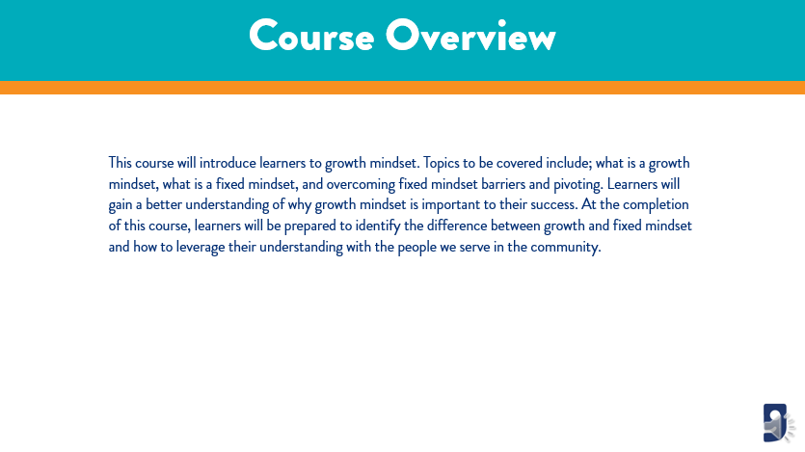

***Slide 2: Course Overview***

***Estimated duration:***

***Participant Guide Page:***

***Notes:***

**Slide Title: Course Objectives**

**Say:** One of the important aspects of a training course are the course objectives. The objectives provide insight into what you will learn from the content presented to you today. For the Growth Mindset course, the objectives we will cover include:

* Define Growth and Fixed Mindset
* Examine ways to overcome mindset barriers, and
* Explain how to cultivate a growth mindset

**Explain:** This course will provide you the basic foundations of how to identify growth vs fixed mindset and how we can leverage this knowledge with the jobseekers, colleagues, family, and friends.

**Discuss:** Growth Mindset is an important part of your role as a member of the Mission Services Team. At times, you will be presented with opportunities to flex your knowledge and skillset in identifying fixed mindset mentality and how to properly address it. This will position you to be better equipped to share knowledge and motivate your jobseekers and anyone you work closely with.

**Say:** Next, I would like to review with you the topics we will cover in today’s course.

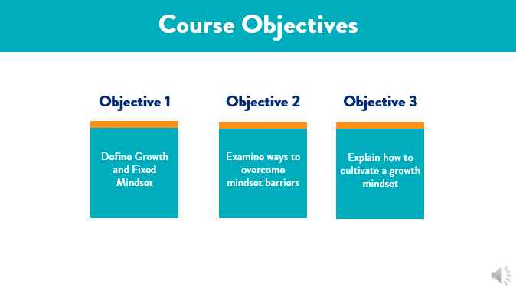

***Slide 3: Course Objectives***

***Estimated duration:***

***Participant Guide Page:***

***Notes:***

**Slide Title: Course Topics**

**Say:** Another important aspect of a training course is the course topics. The course topics give us insight into what we will be learning in the session.

The topics we will cover in today’s session include:

* Identify my current mindset
* What is growth and fixed mindset
* Where do I see fixed mindset in my role?
* Overcoming a fixed mindset
* Cultivating a growth mindset
* Knowledge check
* Next steps

**Explain:** Next, I want to take a moment to cover some course rules with you before we jump right in to the content we are set to cover today.

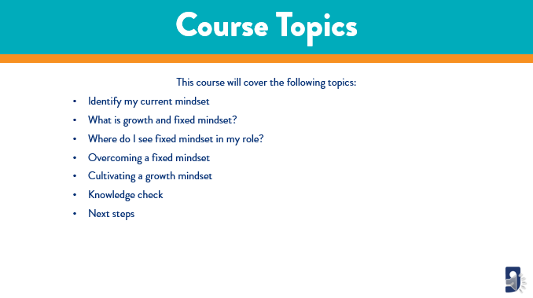

***Slide 4: Course Topics***

***Estimated duration:***

***Participant Guide Page:***

***Notes:***

**Slide Title: Course Rules**

**Say:** The rules for this course will look a little different as you are completing this session in a self-paced modality. Let’s talk a little about the course rules now:

* Make sure you are in a learning environment free from distractions.
* Feel free to pause this course at any time if you need to step away or take a break.
* Write down any questions you have for your leaders and send it to them after the completion of this course.
* Write down any feedback you have for L&D and forward that to your respective leader.

**Say:** Now that we have covered the course rules, let’s jump right in to our first topic which is, Identifying your current mindset.

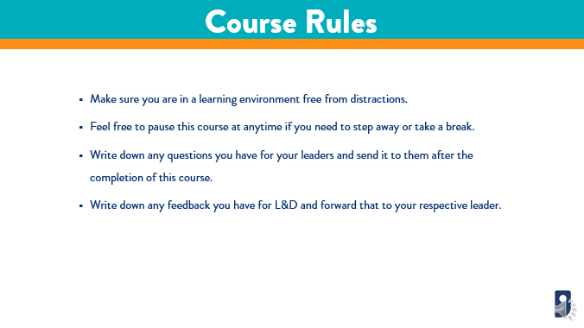

***Slide 5: Course Rules***

***Estimated duration:***

***Participant Guide Page:***

***Notes:***

**Slide Title: What is your current mindset?**

**Say:** Before we can really begin to discuss what a growth mindset is, we need to take an opportunity to self-assess and identify what our individual mindset is. To do this, I have a quick self-assessment I would like you to complete. When I instruct you to do so, I want you to pause this video and take about 5 minutes to complete the Mindset Self-Assessment.

**Explain:** Be sure to take your time and read each question thoroughly. Make sure you understand the question prior to selecting a response. We want to make sure that you answer these questions to the best of your knowledge as this will ensure we have the most accurate understanding of your current mindset. When you are finished, go ahead and click the Play on the video and we will debrief your self-assessment. I will spend some time discussing your score, dig a little deeper into the meaning of that score, and how it correlates to your current mindset.

**Say:** If you are ready, go ahead and pause the video now and start the Mindset Self-Assessment.



***Slide 6: What is your current mindset?***

***Estimated duration:***

***Participant Guide Page:***

***Notes:***

**Slide Title: What is your current mindset?**

**Say:** Welcome back! I hope you had an opportunity to review the self-assessment and score your answers. Are you ready to move forward?

**Explain:** When completed thoroughly, you should have a score that ranges from 8-48. Let’s talk a little about the scoring and your results, in terms of what your current mindset says about you.

**Discuss:** Based on your score, your results can be broken down into 1 of 5 categories.

If your score was:

* **8-16:** You strongly believe that your intelligence is FIXED – that is doesn’t change much. If you cannot perform perfectly, you would rather not complete a task. You tend to think smart people don’t have to work hard.
* **17-24:** You lean towards thinking that your intelligence does not change much, you prefer not to make any mistakes if you can help it, and you also do not like to put in a lot of work. You may lean towards the idea that learning should be easy.
* **25-32:** You’re not sure whether you can change your intelligence. You care about your performance and you also want to learn, but, you don’t really want to work too hard for it.
* **33-40:** You believe that your intelligence is something you can increase. You care about learning and you are willing to work hard. You want to always excel; however, you think it is more important to learn rather than to always perform well.
* **41-48:** You feel certain that you can always increase your intelligence by learning, and you love a challenge. You believe that the best way to learn is to work hard, and you strongly believe that making mistakes is an inevitable part of the learning process.

**Say:** Now I want you to stop for a moment and reflect on your score and what it says about you and your mindset. Ask yourself, “Was I aware of this before completing this activity?” Being aware of your current mindset is the first step in learning how to pivot from a fixed mindset to a growth mindset, but also, it is the first and most important step in learning how to cultivate a growth mindset. Once you have a better understanding of these concepts, you will be better prepared to serve your jobseekers and our community. Let’s move on to our next topic where we will define what growth and fixed mindset means.

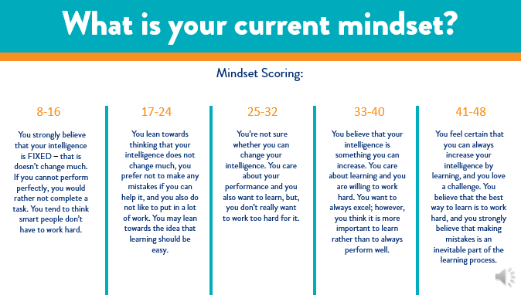

***Slide 7: What is your current mindset?***

***Estimated duration:***

***Participant Guide Page:***

***Notes:***

**Slide Title: What is Growth and Fixed Mindset**

**Say:** In your own words, I want you to write down what you think Growth Mindset is. Then, I want you to write down, in your own words, what a fixed mindset is. Go ahead and pause the video here, and when you're finished, click the Play button so we can continue.

**Say:** Welcome back. I hope you had some time to write down your own personal definitions of what growth and fixed mindset are. Let’s take a moment to discuss each of these in more detail.

**Discuss:** By definition, Growth Mindset is described as: a belief that intelligence and talent can be improved. A fixed mindset is the belief that intelligence and talent cannot be improved. So, what does that mean? How does that show up in the work we do every day? Let’s talk more about that.

A fixed mindset cultivates the idea that you are as smart as you will ever be and that can never change. You are who you are and you were born with the talents and smarts that you currently possess. It leads you into a mindset that since you have settled for this belief, there is no point in working hard to become better, because you just can’t.

A growth mindset is the opposite. A growth mindset cultivates the idea that you can continually build upon your intelligence and talents through hard work, dedication, and learning experience. This mindset speaks to you being born with a certain level of intelligence; however, it also speaks to an inner motivation that compels you to continually seek out knowledge and upskilling through trial and error and learning lessons. A person with a growth mindset is always up for a challenge.

**Say:** So, which are you? Which do you want to become? Think about that as we continue to move through this course and content.

***Slide 8: What is Growth and Fixed Mindset***

***Estimated duration:***

***Participant Guide Page:***

***Notes:***

**Slide Title: Growth Mindset Activity**

**Say:** In order to better understand the meaning of growth and fixed mindset, it is important to identify ways the mindsets show up. It could happen at home with your family, at work with your colleagues, or even with everyday people you interact with. One of the amazing things about knowing the difference between the two mindsets is that you will always have an immediate opportunity to see it in action and immediately respond so that you can help a person, or even yourself, pivot from a fixed mindset to a growth mindset.

**Explain:** Another reason why it is important to know the differences between the two mindsets is because it positions you in a way to motivate those around you. Let’s take a moment to complete a quick activity on identifying a Growth vs a Fixed mindset.

**Say:** When I prompt you, pause this video and locate the Growth vs Fixed mindset activity in your participant guide. Please allow yourself 5 minutes to complete this activity. Once you are finished, click the Play button. When we return, we will review your responses together. Go ahead and pause your video now.

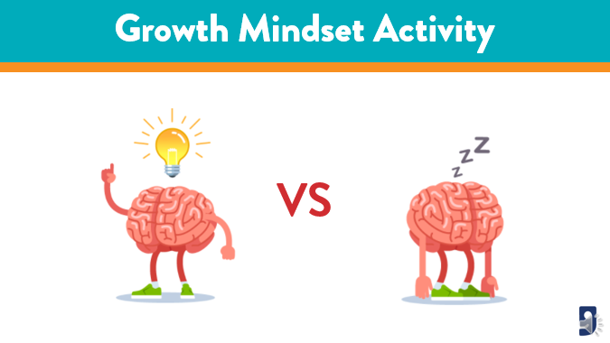

***Slide 9: Growth Mindset Activity***

***Estimated duration:***

***Participant Guide Page:***

***Notes:***

**Slide Title: Growth Mindset Activity**

**Say:** Did you finish your activity already? I hope you enjoyed that exercise, it was designed to help you understand the difference between the mindsets. Now that you have completed your activity, let’s review the answers together. Are you ready?

**Discuss:** Make sure you have something to write with, and we are using the honor system here, so be sure to correct your answers accordingly. Let’s get started:

* I’m not good at this… is a Fixed Mindset
* What am I missing? This is a Growth Mindset
* I’ll use a different strategy… is a Growth Mindset
* It’s good enough… is a Fixed Mindset
* I can’t make this any better… is a Fixed mindset
* I made a mistake… is a Growth Mindset
* Is this really my best work? This is a Growth Mindset
* I can always improve… is a Growth Mindset
* This is too hard… is a Fixed Mindset
* Mistakes help me learn… is a Growth Mindset
* I will never be that smart… is a Fixed mindset
* There is always a plan B… is a Growth Mindset
* I can learn and grow from this… is a Growth Mindset
* I just can’t do this… is a Fixed Mindset
* This may take some time… is a Growth Mindset
* My friend can do this, but I can’t… is a Fixed Mindset
* I will use a different strategy… is a Growth Mindset
* I am going to train my brain… is a Growth Mindset

**Say:** How did you do? If you scored low, don’t worry. The idea of this course is to help you become familiar with these concepts, so pivot that fixed mindset and move into a growth mindset! How did you answer the questions on your activity? Let’s talk a little about those.

**Discuss:** The first question was: What did you notice about the language in the fixed mindset statement? Well, if your answer spoke to a negative, I can’t do it, I’m giving up type of vibe, you are correct! Fixed mindset statements imply a person giving up, or not willing to try. There is a lack of challenge or desire to want to be better. That is where the idea of “I am who I am and I can’t change anything about me.”

**Discuss:** Now in the second question, what did you notice about the language in the growth mindset statement? What was your response? If you answer spoke to a positive, I made a mistake, but I will try harder next time type of vibe, you would be correct! Growth mindset statements imply that a person takes ownership of their mistakes and possess a certain derive to want to do better next time. This is where the idea of, “I can continue to grow and change, my mistakes are part of my journey” comes from.

**Say:** I hope you enjoyed this activity, I am sure you did an amazing job on it. Next, I want to continue our conversation about growth and fixed mindset statements and dive a little deeper into how these show up with people we interact with every day.

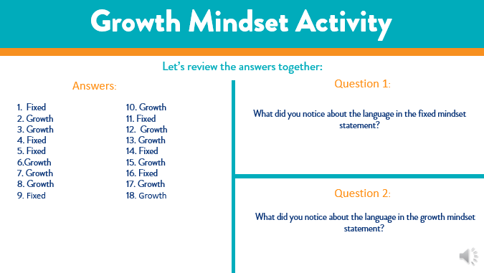

***Slide 10: Growth Mindset Activity***

***Estimated duration:***

***Participant Guide Page:***

***Notes:***

**Slide Title: How do these mindsets show up?**

**Say:** Now that we have a better understanding of what growth and fixed mindsets are, and we are able to identify statements that represent each, I want to take some time to talk about what these mindsets look like and how they show up in everyday interactions.

**Discuss:** Let’s think about everything we do in a day. Think about your daily interactions and the people we serve. You may interact with family, friends, colleagues, and jobseekers on a daily basis. That is a really big group of people that you have the opportunity to exchange conversation with every day. Now let’s break this down a little further and identify examples of interactions with these groups, and how growth and fixed mindset might show up.

**Say:** Let’s start with family. When you think of your daily interactions with family, can you think of how growth and fixed mindset show up? I was at the park with my young son the other day, and we were taking his new scooter out for a ride. Now, he’s not very athletic, he prefers videos games, however, I want to start getting him more active. While we were at the park, I noticed both of these mindsets show up. When my son first began to ride, he was getting tired easily and wanted to give up. He said, “Mom, I can’t do this.” At that moment, I asked him, “Baby, is it that you can’t do it, or you don’t want to try?” He thought about it for a moment and responded, “No, I just want to give up and go home and play video games.” So, it was in that moment I knew, I needed to find a connection with him that would help him become motivated, and pivot into a growth mindset. I then said to him, “I bet you can’t do 5 laps around a basketball court?” He looked at me and said, “Yes I can! I bet you I can do 10 laps!” So, in that moment I knew I had him, and I wanted to keep him motivated to try, so I said to him, “Okay, if you can do 10 laps around the basketball court, you will win an hour on the video game of your choice today.” I decided to incentivize his video game time, while teaching him a lesson, all while he had no idea what I was doing. He did 10 laps, then 15, and then 20. He then challenged me to race him around the basketball court for another hour of game time. Unfortunately, he finessed me, and I lost, I even cheated and still lost, thus my son in turn teaching me a lesson, that cheaters never win! ☺ The best part of this entire story and why I share it with you is because as we were heading back to the car to leave the park, he looked up at me and said, “Mom, I want to come back tomorrow, and I want to do more laps and racing with you. This was fun, and I get better and faster the more I try.” I knew in that moment, I helped him switch from a fixed mindset to a growth mindset.

**Say:** Let’s talk about the other areas of our lives and how these mindsets show up.

* **Friends:** A fixed example is “I can’t play softball, I'm not very good at it.” A growth example is “Although I’m not a great softball player if I continue to practice I know I’ll get better.”
* **Colleagues:** A fixed example is “I’m never going to get a promotion.” A growth example is “If I upskill and continue working hard, I will be ready for the next promotion opportunity.”
* **Jobseekers:** A fixed example is “I didn’t get the job I applied for, I give up”. A growth example is “I will continue to apply for jobs until I find the right one for me.”

**Ask:** Can you think of other ways this might show up in your daily interactions? When you have some time, make sure to write your thoughts down in your participant guide, so that you can always remain aware of those instances so you can continue to inspire and motivate the people you serve.

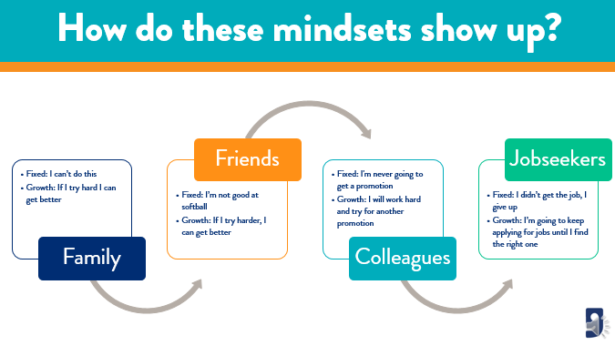

***Slide 11: How do these mindsets show up?***

***Estimated duration:***

***Participant Guide Page***

***Notes:***

**Slide Title: Overcoming mindset barriers**

**Say:** So, how do we overcome a fixed mindset? Think of your everyday interactions, and consider how you will help others overcome a fixed mindset. Think about the times you might have experienced a personal fixed mindset. How do you work through these instances?

**Discuss:** Let’s talk about 6 strategies you can develop and implement to overcome a fixed mindset.

* **Shift your mindset to see failures as opportunities.** As you begin to view your failures as growth opportunities, you shift your mindset towards challenges and turn that into a positive outlook.
* **Quit seeking approval.** Own who you are. When you set aside seeking the approval of others, we prioritize our potential for growth and increase our successes.
* **Trust the process rather than focusing on the end result.** Each time you fail, you are learning and sharpening your traits, qualities, and intelligence.
* **Listen to your internal self.** Remind yourself that you are investing in your success, your future, and you are growing into the individual you always envisioned yourself to be.
* **Never be afraid to fail.** We are wired to fail and to fail often, but as we get older, we start to fear failure. Listen to your inner voice and challenge yourself to overcome and push forward
* **Develop and be certain of your purpose.** Don’t be afraid to remind yourself everyday what your purpose is and always keep that in the forefront of everything you do.

**Say:** When you begin to cultivate a growth mindset, you not only empower yourself to push forward and continually re-invent yourself, but you open yourself up to opportunities to grow, and shape yourself and others, into the best version of themselves. Also, being equipped with the knowledge of mindset pivoting allows you to encourage others to take a step back, evaluate their own mindset, and help guide them on a path that supports continued learning experiences. I want to challenge you to think of ways you can begin to help your jobseekers and people you interact with daily overcome their own fixed mindsets. Keep that in mind as you move forward in your role within Mission Services.

**Say:** Now that we have covered how to overcome a fixed mindset, let’s move into a discussion around cultivating a growth mindset for continued success.

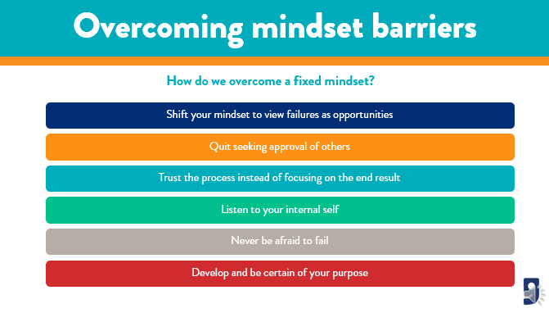

***Slide 12: Overcoming mindset barriers***

***Estimated duration:***

***Participant Guide Page:***

***Notes:***

**Slide Title: Cultivating a growth mindset**

**Say:** Once you understand how you can overcome a fixed mindset, it’s important to begin to have a growth mindset. Cultivating a growth mindset is important because it helps you break down barriers that may hold you back from learning something new or upskilling yourself. Growth mindset paves a way for persistence and determination. Doing this ultimately improves the way you learn.

**Discuss:** There are small steps you can take to begin cultivating a growth mindset. Once you have mastered this mindset, you can begin to help others identify where they are at and how to pivot to a growth mindset. Some of the strategies include:

* **Know your purpose** – What is your purpose, and how will you let it guide you on your journey? Make sure to thoroughly understand it and create a growth mindset that will help you continually work towards meeting that purpose every day.
* **Reflect** – Take ownership and embrace your failures. Learn to become comfortable with failure. Always be aware of your opportunities for growth and work towards those.
* **Challenge yourself** – I want to encourage you to break through the negative perception of challenges. Instead, start to visualize challenges as learning experiences.
* **Alter your attitude** – Shifting from a fixed mindset to a growth mindset empowers you to put out a positive energy into your environment, thus, inspiring others to follow suit.
* **Ask for feedback** – Although getting feedback can be hard at times, its an opportunity to identify a learning experience and learn from your mistakes. This helps you become the best version of yourself.
* **And, incorporate “Not Yet”** – Integrating the words “Not Yet” into your vocabulary signals that despite any struggles, you can overcome anything. It’s a matter of time and little effort.

**Say:** The key to cultivating a growth mindset is to recognize where you are at in your journey, know your purpose, and be willing to help other cultivate their own growth mindset.

**Say:** Can you think of other ways or strategies you could implement to help you create and maintain a growth mindset? I encourage you to write those down in your participant guide and refer back to them from time to time.

**Say:** Now that we have come to the end of our session today, I want to check your level of understanding on the content I presented to you, today.

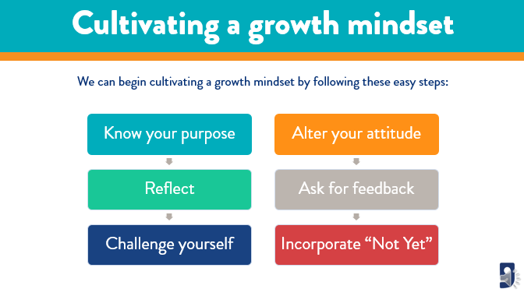

***Slide 13: Cultivating a growth mindset***

***Estimated duration:***

***Participant Guide Page:***

***Notes:***

**Slide Title: Knowledge Check**

**Say:** The next part of this course is to designed to check your understanding of the content that was presented today. In your participant guide, you will find a knowledge check worksheet. Pause this video when I give you the prompt. I want you to take about 10 minutes to review and answer these knowledge check questions. Once you are finished, click Play on the video to finish the session.

**Say:** Remember, when you are finished with the course, provide your leader with your knowledge check worksheet, as this will ensure you are given credit for participating and completing the Growth Mindset course today. If you have any further questions, please be sure to speak with your leader.

**Say:** Alright, go ahead and pause the video now and begin your knowledge check.

**Return:**

**Say:** Welcome back! I hope you enjoyed completing your knowledge check. Let’s move forward and discuss next steps as we wrap up this session.

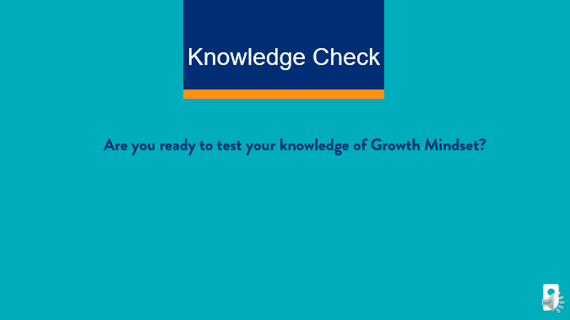

***Slide 14: Knowledge Check***

***Estimated duration:***

***Participant Guide Page:***

***Notes:***

**Slide Title: Next Steps**

**Say:** Some next steps I want to cover include:

* Be sure to pass your feedback and questions to your respective leaders.
* Make sure you pass on your knowledge check activity from this course to your leader as this is what will confirm your completion of this course.
* And lastly, work with your manager to schedule time to complete the other Core Courses that have been released this quarter.

**Say:** It is important to keep your upskilling and training at the forefront of everything you do.

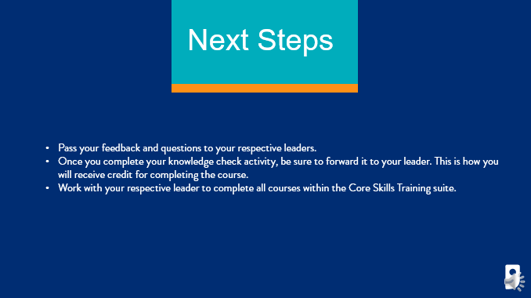

***Slide 15: Next Steps***

***Estimated duration:***

***Participant Guide Page:***

***Notes:***

**Slide Title: Questions**

**Say:** In the beginning of this course, I asked you to write down questions as you moved through the session. If you have any questions written down, or if you have questions that have crossed your mind now, I encourage you to write those down and schedule time with your leader to work through them and get answers.

**Say:** If you have feedback for the Learning and Development team on this training, we encourage you to reach out to LearningandDevelopment@goodwillaz.org. I am always happy to jump in and help when I can. Please be sure to forward your feedback to your leader first, then you can send it to the team.

**Close:** I want to take the opportunity to thank you for completing this course today. As a member of this team, I want to thank you for all the hard work and dedication you provide our jobseekers and community every day. It is because of you, we were able to provide career and employment services to our communities and help strengthen families in the communities we serve. Thank you for all you do! I appreciate your time today and I hope you gained a little more knowledge on an unfamiliar topic. I encourage you to continue to ask questions and take the information you have learned and leverage it with your colleagues and jobseekers. Have a wonderful day!



***Slide 16: Questions***

***Estimated duration:***

***Participant Guide Page:***

***Notes:***

**Slide Title: References**

**Say:** In an effort to give credit when credit is due, we have included a reference page to call out the resources used to create this content here for you today.

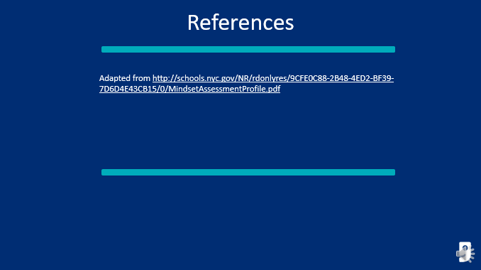

***Slide 17: References***

***Estimated duration:***

***Participant Guide Page:***

***Notes:***

Growth Vs Fixed Mindset Answer Key

|  |  |  |  |
| --- | --- | --- | --- |
| **Statement** | **Growth Mindset** | **Fixed Mindset** | **Correct? Yes/No** |
| I’m not good at this. |  |  |  |
| What am I missing? |  |  |  |
| I’ll use a different strategy. |  |  |  |
| It’s good enough. |  |  |  |
| I can’t make this any better. |  |  |  |
| I made a mistake. |  |  |  |
| Is this really my best work? |  |  |  |
| I can always improve. |  |  |  |
| This is too hard. |  |  |  |
| Mistakes help me learn. |  |  |  |
| I will never be that smart. |  |  |  |
| There is always a plan B. |  |  |  |
| I can learn and grow from this. |  |  |  |
| I just can’t do this. |  |  |  |
| This may take some time. |  |  |  |
| My friend can do this, but I can’t. |  |  |  |
| I will use a different strategy. |  |  |  |
| I am going to train my brain. |  |  |  |

What did you notice about the language in the fixed mindset statements? *(Statements imply giving up)*

What did you notice about the language in the growth mindset statements? *(Statements imply motivation to learn)*

Knowledge Check Answer Key

**Question:** *Define Growth Mindset*

**Answer:**

*A growth mindset cultivates the idea that you can continually build upon your intelligence and talents through hard work, dedication, and learning experience.*

**Question:** *Define Fixed Mindset*

**Answer:**

*A fixed mindset cultivates the idea that you are as smart as you will ever be and that can never change. You are who you are and you were born with the talents and smarts that you currently possess.*

**Question:** *Select the fixed mindset statements*

**Answer:**

*A. How can I improve next time?*

*B. I’m not smart enough.*

*C. If I try harder I can increase my intelligence.*

**Question:** *Select the growth mindset statements*

**Answer:**

*A. I just can’t do it.*

*B. This is too hard, why even try.*

*C. Failure is an opportunity to grow.*

**Question:** *What are 3 ways to overcome mindset barriers?*

**Answer:**

*A. Develop your purpose, shift your mindset, and don’t ask for feedback*

*B. Don’t seek approval, don’t be afraid to fail, and view failures as opportunities*

*C. Trust the process, listen to your internal self, and believe you are good enough*

**Question:** *What are 3 ways to cultivate a growth mindset?*

**Answer:**

*A. Alter your attitude, ask for feedback, and believe intelligence cannot be increased*

*B. Know your purpose, incorporate “Not Yet”, and seek out approval from leaders and colleagues*

*C. Reflect, challenge yourself, and know your purpose*

**Question:** *Scenario 1: You have a jobseeker who has applied for five jobs in the last week. The jobseeker has not received an invite to interview for any of the jobs. When you speak to the jobseeker, they confide in you about how difficult job searching is, and that they want to “just give up.” Explain how you would help your jobseeker pivot from a fixed mindset to a growth mindset in this instance.*

**Answer:**

*A. Empathize with the jobseeker, and motivate them to find their purpose, and guide them to help shift their mindset from giving up to pushing forward.*

*B. Tell them to just give up, because this has been a hard job search journey for them.*

*C. Offer to search and apply for jobs for them, to help them find employment.*

**Question:** *Scenario 2: You meet with a new job seeker who would like to begin to receive career services. As you review the courses we offer for upskilling, your jobseeker informs you that they are not interested in taking the Computer Basics courses. Upon further conversation, you learn that your jobseeker has never used a computer. In that conversation, your jobseeker states they have no desire to use computers because they are looking for work that won’t require upskilling in technology. Also, your jobseeker states they are too old to learn new skills and they are as smart as they will ever be. Explain how you would help this jobseeker switch their mindset and encourage them to sign up for computer basics.*

**Answer:**

*A. Explain to the jobseeker that you understand, and only offer courses they are interested in.*

*B. Tell the job seeker they should look for jobs that don’t require technology knowledge so they don’t have to feel pressured to upskill.*

*C. Have a conversation with the job seeker and explain to them the current workforce, the skill sets employers are looking for, and why it is important to upskill in technology. Help the jobseeker understand the importance of learning experiences and the opportunity they have to grow and become the best version of themselves.*

**Question:** *Scenario 3: You meet with a jobseeker who has recently signed up for www.mycarreradvisor.com. You learn that your jobseeker created a new resume and has sent it in for feedback. Upon reviewing their resume, you notice some mistakes, and inconsistencies, so you meet with them to give your feedback. Once you have completed your feedback, your jobseeker responds by saying, “Well, I think the resume is good enough, and I just want to leave it as is, because I can’t make it any better.” Explain how you would motivate your jobseeker, and help them shift their mindset.*

**Answer:**

*Personal Response: (Graded by leader)*

**Question:** *What are your three biggest takeaways you learned from the Growth Mindset course you completed today?*

**Answer:**

*Personal Response: (Graded by leader)*