**Essential Skills**

**Critical Thinking**

**Instructor Guide**

**Purpose**

The purpose of this course is to provide jobseekers foundational information on Interpersonal Soft Skills.

**How to Use This Guide**

This facilitator guide is designed to help you deliver the Essential Skills-Critical Thinking. Explanations of what to say do, and how to facilitate activities are provided within this guide; however, you can use the left side of each page to enter your own notes to help you train this session.

This course is highly reliant on participant contribution and input. You will also see “PG” referenced throughout this material, it stands for Participant Guide. Durations are estimates only and do not account for the level of discussion you may have during each one of your training sessions.

**Materials Needed**

* Projector
* Computer
* Instructor Guide
* Participant Guide
* Pen/Pencil
* Computer Lab
* Markers
* Flip Chart Paper

**Learning Objectives**

At the completion of this course, learners will be able to:

* What is Critical Thinking?
* How to Become a Critical Thinker
* Critical Thinking in the Workplace

**Course Duration:** 60 minutes. (Depending on Q&A)

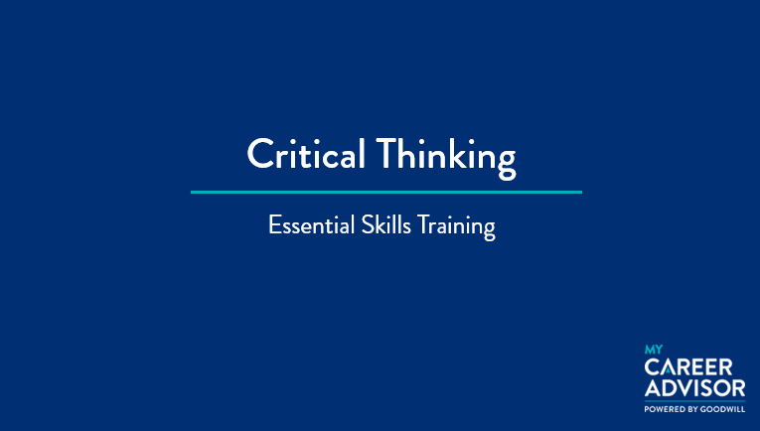

***Side 1: Title Slide***

***Estimated duration: 1 min***

***Notes to Instructor:***

***Notes:***

**SAY:** Welcome to the Essential Skills – Critical Thinking course.

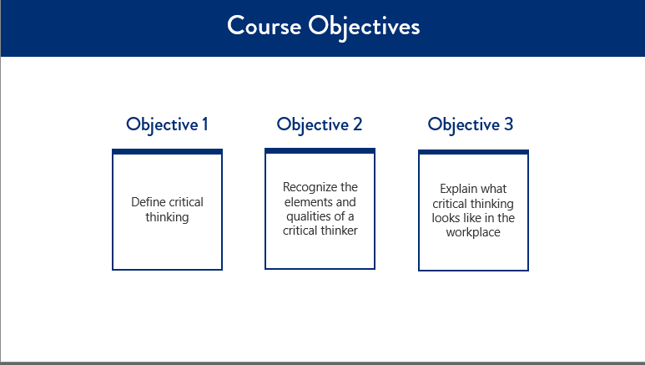

***Side 2: Course Objectives***

***Estimated duration: 1 min***

***Notes to Instructor:***

***Notes:***

**SAY:** The objectives for this course include:

* Define critical thinking
* Recognize the elements and qualities of a critical thinker
* Explain what critical thinking looks like in the workplace

Let’s move forward and talk about the course topics.

**SAY:** This course will cover the following topics:

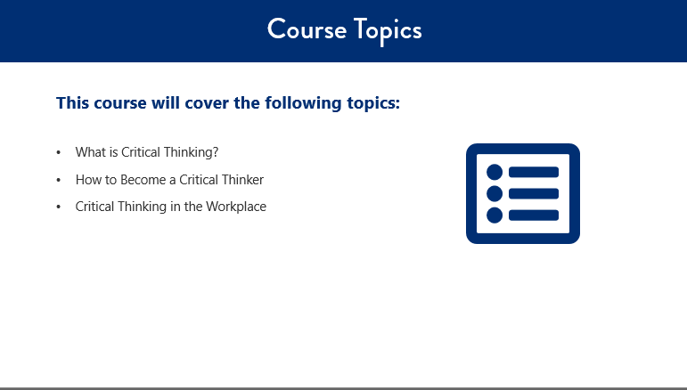

***Side 3: Course Topics***

***Estimated duration: 1 min***

***Notes to Instructor:***

***Notes:***

* What is Critical Thinking?
* How to Become a Critical Thinker
* Critical Thinking in the Workplace

Let’s begin by defining what is critical thinking.

**SAY:** Critical thinking is the logical process of conceptualizing, applying, analyzing, synthesizing, and evaluating information gathered from observation, experience, reflection, or communication, to guide belief and action.

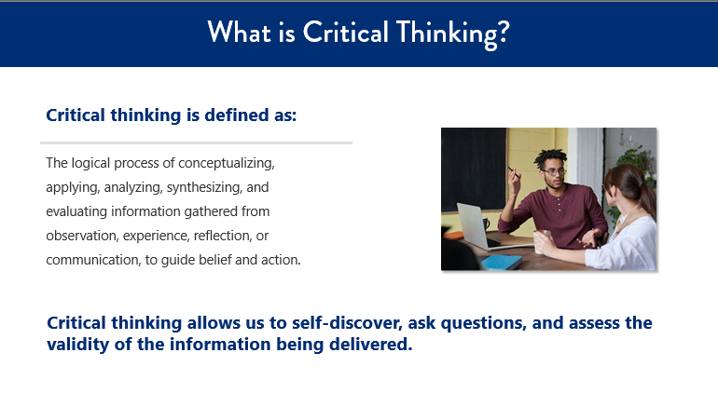

***Side 4: What is Critical Thinking***

***Estimated duration: 1 min***

***Notes to Instructor:***

***Notes:***

**SAY:** As a result, possessing the ability to think critically, allows for the following:

* The ability to formulate though-out questions in a clear and concise way
* Assessing relevant information, interpreting information effectively, and drawing solid conclusions for a solution
* Allows for open-mindedness and assessing data from an unbiased perspective
* Supports effective communication in discovering solutions to complex problems

In short, critical thinking is a modality of the thinking process that assess itself. Through this, we self-discover, ask questions and assess the validity of the information being delivered.

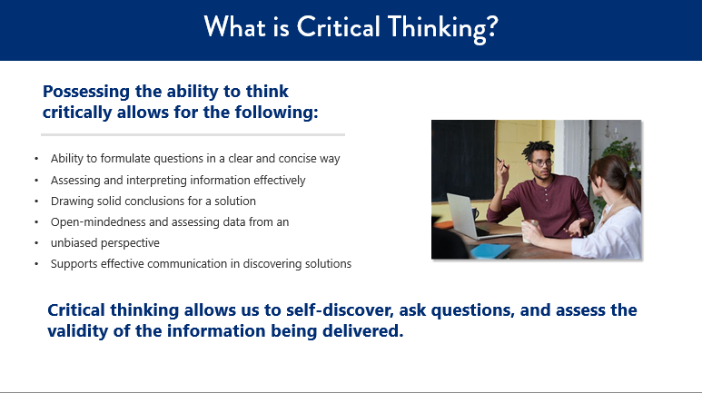

***Side 5: What is Critical Thinking***

***Estimated duration: 1 min***

***Notes to Instructor:***

***Notes:***

**SAY:** There are three elements to thinking critically: evidence, reasoning, and myths.

**CLICK**

Evidence includes everything that is used to determine or demonstrate the truth.

**CLICK**

Reasoning means forming conclusions, judgments, or inferences from facts.

**CLICK**

A myth is a deceptive, misleading, false notion, or belief. Myths use faulty reasoning. This means that a myth is partially built on facts, but its not true.

**SAY:** To summarize how these elements work together; when critically thinking you must use reasoning to examine evidence and determine what part of the evidence could be a myth.

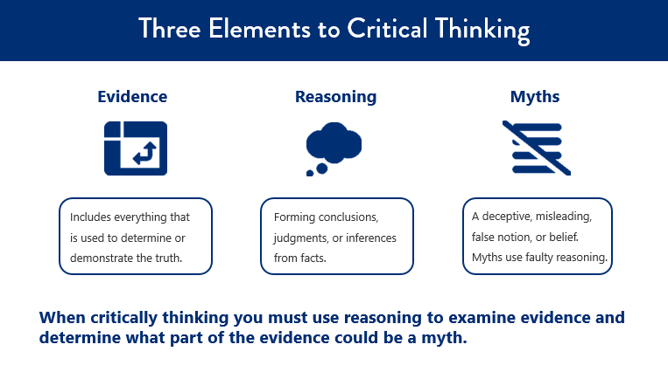

***Side 6 Three Elements to Critical Thinking***

***Estimated duration: 1 min***

***Notes to Instructor:***

***Notes:***

**SAY:** Based on an article from Entrepreneur, critical thinkers do more than gather information and data. They look at things from a different perspective to arrive at the right decision. Critical thinkers are autonomous, participate in continuous learning, they are self aware, and have a desire to continued improvement.

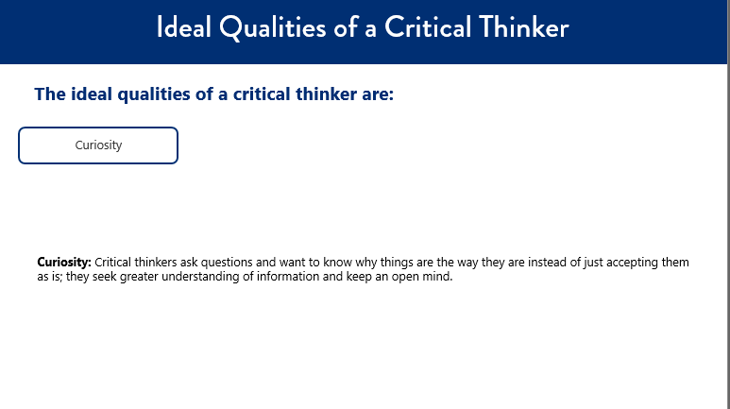

***Side 7: Ideal Qualities of a Critical Thinker***

***Estimated duration: 1 min***

***Notes to Instructor:***

***Notes:***

There are 8 ideal qualities of a critical thinker. They are:

Curiosity: Critical thinkers ask questions and want to know why things are the way they are instead of just accepting them as is; they seek greater understanding of information and keep an open mind.

**SAY:** Objectivity:Critical thinkers focus on facts and information. They remain impartial and remove the emotional component from their decision making. We cannot remain completely objective, so it is important for us to be aware of our bias.

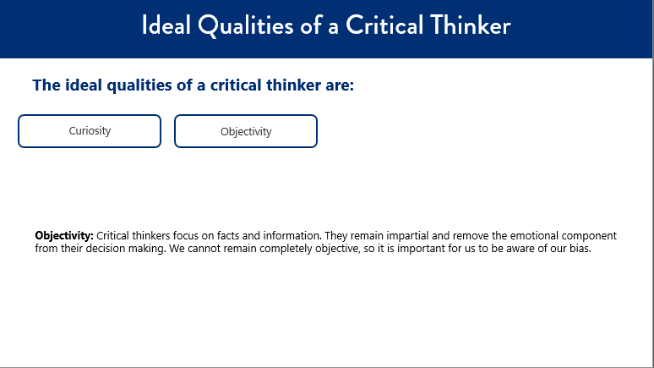

***Side 8: Ideal Qualities of a Critical Thinker***

***Estimated duration: 1 min***

***Notes to Instructor:***

***Notes:***

**SAY:** Analytical thinking:Critical thinkers are able to examine and look at relationships, data, and other information from various perspectives. They are also able to separate information into smaller chunks and then assess how they work together. This quality also ties in with objectivity.

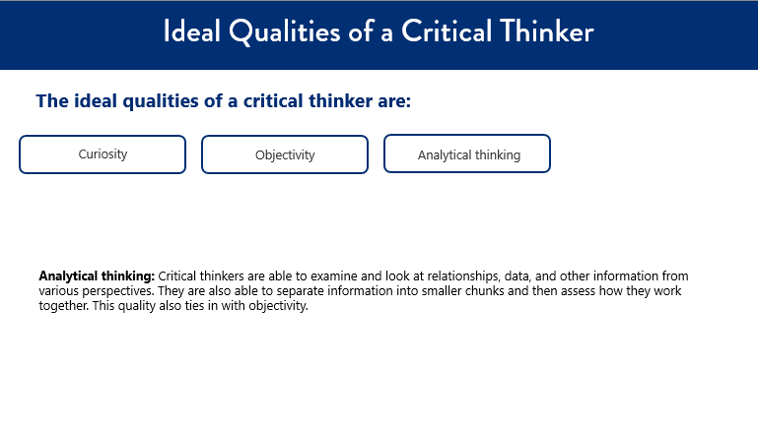

***Side 9: Ideal Qualities of a Critical Thinker***

***Estimated duration: 1 min***

***Notes to Instructor:***

***Notes:***

**SAY:** Identifying bias:Critical thinkers work on identifying their beliefs, biases, and fixed ideas, and they ask themselves what of those are trustworthy. They focus on this self-awareness so that bias will not negatively impact their thinking or decision making.

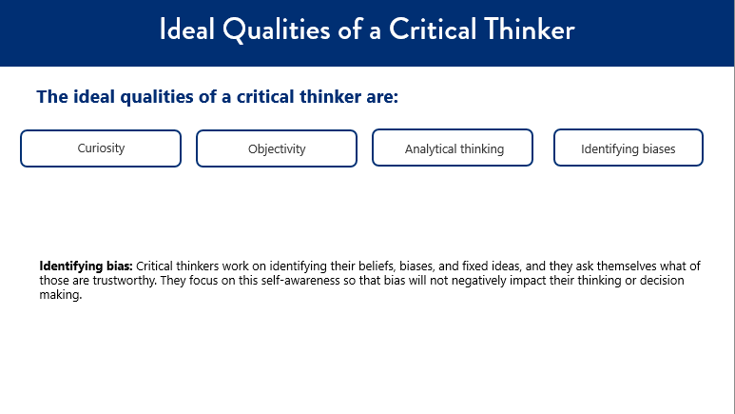

***Side 10: Ideal Qualities of a Critical Thinker***

***Estimated duration: 1 min***

***Notes to Instructor:***

***Notes:***

**SAY:** Compassion and empathy:Critical thinkers genuinely care about others and their well being. They do their best to view people’s situations from another lens, they’re considerate, and work to be there to listen or help the other person.

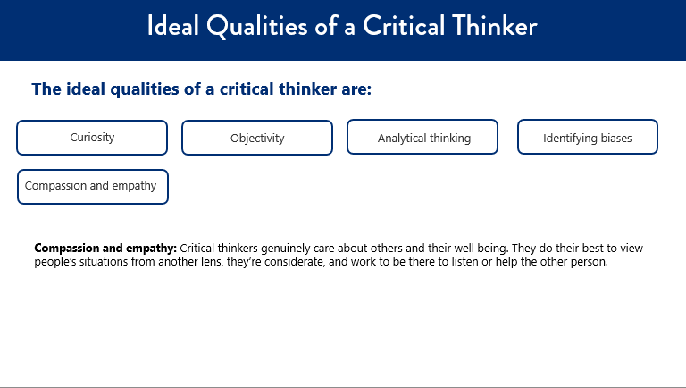

***Side 11 : Ideal Qualities of a Critical Thinker***

***Estimated duration: 1 min***

***Notes to Instructor:***

***Notes:***

**SAY:** Creative thinking:Critical thinkers like to problem solve and brainstorm ideas rather than follow standardized thinking. They are able to bring in new ideas while also applying logic and analysis.

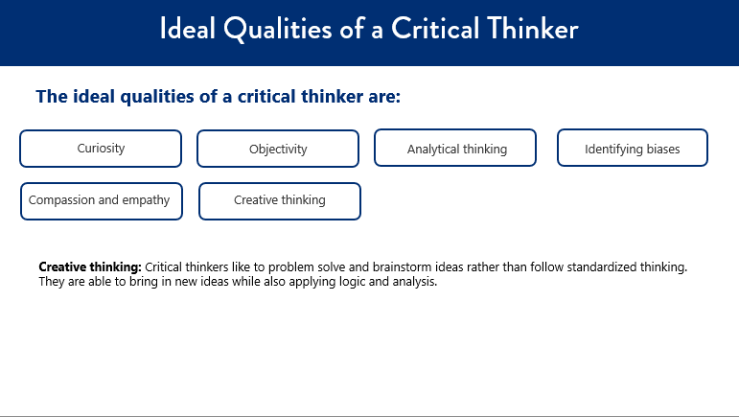

***Side 12: Ideal Qualities of a Critical Thinker***

***Estimated duration: 1 min***

***Notes to Instructor:***

***Notes:***

**SAY:** Effective communicators: Critical thinkers can communicate in a clear and concise manner and they’re able to see things from different angles. They can relay information via different mediums and grasp how others respond.

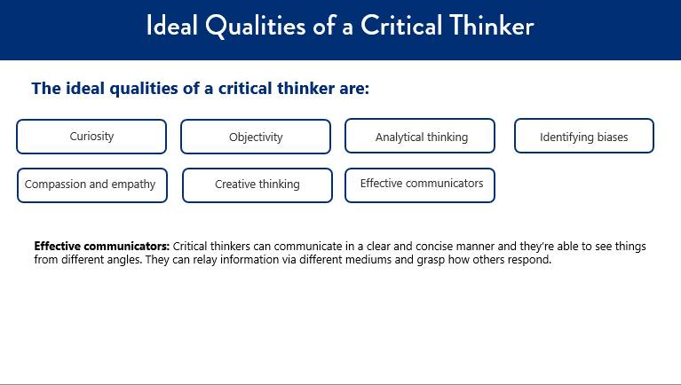

***Side 13: Ideal Qualities of a Critical Thinker***

***Estimated duration: 1 min***

***Notes to Instructor:***

***Notes:***

**SAY:** Active listeners**:** Critical thinkers are focused on hearing from other’s rather than getting their message out. They participate, engage, and seek to understand and gather information rather than make assumptions.

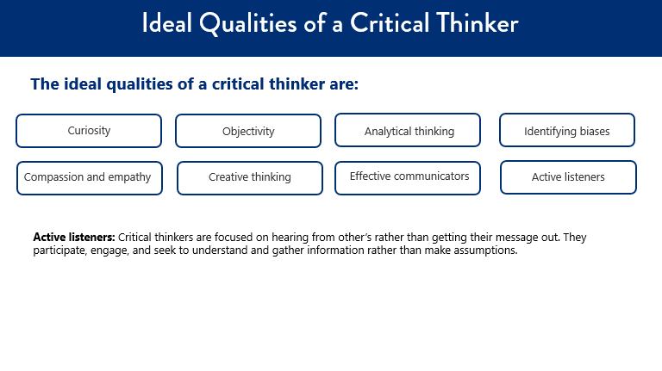

***Side 14: Ideal Qualities of a Critical Thinker***

***Estimated duration: 1 min***

***Notes to Instructor:***

***Notes:***

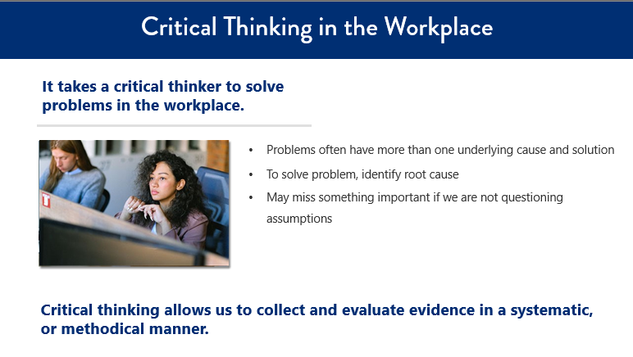

***Side 15: Critical Thinking in the Workplace***

***Estimated duration: 1 min***

***Notes to Instructor:***

***Notes:***

**SAY:** It takes a critical thinker to solve problems in the workplace.

Often a problem has more than one underlying cause and more than one possible solution. In order to solve the problem, we must identify the root cause. Critical thinking allows us to collect and evaluate evidence in a systematic, or methodical manner. If we do not think critically, we will most likely miss something important because we are not questioning assumptions.

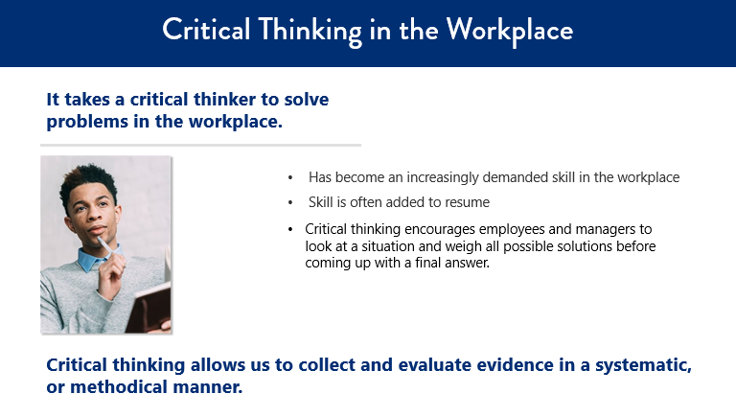

***Side 16: Critical Thinking in the Workplace***

***Estimated duration: 1 min***

***Notes to Instructor:***

***Notes:***

**SAY:** Critical thinking has also become an increasingly-demanded skill in the workplace.

Job candidates often add critical thinking to their resume list of marketable skills and strengths because they know employers desire intuitive and analytical job applicants.

Critical thinking encourages employees and managers to look at a situation and weigh all possible solutions before coming up with a final answer. It can be a long process that requires input from different people within the organization. However, the benefits of critical thinking skills can serve you and all employees well in the workplace.

**SAY:** Benefits of critical thinking in the workplace include:

Bringing new ideas**.** When an issue comes up, a common reaction is to assume that it falls into a predetermined category. Critical thinking does not make any assumptions. Instead, it removes the temptation to immediately classify every issue under something that has happened in the past. It forces employees and managers to look beyond conventional solutions and search for new ideas that can help to efficiently address problems.

Fostering teamwork**.** All employees can get involved in the critical thinking process. The more people that are involved, the more solutions your company will come up with. It gives people of diverse backgrounds an opportunity to work together on product solutions, and gives each employee a chance to impact the future of the organization. Critical thinking exercises promote workplace acceptance and can be used as part of diversity training.

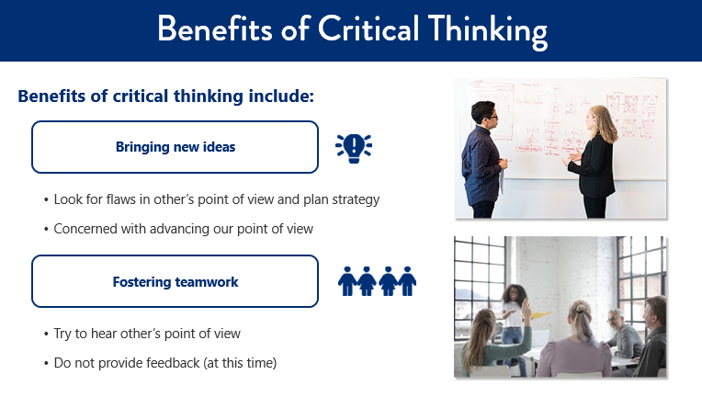

***Side 17: Benefits of Critical Thinking***

***Estimated duration: 1 min***

***Notes to Instructor:***

***Notes:***

**SAY:** Promoting options.By developing multiple solutions to resolve the same issue, a company can offer a range of solutions for clients to choose from, while also encouraging innovation. This also allows a company to develop solutions that use resources that are available, as opposed to purchasing new materials.

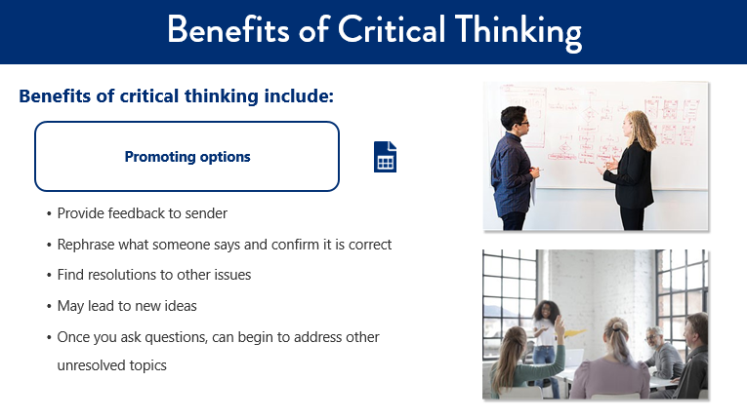

***Side 18: Benefits of Critical Thinking***

***Estimated duration: 1 min***

***Notes to Instructor:***

***Notes:***

Critical thinking can lead us to find resolutions to other issues. For example, a critical thinking exercise on how to handle a new manufacturing process may lead to ideas for other manufacturing methods. Once you get started asking questions for one topic, you can begin to address other unresolved topics.

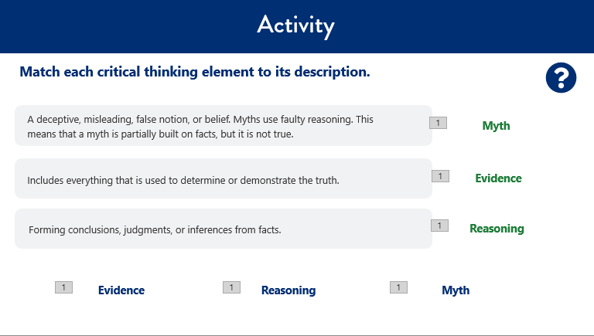

***Side 19: Activity***

***Estimated duration: 1 min***

***Notes to Instructor:***

***Notes:***

**Say:** Let’s do an activity together. Match each critical thinking element to its description.

**Do: *Click to reveal answers***

The answers are now shown on screen.

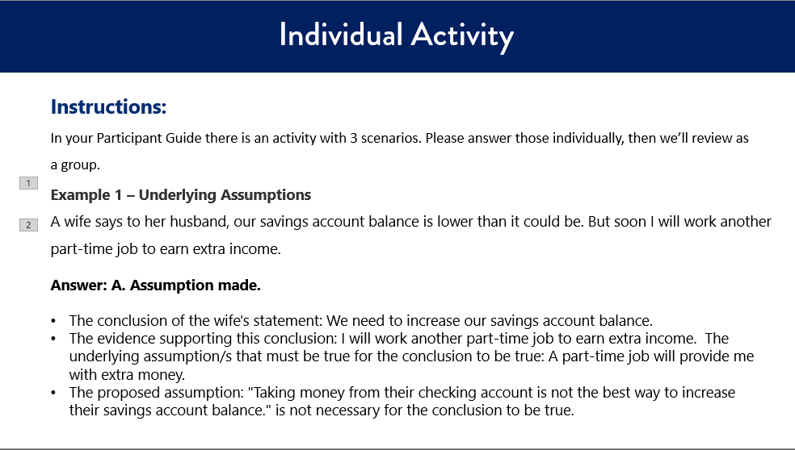

***Side 20: Individual Activity***

***Estimated duration: 1 min***

***Notes to Instructor:***

***Notes:***

**SAY:** In your Participant Guide there is an activity with 3 scenarios. Please answer those individually, then we’ll review as a group.

WHEN YOU ARE READY TO REVIEW:

**CLICK:**

A wife says to her husband, our savings account balance is lower than it could be. But soon I will work another part-time job to earn extra income.

**CLICK:**

Answer: **A. Assumption made.**

**The conclusion of the wife's statement:**We need to increase our savings account balance.

**The evidence supporting this conclusion:**I will work another part-time job to earn extra income. **The underlying assumption/s that must be true for the conclusion to be true:** A part-time job will provide me with extra money.

**The proposed assumption:** "Taking money from their checking account is not the best way to increase their savings account balance." is not necessary for the conclusion to be true.

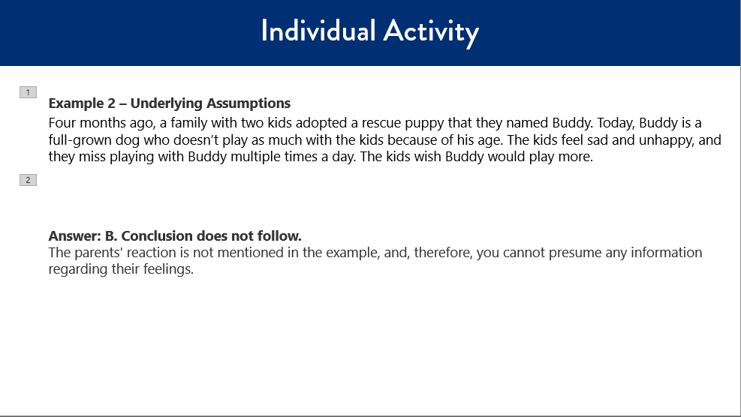

***Side 21: Individual Activity***

***Estimated duration: 1 min***

***Notes to Instructor:***

***Notes:***

**SAY:** **Example 2 – Interpreting Information**

Four months ago, a family with two kids adopted a rescue puppy that they named Buddy. Today, Buddy is a full-grown dog who doesn’t play as much with the kids because of his age. The kids feel sad and unhappy, and they miss playing with Buddy multiple times a day. The kids wish Buddy would play more.

**CLICK:**

Answer: B. Conclusion does not follow.

The parents' reaction is not mentioned in the example, and, therefore, you cannot presume any information regarding their feelings.

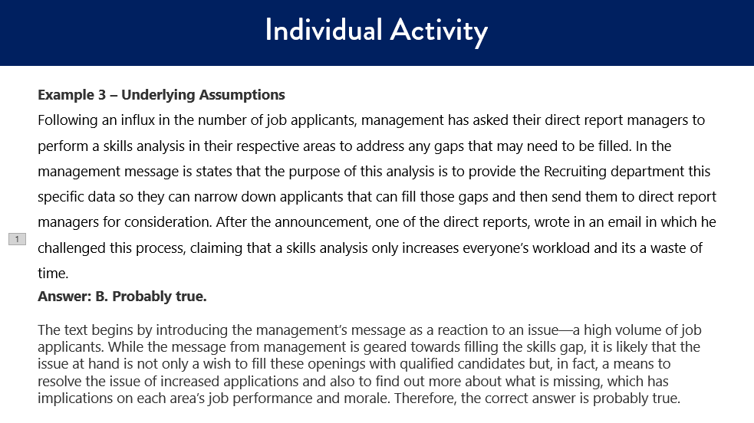

***Side 22: Individual Activity***

***Estimated duration: 1 min***

***Notes to Instructor:***

***Notes:***

**SAY: Example 3 – Inferences**

Following an influx in the number of job applicants, management has asked their direct report managers to perform a skills analysis in their respective areas to address any gaps that may need to be filled. In the management message is states that the purpose of this analysis is to provide the Recruiting department this specific data so they can narrow down applicants that can fill those gaps and then send them to direct report managers for consideration. After the announcement, one of the direct reports, wrote in an email in which he challenged this process, claiming that a skills analysis only increases everyone’s workload and its a waste of time.

**CLICK:**

Answer: B. Probably true.

The text begins by introducing the management’s message as a reaction to an issue—a high volume of job applicants. While the message from management is geared towards filling the skills gap, it is likely that the issue at hand is not only a wish to fill these openings with qualified candidates but, in fact, a means to resolve the issue of increased applications and also to find out more about what is missing, which has implications on each area’s job performance and morale. Therefore, the correct answer is probably true.

**SAY:** Now it is time to check your understanding.



***Side 23: Knowledge Check***

***Estimated duration: 1 min***

***Notes to Instructor:***

***Notes:***

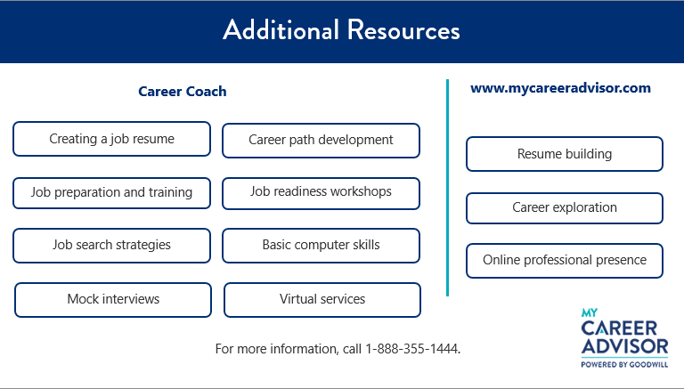

***Side 24: Additional Resources***

***Estimated duration: 1 min***

***Notes to Instructor:***

***Notes:***

**Review as appropriate**:

Goodwill also offers additional resources.

Career Coaches can assist you with the following services:

* Creating a job resume
* Job preparation and job training
* Job search strategies (including leads and searching)
* Mock interviews
* Career path development
* Job readiness workshops
* Basic computer skills
* Virtual services

Physical career centers also have the following technology available:

* Computers
* Phones
* Fax machines
* Printers

Career Coaches can also help you use and navigate the www.mycareeradvisor.com website, as well as provide information about job openings, hiring events, and training.

www.mycareeradvisor.com has:

* Resume building
* Career exploration
* Online professional presence

For more information, please call 1-888-355-1444.

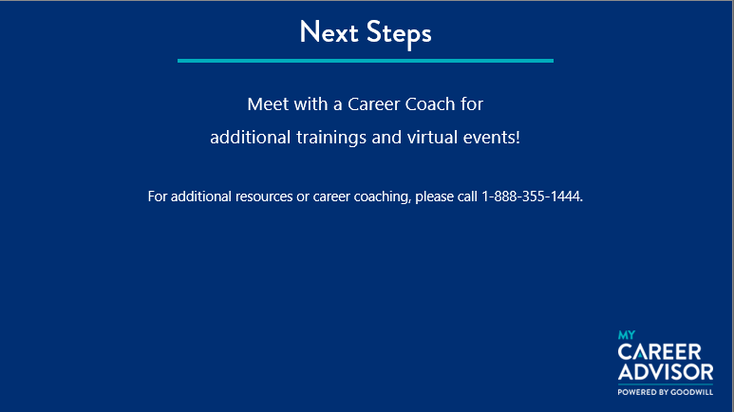

***Side 23: Next Steps***

***Estimated duration: 1 min***

***Notes to Instructor:***

***Notes:***

**SAY:**

If you would like to receive additional information on other courses or career services that we offer, please meet with a Career Coach. For additional resources or career coaching, please call 1-888-355-1444.

**SAY:**

This page is to give credit to those resources and information used to help create this course. We want to ensure that as a company we are recognizing the wealth of knowledge from these sites to help bring awareness and learning to you here at Goodwill.

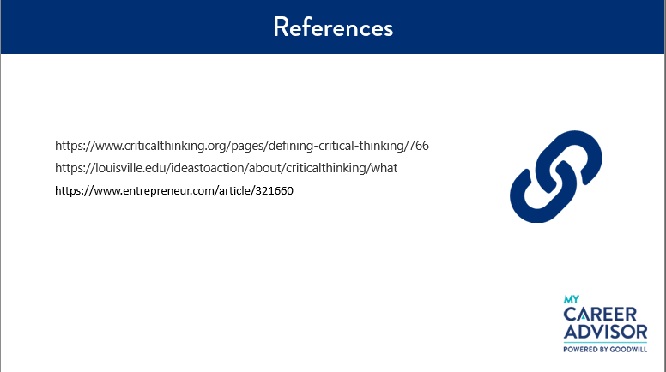

***Side 24: References***

***Estimated duration: 1 min***

***Notes to Instructor:***

***Notes:***

**KNOWLEDGE CHECK**

* Correct answer/s are in bold

1. **What is the definition of critical thinking?**
2. **Critical thinking is the logical process of conceptualizing, applying, analyzing, synthesizing, and/or evaluating information gathered from observation, experience, reflection, or communication, to guide belief and action.**
3. Critical thinking is the logical process of conceptualizing, applying, and/or evaluating information gathered from reflection or communication, to guide belief and action.
4. Critical thinking is the logical process of conceptualizing, synthesizing, and/or evaluating information gathered from observation, experience, reflection, or communication, to guide belief and action.
5. Critical thinking is conceptualizing, applying, analyzing, and/or evaluating information gathered from observation or communication, to guide belief and action.
6. **What are three ways we can effectively solve problems and think critically? Select all that apply.**
   1. Handling difficult situations
   2. **Overcoming adversity**
   3. **Adapting to change**
   4. Inquisitive and innovative
   5. **Creative and innovative**
7. **The three elements of critical thinking are _________. Select all that apply.**
   1. **Reasoning**
   2. Systematic
   3. Truth
   4. **Evidence**
   5. **Myth**
8. **Critical thinking allows us to collect and evaluate evidence in a ______, or ________, _____________.**
   1. Critical thinking allows us to collect and evaluate evidence in a logical, or random, manner.
   2. **Critical thinking allows us to collect and evaluate evidence in a systematic, or methodical, manner.**
   3. Critical thinking allows us to collect and evaluate evidence in a disorganized, or systematic, manner.
   4. Critical thinking allows us to collect and evaluate evidence in an inconsistent, or casual, manner.
9. **True or false. Critical thinking encourages employees and managers to look at a situation and weigh all possible solutions before coming up with a final answer.**
   1. **True**
   2. False
10. **Three benefits to critical thinking in the workplace are ____________. Select all that apply.**
    1. Delaying collaboration
    2. **Fostering teamwork**
    3. Limiting ideas
    4. **Promoting options**
    5. **Bringing new ideas**