**Essential Skills**

**Conflict Resolution**

**Instructor Guide**

**Purpose**

The purpose of this course is to provide jobseekers foundational information on Interpersonal Soft Skills.

**How to Use This Guide**

This facilitator guide is designed to help you deliver the Essential Skills-Active Listening course. Explanations of what to say do, and how to facilitate activities are provided within this guide; however, you can use the left side of each page to enter your own notes to help you train this session.

This course is highly reliant on participant contribution and input. You will also see “PG” referenced throughout this material, it stands for Participant Guide. Durations are estimates only and do not account for the level of discussion you may have during each one of your training sessions.

**Materials Needed**

* Projector
* Computer
* Instructor Guide
* Participant Guide
* Pen/Pencil
* Computer Lab
* Markers
* Flip Chart Paper

**Learning Objectives**

At the completion of this course, learners will be able to:

* Define conflict resolution
* Explain what conflict resolution looks like in the workplace
* Describe why it is important to resolve conflict
* Recognize conflict resolution techniques

**Course Duration:** 60 minutes. (Depending on Q&A)

**SAY:** Welcome to the Essential Skills – Conflict Resolution course.

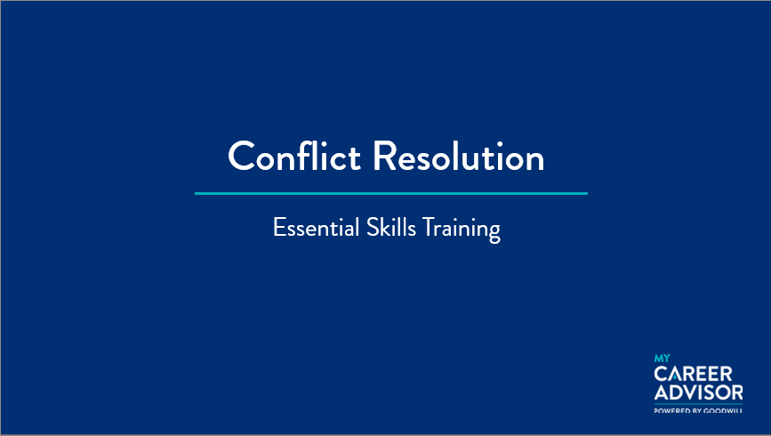

***Slide 1: Title Slide***

***Estimated duration: 1 min***

***Notes to Instructor:***

***Notes:***

**SAY:** The objectives for this course include:

* Define conflict resolution
* Explain what conflict resolution looks like in the workplace
* Describe why it’s important to resolve conflict
* Recognize conflict resolution techniques

Let’s move forward and talk about the course topics.

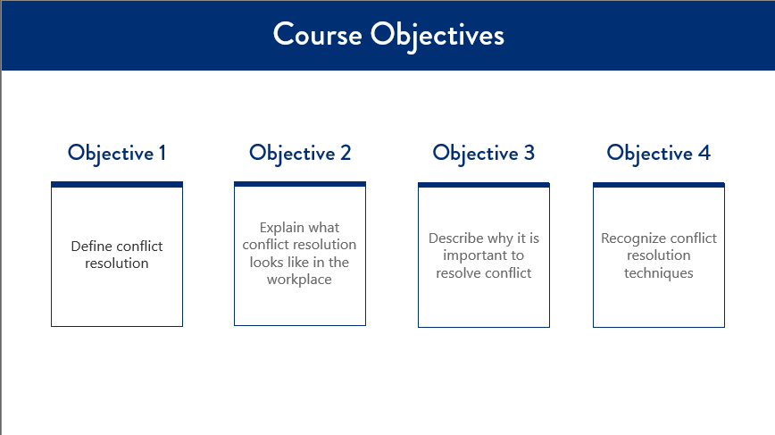

***Slide 2: Course Objectives***

***Estimated duration: 1 min***

***Notes to Instructor:***

***Notes:***

**SAY:** This course will cover the following topics:

* What is Conflict Resolution?
* Conflict Resolution in the Workplace
* Why it’s Important to Resolve Conflict
* Conflict Resolution Technique

Let’s begin by defining what is conflict resolution

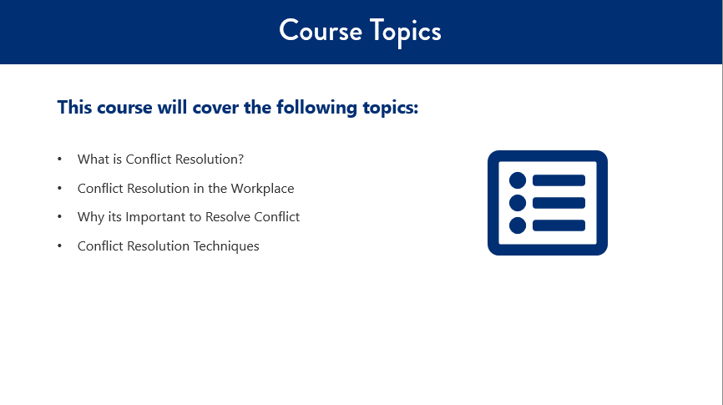

***Slide 3: Course Topics***

***Estimated duration: 1 min***

***Notes to Instructor:***

***Notes:***

**SAY:** Conflict, arguments, and change happens every day in our lives, as well as in the lives of colleagues and within our organization. Conflict resolution is a way for two or more parties to find solutions to a disagreement they may be experiencing. **The disagreement may be personal, financial, political, or emotional.** When a dispute arises, often the best course of action is to resolve the disagreement.

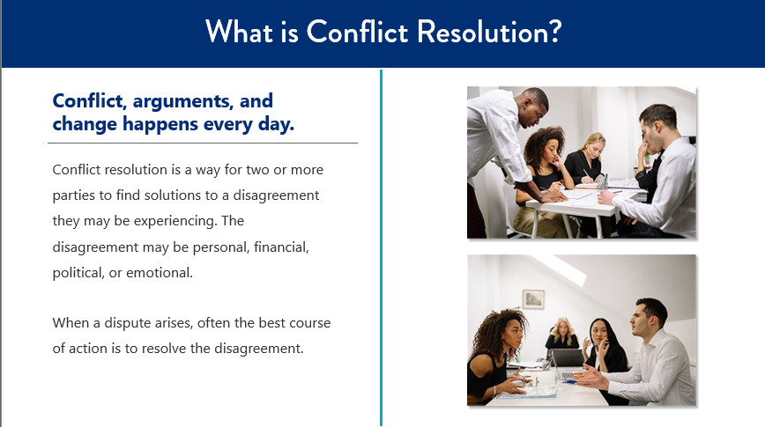

***Slide 4: What is Conflict Resolution?***

***Estimated duration: 1 min***

***Notes to Instructor:***

***Notes:***

**SAY:** The goals of working through conflict are:

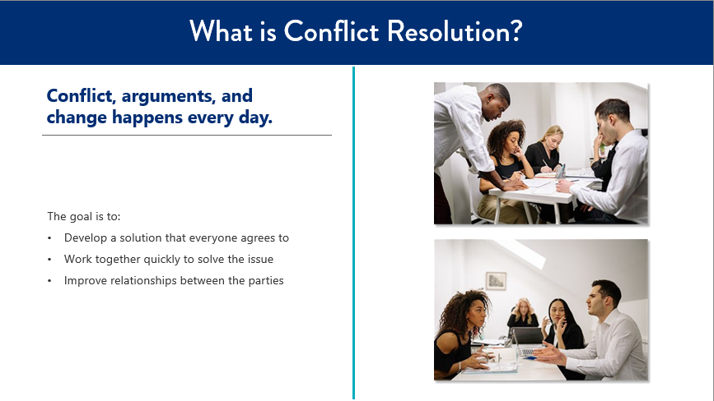

***Slide 5: What is Conflict Resolution?***

***Estimated duration: 1 min***

***Notes to Instructor:***

***Notes:***

• To develop a solution that everyone agrees to

• Work together quickly to solve the issue

• To improve the relationships between the parties experiencing conflict

**SAY:** Conflict resolution support all parties involved. Often, each side will find that by participating in finding the solution rather than just walking away, they are more satisfied. It can also be a way for a group to get resources that might otherwise be out of reach.

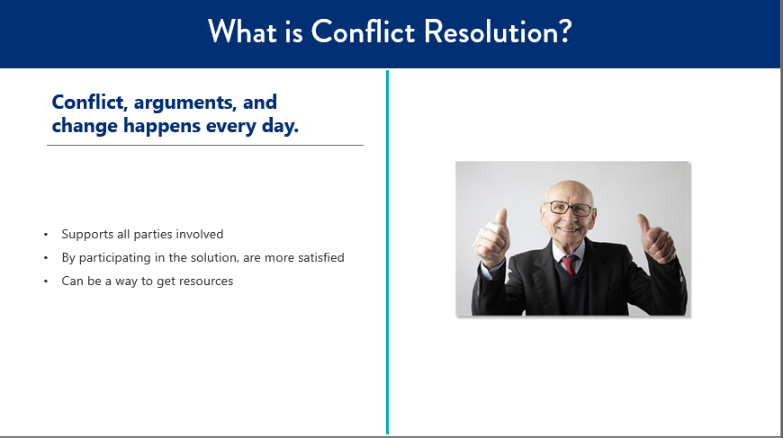

***Slide 6: What is Conflict Resolution?***

***Estimated duration: 1 min***

***Notes to Instructor:***

***Notes:***

**SAY:** Developing effective conflict resolution skill sets are an essential component of any organization. Unresolved conflict often results in loss of productivity, the stifling of creativity, and the creation of barriers to cooperation and collaboration.

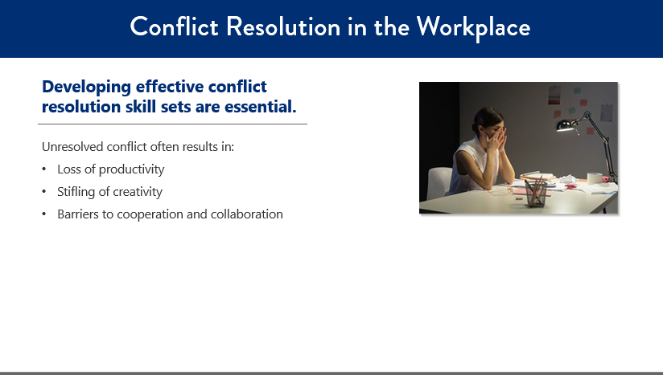

***Slide 7: Conflict Resolution in the Workplace***

***Estimated duration: 1 min***

***Notes to Instructor:***

***Notes:***

**SAY:** Conflict is a normal part of any social and organizational setting. The challenge of conflict lies in how you deal with it. If concealed, avoided or ignored, conflict will likely get worse and grow into resentment, create withdrawal or cause division within an organization.

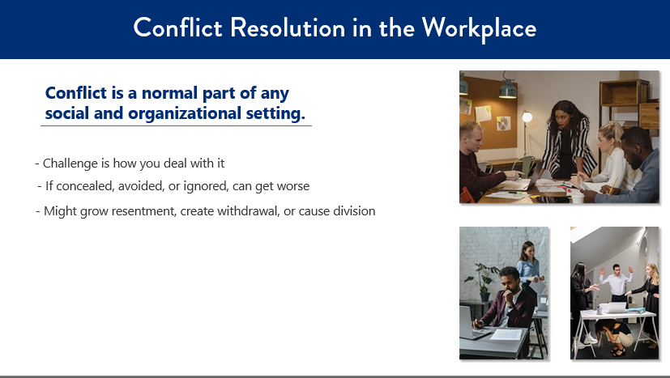

***Slide 8: Conflict Resolution in the Workplace***

***Estimated duration: 1 min***

***Notes to Instructor:***

***Notes:***

**ASK:** So, what creates conflict in the workplace?

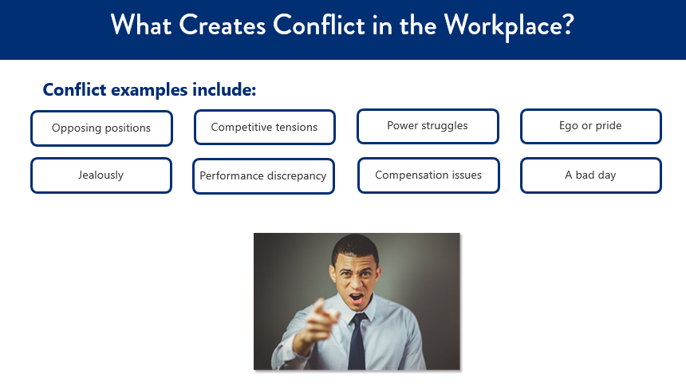

***Slide 9: What creates conflict in the workplace?***

***Estimated duration: 1 min***

***Notes to Instructor:***

***Notes:***

**Discussion:** Ask job seekers if they’ve had conflict in the workplace AND, if they have, was it ever resolved? After their stories, you can refer back to them if they line up with one of the following causes.

**Click: There are 8 clicks to reveal the following:**

* Opposing positions
* Competitive tensions
* Power struggles
* Ego or pride
* Jealousy
* Performance discrepancy
* Compensation issues
* A bad day

**SAY:** While the answer to this question gives the impression that just about anything and everything creates conflict, ***the reality is that the root of most conflict either begins because of poor communication or the inability to control one’s emotions. Let’s examine these two major causes of conflict. (PG)***

**SAY: Communication** – If you reflect back on conflicts you’ve encountered over the years, you’ll quickly recognize many of them resulted from a lack of information, poor information, no information, or misinformation. Let’s assume for a moment that you were lucky enough to have received good information but didn’t know what to do with it – that is still a communication problem, which in turn can lead to conflict. ***Clear, concise, accurate, and timely communication of information can help ease both the number and severity of conflicts***.

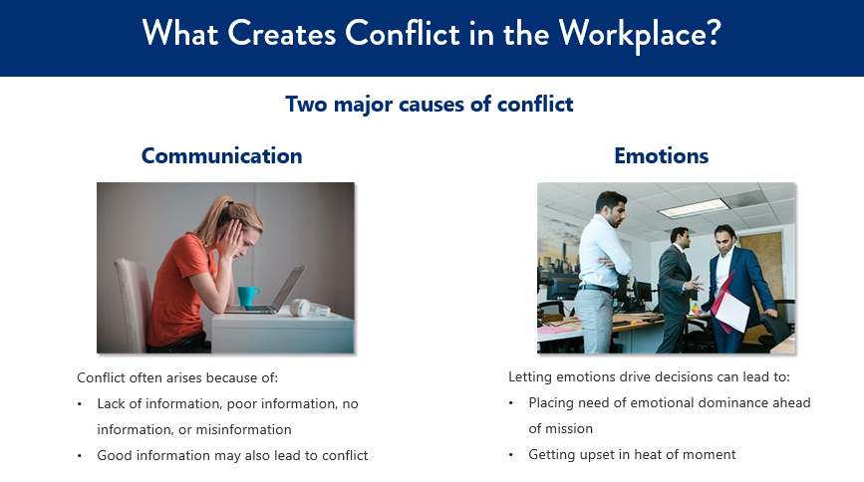

***Slide 10: What creates conflict in the workplace?***

***Estimated duration: 1 min***

***Notes to Instructor:***

***Notes:***

**CLICK**

**Emotions** – Another common mistake in workplace communications, which leads to conflict, is letting emotions drive decisions. One example is when an otherwise savvy executive places the need for emotional dominance ahead of achieving their mission. In this situation, the executive may not even realize this is happening. Another example is when an employee throws a fit and gets very upset in the heat of the moment. In this situation, the employee was losing themselves in their emotions rather than protecting their future.

**ASK:** What can help reduce the amount of conflict?

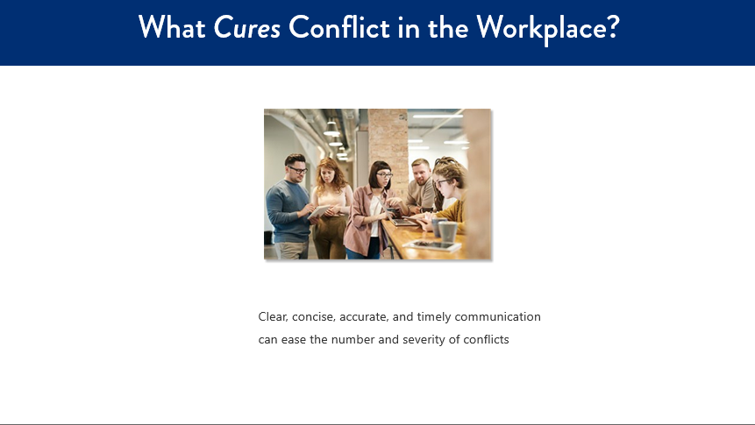

***Slide 11: What cures conflict in the workplace.***

***Estimated duration: 1 min***

***Notes to Instructor:***

***Notes:***

**SAY:** Clear, concise, accurate, and timely communication can ease the number and severity of conflicts

**SAY:** The main goal of practicing conflict resolution is to come to an agreement that everyone involved can agree upon.

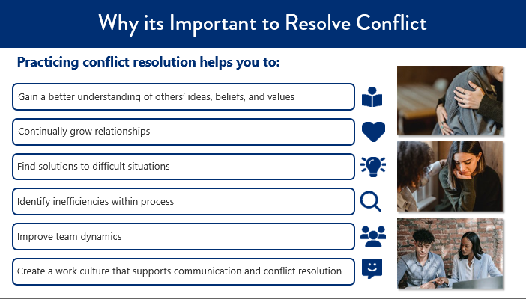

***Slide 12: Why is it important to Resolve Conflict?***

***Estimated duration: 5 min***

***Notes to Instructor:***

***Notes:***

Practicing conflict resolution helps you to:

**CLICK**

•**Gain a better understanding of others’ ideas, beliefs, and values.**

In order to resolve a conflict, you'll need to look at the conflict from your opponent's point of view and learn more about this person or group's perspective and motivation.

**CLICK**

**Continually grow relationships.**

If you make peace with your opponents, you increase allies in your circle. Successful conflict resolution builds a pathway for stronger relationships.

**CLICK**

**Find solutions to difficult situations.**

Conflicts waste resources such as time, energy, good reputation, and motivation. By resolving conflict, you avoid wasting valuable resources and open the opportunity to gain new allies and resources.

**CLICK**

**Identify inefficiencies within process.**

This can lead to increased productivity and streamlined projects and timelines.

**Continued on next page**

**CLICK**

**Improve team dynamics.**

By improving how individuals within a team communicate with one another, you are avoiding additional conflict and the potential of a toxic work environment.

**CLICK**

**Create a work culture that supports communication and conflict resolution.**

Not only should this be a priority, it is also in the best interest for organizations, employees, and customers.

Conflict resolution can only be successful when there is a sincere desire to do so. Turning the other cheek, compromise, forgiveness, compassion, empathy, finding common ground, being an active listener, service above self, and numerous other approaches are ways each of us can build rapport and resolve conflict.

**SAY:** Conflict resolution in only successful when there is a sincere desire to do so.

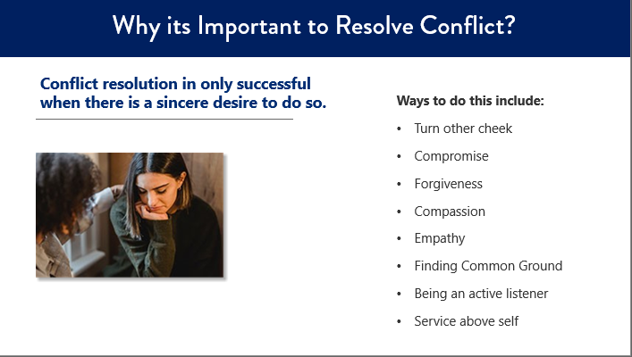

***Slide 13: Why it’s important to Resolve Conflict?***

***Estimated duration: 1 min***

***Notes to Instructor:***

***Notes:***

Turning the other cheek, compromise, forgiveness, compassion, empathy, finding common ground, being an active listener, service above self and numerous other approaches are ways each of us can build rapport and resolve conflicts.

**SAY:** Conflict resolution can help with any disagreement you may experience. Our daily lives offer plenty of opportunities for negotiation between family, colleagues, and friends. As a result, you probably already have a variety of effective strategies for resolving minor conflicts. But for more serious conflicts, and conflicts between groups rather than individuals, you may need some additional skills.

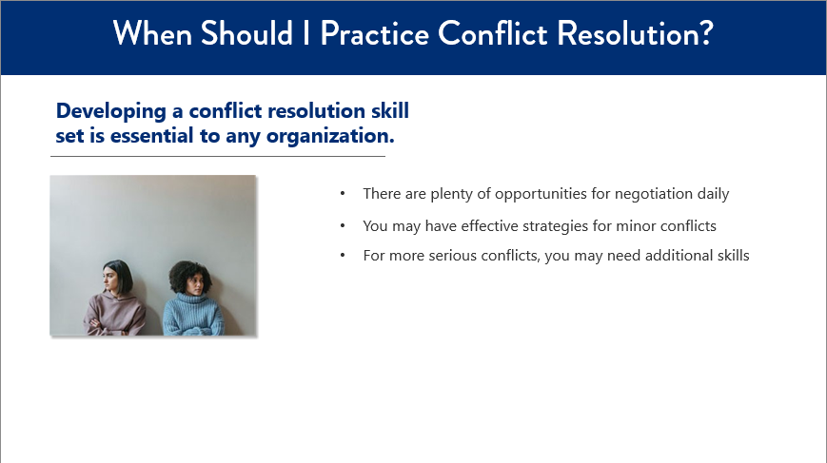

***Slide 14: When should I practice Conflict Resolution?***

***Estimated duration: 1 min***

***Notes to Instructor:***

***Notes:***

**ASK:** How, for example, should you structure a meeting between your group and your opponent? When should you settle, and when should you fight for more? How should you react if your opponent attacks you personally?

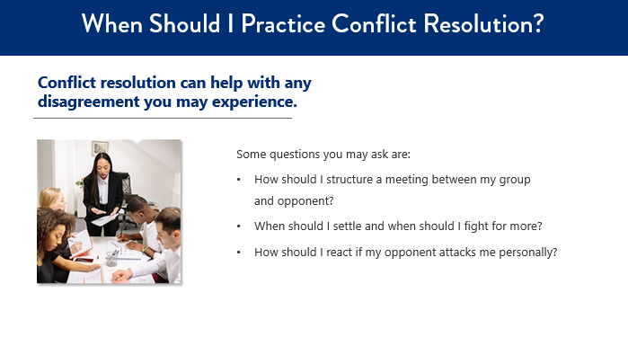

***Slide 15: When should I practice Conflict Resolution?***

***Estimated duration: 1 min***

***Notes to Instructor:***

***Notes:***

**SAY:** Developing a conflict resolution skill set is essential to any organization.

Some questions you may ask are:

* How should I structure a meeting between my group and opponent?
* When should I settle and when should I fight for more?
* How should I react if my opponent attacks me personally?

Let’s talk about conflict resolution techniques next.

**SAY:** Developing a conflict resolution skill set is essential to any organization.

Some questions you may ask are: How should I structure a meeting between my group and opponent? When should I settle and when should I fight for more? How should I react if my opponent attacks me personally?

**SAY:** Here is a technique that can help you work through any conflict that may arise. Its called CALM. Let’s walk through this in more detail.

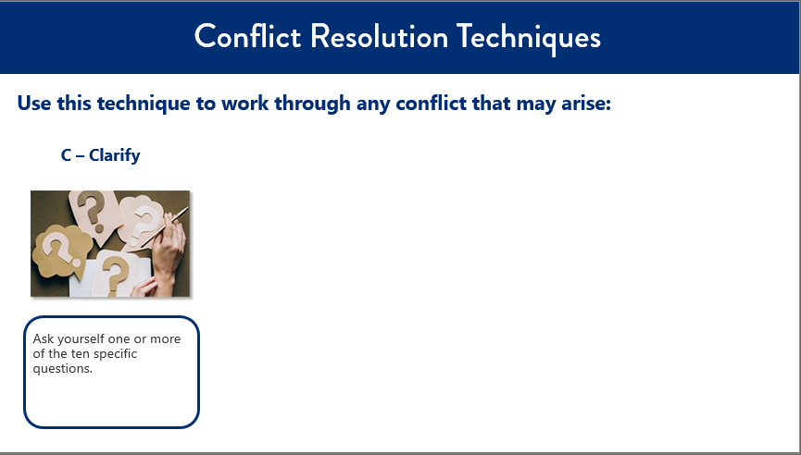

***Slide16: Conflict Resolution Techniques***

***Estimated duration: 1 min***

***Notes to Instructor:***

***Notes:’***

**C** stands for **Clarify**. When encountering conflict, you can clarify the issue by asking yourself one or more of the following ten questions:

**CLICK**

What exactly am I upset about and what specifically happened to upset me?

**CLICK** 2

What emotions am I feeling and why do I feel this way?

**CLICK**

What did I do to contribute to the problem?

**CLICK**

Is my reaction warranted or am I overreacting?

**CLICK**

What would a successful outcome to this conflict look like?

**CLICK**

How would I want to be approached if I was the other party?

**CLICK**

Is it possible that the other person had good intentions that I did not notice?

**CLICK**

Does this happen frequently, or is this the first time?

**CLICK**

How does this conflict impact my work?

**CLICK**

What can I do to increase the chances of a successful resolution?

**SAY: A** stands for **Address the problem**. Think about how you will approach the other person and take note of the issue at hand so that you can describe what happened, how you feel, and the negative effects of the disagreement in the workplace.

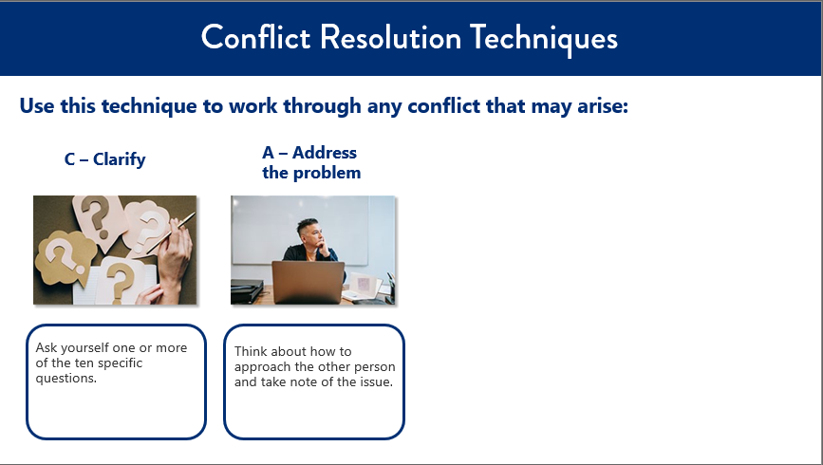

***Slide 17: Conflict Resolution Techniques***

***Estimated duration: 1 min***

***Notes to Instructor:***

***Notes:***

**SAY: L** stands for **Listen to the other side**. Use active listening and be an empathetic listener by acknowledging the speaker’s concerns and recognizing his or her point of view.

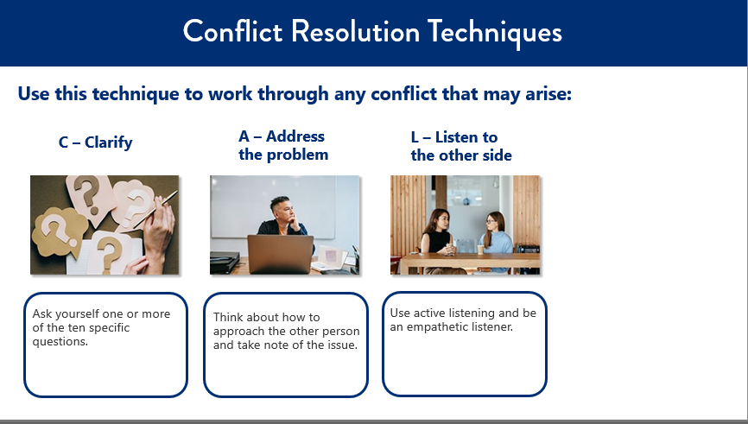

***Slide18: Conflict Resolution Techniques***

***Estimated duration: 1 min***

***Notes to Instructor:***

***Notes:***

**SAY: M** stands for **Manage your way to resolution**. Reach an agreement that a problem does exist, and then work to come up with a solution that will be best for both sides. End your conversation on a positive note.

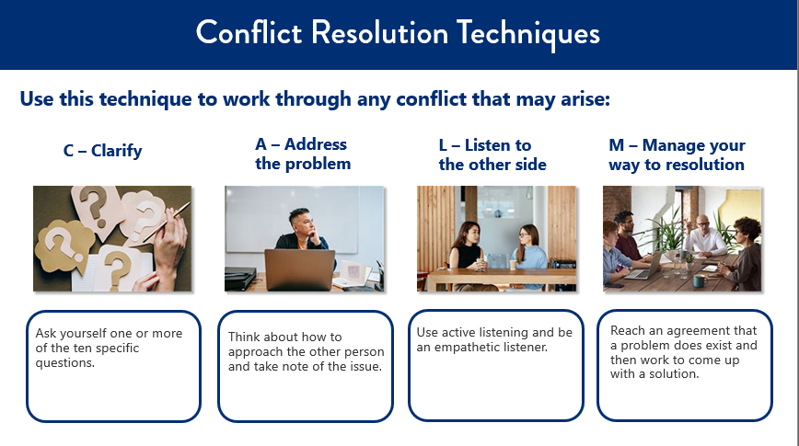

***Slide19: Conflict Resolution Techniques***

***Estimated duration: 1 min***

***Notes to Instructor:***

DISCUSS: You can refer back to the conversation had on slide 9 and have the students see how CALM may have changed the outcome if it had been used.

***Notes:***

**SAY:** Let’s take some time to practice what we learned in this course.

In your Participant Guide, select which part of the CALM technique is being described in each part of the scenario. These are just some examples of the process. Remember to follow all the steps when practicing conflict resolution.

**DISCUSS:** Review their answers as a group and create a conversation as appropriate.

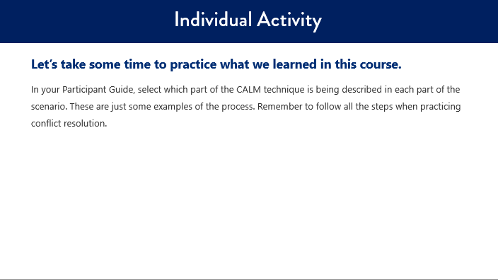

***Slide 20: Activity***

***Estimated duration: 1 min***

***Notes to Instructor:***

***Notes:***

**SAY:** In your Participant Guide there is a Knowledge Check with 5 questions. Please answer those individually, then we’ll review as a group.

**DISCUSS:** When they are complete, as a group discuss the answers.

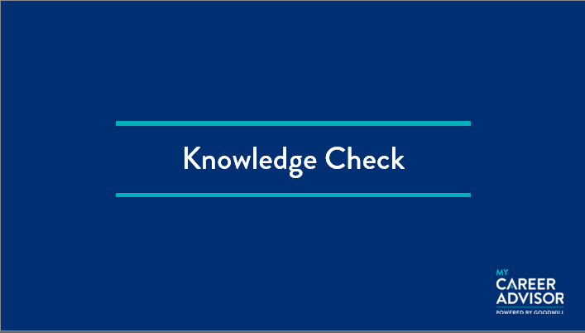

***Slide 21: Knowledge check***

***Estimated duration: 1 min***

***Notes to Instructor:***

***Notes:***

Goodwill also offers additional resources.

Career Coaches can assist you with the following services:

* Creating a job resume
* Job preparation and job training
* Job search strategies (including leads and searching)
* Mock interviews
* Career path development
* Job readiness workshops
* Basic computer skills
* Virtual services

Physical career centers also have the following technology available:

* Computers
* Phones
* Fax machines
* Printers

Career Coaches can also help you use and navigate the www.mycareeradvisor.com website, as well as provide information about job openings, hiring events, and training.

www.mycareeradvisor.com has:

* Resume building
* Career exploration
* Online professional presence

For more information, please call 1-888-355-1444.

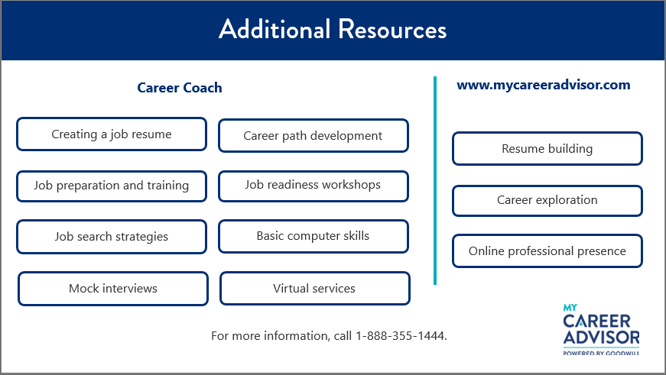

***Slide 21: Resources***

***Estimated duration: 1 min***

***Notes to Instructor:***

***Notes:***

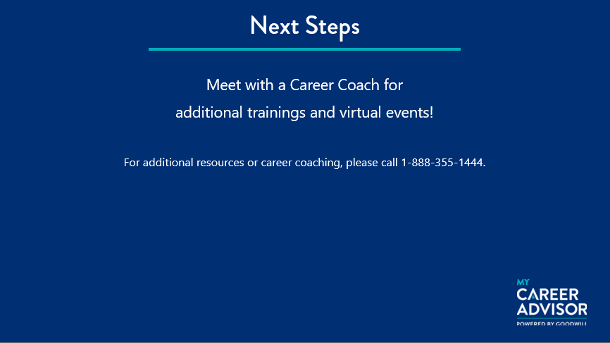

***Slide 22 : Next Steps***

***Estimated duration: 1 min***

***Notes to Instructor:***

***Notes:***

If you would like to receive additional information on other courses or career services that we offer, please meet with a Career Coach. For additional resources or career coaching, please call 1-888-355-1444.

**KNOWLEDGE CHECK**

* Correct answer/s are in bold

1. **What is the definition of conflict resolution?**
2. A way for you to find solutions to a disagreement you may be experiencing. The disagreement may be personal, financial, political, or emotional.
3. A way for two or more parties to find solutions to a disagreement they may be experiencing. The disagreement may be financial, political, or emotional.
4. A way for two or more parties to find solutions to a disagreement they may be experiencing. The disagreement may be personal, political, or emotional.
5. **A way for two or more parties to find solutions to a disagreement they may be experiencing. The disagreement may be personal, political, or emotional.**
6. **Unresolved conflict often results in ____________. Select all that apply.**
   1. **Creation of barriers to cooperation and collaboration**
   2. Increased productivity
   3. **Loss of productivity**
   4. **Stifling of creativity**
   5. Promoting creativity
7. **The two major sources of conflict in the workplace are:** 
   1. Finances and emotions
   2. Relationships and emotions
   3. **Communication and emotions**
   4. Communication and team dynamics
8. **Practicing conflict resolution helps you to: Select all that apply.** (all apply)
   1. **Create a work culture that supports communication and conflict resolution**
   2. **Identify inefficiencies within processes**
   3. **Gain a better understanding of others' ideas, beliefs, and values**
   4. **Continually grow relationships**
   5. **Find solutions to difficult situations**
   6. **Improve team dynamics**
9. **True or false. Conflict resolution can be successful as long as you try.**
   1. True
   2. **False**