**Mission Services**

**Essential Skills:**

**Business Communication**

**Participant Guide**





Welcome to Mission Service's Essential Skills Training. This course will focus on the topic: Email and Business Communication. Remember that the Essential Skills Training will encompass numerous courses developed specifically to help you build your soft skills within the workplace.

Topics to be covered include; the fundamentals of email and business communication. Learners will cover topics such as business communication etiquette, why it's essential, and how to upskill in this area.  At this course's conclusion, learners will better understand email and business communication best practices and how to leverage this skill in their everyday interactions.

Before you get started, make sure you have the following items to ensure the successful completion of this course:

* Something to write with – pen or pencil
* Your participant guide- This can be accessed via the L&D Learning Portal
* A quiet place to complete your training that is free from any distractions
* And a headset, if needed

Slide Deck



_____________________________________________________________________________________________________________________________________________________________________________________________________________________________________________________________________________________________________________________________________________________________________________________________________________________________________________________________________________________________________________________________________________________________________________________________________________________________________________________________________________________________________________________________________________________________________________________________________________________________________________________________________________________________________________________________________________________________________________________________________________________

­­­­­­­­­­­­­­­­­­­­­­­­­­­­­­

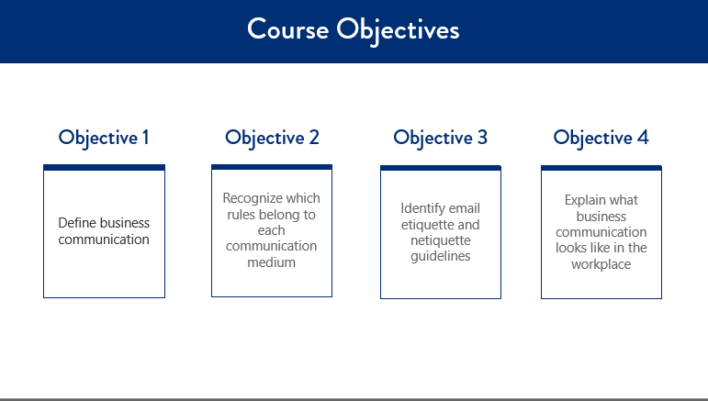

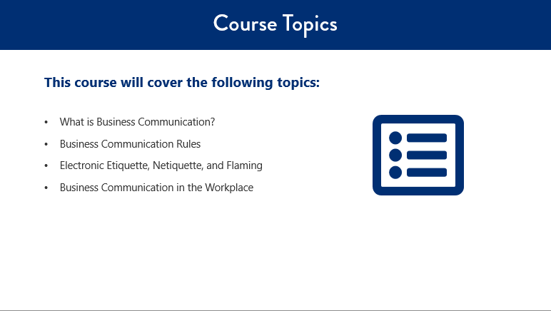

What is Business Communication?

Business Communication is defined as:

**_______________________________________________________________________________________________________________________________________________________________________________________________________________________________________________________________________________________**

Business Communication allows for the following (fill in the blank when appropriate):

* The __________________ of information
* Organizational ___________________
* Promotion of ___________________ products and services
* The exchange of ___________ and ______________________ transfer with colleagues

Other notes:

**_______________________________________________________________________________________________________________________________________________________________________________________________________________________________________________________________________________________**

These new ways of communicating allow people, organizations, and cross-functional teams to communicate efficiently and access what they need.

Business Etiquette Concerns in Methods of Communication

**__________________________________________________________________________________________________________________________________________________________________________________________**

**__________________________________________________________________________________________________________________________________________________________________________________________**

**__________________________________________________________________________________________________________________________________________________________________________________________**

**__________________________________________________________________________________________________________________________________________________________________________________________**

**__________________________________________________________________________________________________________________________________________________________________________________________**

**__________________________________________________________________________________________________________________________________________________________________________________________**

Flaming is when a critical message is sent via email, usually in a quick response to another message that causes an emotional reaction.

Things that flame:

* **______________________________________________________________________________________**
* **______________________________________________________________________________________**
* **______________________________________________________________________________________**
* **______________________________________________________________________________________**
* **______________________________________________________________________________________**
* **______________________________________________________________________________________**
* **______________________________________________________________________________________**

How to prevent a flaming incident:

* **______________________________________________________________________________________**
* **______________________________________________________________________________________**
* **______________________________________________________________________________________**

When sending an email or other electronic communication, be aware of the following netiquette errors:

* **______________________________________________________________________________________**
* **______________________________________________________________________________________**
* **______________________________________________________________________________________**
* **______________________________________________________________________________________**
* **______________________________________________________________________________________**

The culture often extends to the etiquette rules of the business.

Communication Guidelines in the Workplace:

* **______________________________________________________________________________________**
* **______________________________________________________________________________________**

* **______________________________________________________________________________________**
* **______________________________________________________________________________________**

* **______________________________________________________________________________________**
* **______________________________________________________________________________________**

Other notes:

**_______________________________________________________________________________________________________________________________________________________________________________________________________________________________________________________________________________________**

Individual Activity:

**Directions**: Identify the etiquette errors in the email example below by circling the INCORRECT answers below.

We'll review this together when you are finished.

**Example 1:**

Circle all of the "errors" in the email:

* Non-professional email address(es)
* Emojis
* ALL CAPS
* Grammar, spelling, and punctuation
* Use of slang or abbreviations
* Forwarding chain emails/replying all

**Directions**: Identify the etiquette errors in the email example below by circling the INCORRECT answers below.

We'll review this together when you are finished.

**Example 2:**

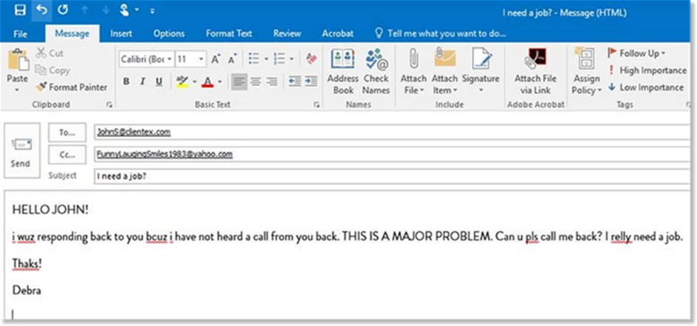

Circle all of the "errors" in the email:

* Non-professional email address(es)
* Emojis
* ALL CAPS
* Grammar, spelling, and punctuation
* Use of slang or abbreviations
* Forwarding chain emails/replying all

**Directions**: Identify the etiquette errors in the email example below by circling the INCORRECT answers below.

We'll review this together when you are finished.

**Example 3:**

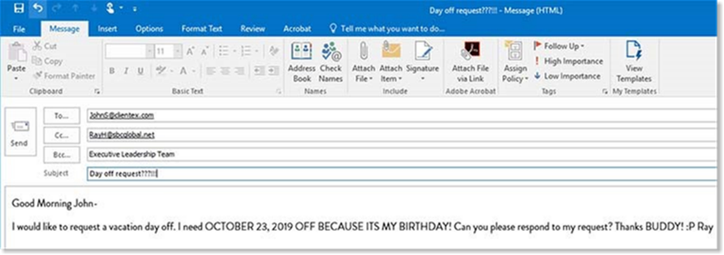

Circle all of the "errors" in the email:

* Non-professional email address(es)
* Emojis
* ALL CAPS
* Grammar, spelling, and punctuation
* Use of slang or abbreviations
* Forwarding chain emails/replying all

KNOWLEDGE CHECK

**Directions:** Circle the letter(s) that corresponds to the correct answer(s).

1. **What is the definition of business communication?**
   1. Business communication is exchanging information in order to promote an organization's goals and intentions.
   2. Business communication is exchanging information in order to promote an organization's goals, objectives, intentions, and activities, as well as increase employee engagement.
   3. Business communication is switching information in order to help an organization's goals, objectives, and activities, as well as increase employee engagement.
   4. Business communication is exchanging information in order to promote an organization's objectives and activities, as well as increase profits within a company.
2. **Through the process of business communication, we achieve _____________: Select all that apply.**
   1. Sharing of information
   2. Employee and management success
   3. Promotion of organization products and services
   4. Organizational success
   5. Exchange of ideas and knowledge transfer with colleagues
3. **What are some ways to prevent being part of a flaming incident. Select all that apply.**
   1. Read the message and then respond right away
   2. Reread the message to see if the person intended the message to be interpreted differently
   3. Use other communication methods if possible
   4. Step away from the computer and give yourself time to calm down
   5. Use emojis, slang, and abbreviations
4. **When sending an email or other electronic communication, be aware of _____________: Select all that apply.**
   1. Emoji's, slang, or abbreviations
   2. Spelling, grammar, and punctuation
   3. ALL CAPS
   4. Tone
   5. Reply All
5. **True or false. The organization's culture often extends to the communication etiquette rules of the business.**
   1. True
   2. False
6. **Why is effective communication in the workplace important? Select all that apply.**
   1. Be professional while maintaining a personable demeanor.
   2. Remember the power of face-to-face communication when appropriate.
   3. Use the correct form of communication.

__________________________________________________________________________________________________________________________________________________________________________________________________________________________________________________________________________________________________________________________________________________________________________________________________________________________________________________________________________________________________________________________________________________________________________________________________________________________________________________________________________________________________________________________________________________________________________________________________________________________________________________________________________________________________________________________________________________________________________________________________________________________________________________________________

­­­­­­­­­­­­­­­­­­­­­­­­­­­­­­



