**Mission Services**

**Essential Skills:**

**Active Listening**

**Participant Guide**





Welcome to Mission Service’s Essential Skills Training. This course will focus on the topic: Active Listening. Remember that the Essential Skills Training will encompass numerous courses developed specifically to help you build your soft skills within the workplace.

Topics to be covered include; what is active listening, how to become an active listener, and identifying active listening in the workplace. After this course, learners will better understand Active Listening best practices and how to leverage this skill in their everyday interactions.

Before you get started, make sure you have the following items to ensure the successful completion of this course:

* Something to write with – pen or pencil
* Your participant guide- This can be access via the L&D Learning Portal
* A quiet place to complete your training that is free from any distractions
* And, a headset, if needed

Slide Deck

__________________________________________________________________________________________________________________________________________________________________________________________________________________________________________________________________________________________________________________________________________________________________________________________________________________________________________________________________________________________________________________________________________________________________________________________________________________________________________________________________________________________________________________________________________________________________________________________________________________________________________________________________________________________________________________________________________________________________________________________________________________________________________________________________

­­­­­­­­­­­­­­­­­­­­­­­­­­­­­­

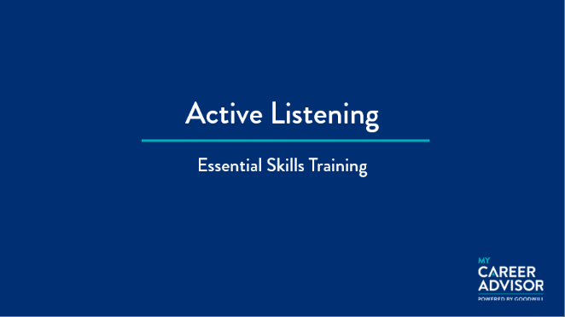

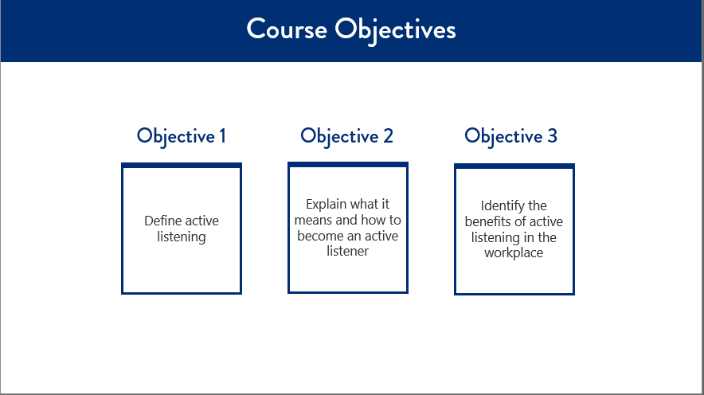

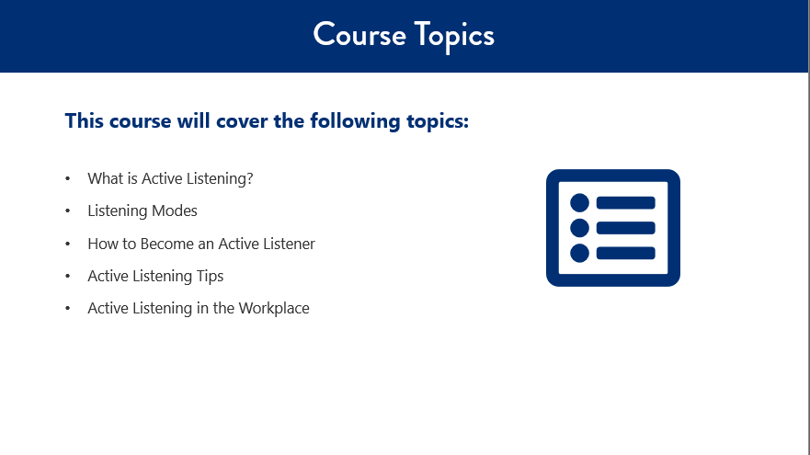

What is Active Listening?

Active listening is critical to effective communication.

Active listening is:

______________________________________________________________________________________

____________________________________________________________________________________________________________________________________________________________________________

Passive listening is:

______________________________________________________________________________________

____________________________________________________________________________________________________________________________________________________________________________

When we are having conversations, what do we listen for?

1. ____________________________________________________________________________________________________________________________________________________________________________
2. ____________________________________________________________________________________________________________________________________________________________________________
3. ____________________________________________________________________________________________________________________________________________________________________________
4. ____________________________________________________________________________________________________________________________________________________________________________

Three Listening Modes:

______________________________________________________________________________

______________________________________________________________________________

______________________________________________________________________________



______________________________________________________________________________

______________________________________________________________________________

______________________________________________________________________________

______________________________________________________________________________

______________________________________________________________________________

______________________________________________________________________________

Which Listening Mode is considered the most important listening technique?

______________________________________________________________________________

Why?

____________________________________________________________________________________________________________________________________________________________________________

Mix and Match Activity

* Resist urge to fill moments
* Respecting quiet moments can be powerful
* If silence is difficult, ask open-ended questions
* Do not underestimate silence
* Start with sentence such as, “So are you saying” or repeat in own words what you heard
* Ask speaker questions
* Creates sense of closeness
* Builds trust and friendships
* Refuse impulse to tell your story on topic
* Ask open-ended questions to deepen conversation and uncover hidden reasoning
* Show respect in your responses
* Look at person you are with
* Nod your head or raise your eyebrows
* Make sounds to indicate attentiveness
* Devote attention to speaker
* Be present
* Observe speaker while they share story
* Be aware of subtle changes
* Observe own thoughts from a distance
* Be mindful
* No need to agree, disagree, or evaluate
* Offer active presence
* Receive message without need to judge or respond

**Put the letter of item below next to the appropriate box of descriptors on the right.**

1.  Focus on the speaker

1.  Use non-verbal cues
2.  Paraphrase

1.  Be comfortable with silence
2.  Ask Questions
3.  Practice a judgement free zone

Active Listening in the Workplace

Being an active listener at work helps you:

______________________________________________________________________________________________________

______________________________________________________________________________________________________

______________________________________________________________________________________________________

______________________________________________________________________________________________________

______________________________________________________________________________________________________

______________________________________________________________________________________________________

______________________________________________________________________________________________________

______________________________________________________________________________________________________

______________________________________________________________________________________________________

______________________________________________________________________________________________________

______________________________________________________________________________________________________

______________________________________________________________________________________________________

______________________________________________________________________________________________________

Knowledge Check

**Directions:** Circle the letter(s) that corresponds to the correct answer(s).

1. **What is the definition of active listening?**
   1. Active listening is the ability to look at the speaker, understand their message, comprehend the information, and respond thoughtfully.
   2. Active listening is the ability to focus completely on a speaker, understand their message, comprehend the information, and respond thoughtfully.
   3. Active listening is the ability to understand their message, comprehend the information, and respond thoughtfully.
   4. Active listening is the ability to focus completely on a speaker, understand their message, and respond thoughtfully.
2. **When we are having conversations, why is it essential that we listen?**Select all that apply.
   1. To obtain information
   2. To learn
   3. For enjoyment
   4. To plan your comeback strategy
   5. To understand
3. **The three modes of listening are _______.**

Select all that apply.

* 1. Combative listening
  2. Passive listening
  3. Dynamic listening
  4. Active listening
  5. Confrontational listening

1. **What does it mean to practice active listening?**

Select all that apply.

* 1. Form counter arguments while the other person is speaking
  2. Keep yourself from getting bored
  3. Make a conscious effort to hear the words and complete message
  4. Do not worry about focusing on what the other person is saying
  5. Pay attention to the other person
  6. Avoid distractions

1. **What are some ways to become a better active listener?**

Select all that apply.

* 1. Paraphrase
  2. Ask questions
  3. Use verbal cues
  4. Focus on the speaker
  5. Be comfortable with silence
  6. Practice judgment

1. **Being an active listener helps you ____________.**

Select all that apply.

* 1. Build trust
  2. Increase your knowledge and understanding of various topics
  3. Avoid missing critical information
  4. Identify and solve problems
  5. Build connections

__________________________________________________________________________________________________________________________________________________________________________________________________________________________________________________________________________________________________________________________________________________________________________________________________________________________________________________________________________________________________________________________________________________________________________________________________________________________________________________________________________________________________________________________________________________________________________________________________________________________________________________________________________________________________________________________________________________________________________________________________________________________________________________________________

­­­­­­­­­­­­­­­­­­­­­­­­­­­­­­





