**Mission Services Core Skills Training**

**Core Values**

**Instructor Guide**

**Goodwill of Central and Northern Arizona**

**Purpose**

The purpose of this course is to introduce learners to the GCNA/GIMV core values. Topics to be covered include; our mission, vision, five core values and the Trust Pledge. Learners will gain a better understanding of what truly makes our organization great, and how we leverage our core values to meet the needs of our customers and community. At the completion of this course, learners will be prepared to identify the organization’s core values and interpret the unique meaning of each item covered in this learning experience.

**How to Use This Guide**

This instructor guide is designed to help you deliver the Core Values course. Explanations of what to say, what to do, and how to conduct activities, if applicable are provided within this guide; however, you can use the left side of each page to enter your own notes to help you train this workshop.

You will also see PG referenced throughout this material, it stands for Participant Guide. References will only be provided when relevant to the training.

Durations, if provided, are estimates only and may not reflect the final training.

**Materials Needed**

Use the following materials as you train this course**:**

* Core Skills_Core Values PPT
* Core Skills_Core Values Participant Guide

**Say:** Welcome to Mission Service’s Core Skills Training. This course will focus on the topic: Core Values. Keep in mind that the Core Skills Training will encompass numerous courses that are developed specifically to meet your unique needs as a member of the Missions Services team. You will continue to receive updates from your respective leaders once additional courses have been released, and are available for you to complete.

**Explain:** This is a self-paced course designed for you to complete at your own pace. Before you get started, make sure you have the following items to ensure successful completion of this course:

* Something to write with – pen or pencil
* Your participant guide- This can be access via the L&D Learning Portal
* A quiet place to complete your training that is free from any distractions
* And, a headset, if needed

**Say:** I am very excited to walk you through this topic today. Let’s move to the next slide and discuss the course overview.



***Slide 1: Title Slide***

***Estimated duration:***

***Participant Guide Page:***

***Notes:***

**Slide Title: Course Overview**

**Say:** This course will introduce learners to GCNA/GIMV core values. Topics to be covered include; our mission, vision, five core values and the Trust Pledge. Learners will gain a better understanding of what truly makes our organization great, and how we leverage our core values to meet the needs of our customers and community. At the completion of this course, learners will be prepared to identify the organization’s core values and interpret the unique meaning of each item covered in this learning experience.

**Explain:** As we move through this course, I encourage you to write down any questions you may have, that you would like addressed by a member of your leadership team or Learning and Development. There is a note section provided to you within your participant guide, so be sure to write down those questions so that we can provide you with a prompt response.

**Say:** Now that we have a high-level overview of the course and what it entails, let’s talk a little more about the course objectives.

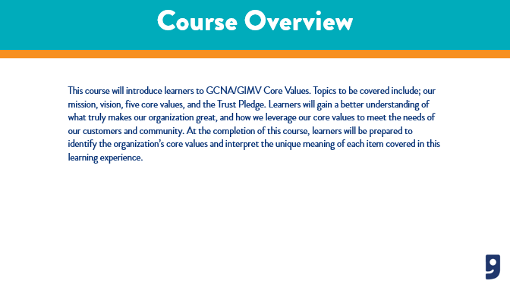

***Slide 2: Course Overview***

***Estimated duration:***

***Participant Guide Page:***

***Notes:***

**Slide Title: Course Objectives**

**Say:** One of the important aspects of a training course are the course objectives. The objectives provide insight into what you will learn from the content presented to you today. For the Core Values course, the objectives we will cover include:

* Examine GCNA/GIMV Mission and Vision
* Identify GCNA/GIMV 5 Core Values
* And, Evaluate the Trust Pledge

**Explain:** This course will provide you the basic foundations of Goodwill's core values and how to leverage them in the workplace and with the people we serve.

**Discuss:** Core Values are an important part of your role as a member of the Mission Services Team. At times, you will be presented with opportunities to flex your knowledge and skillset in identifying our core values and knowing our mission and vision. This will foster an awareness within you to keep our core values at the forefront of everything you do.

**Say:** Next, I would like to review with you the topics we will cover in today’s course.

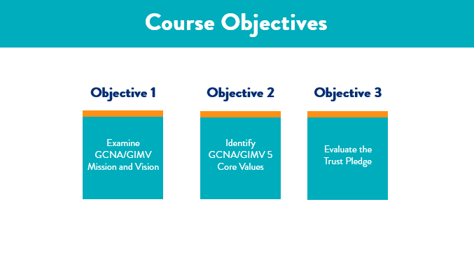

***Slide 3: Course Objectives***

***Estimated duration:***

***Participant Guide Page:***

***Notes:***

**Slide Title: Course Topics**

**Say:** Another important aspect of a training course is the course topics. The course topics give us insight into what we will be learning in the session.

For the Core Values course you are currently taking, the topics we will cover in today’s session include:

* Our Mission
* Our Vision
* Our Core Values
* Trust Pledge
* Knowledge Check
* Next Steps

**Explain:** Next, I want to take a moment to cover some course rules with you before we jump right in to the content we are set to cover today.

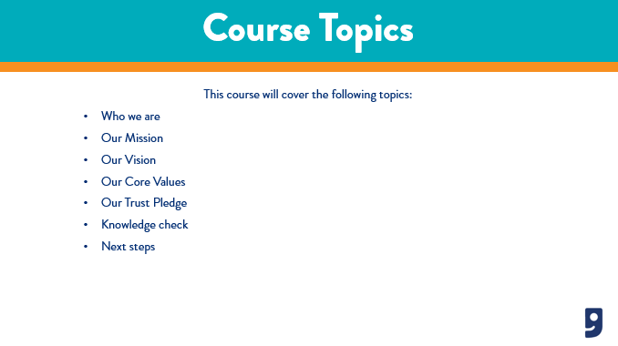

***Slide 4: Course Topics***

***Estimated duration:***

***Participant Guide Page:***

***Notes:***

**Slide Title: Course Rules**

**Say:** The rules for this course will look a little different as you are completing this session in a self-paced modality. Let’s talk a little about the course rules now:

* Make sure you are in a learning environment free from distractions.
* Feel free to pause this course at any time if you need to step away or take a break.
* Write down any questions you have for your leaders and send it to them after the completion of this course.
* Write down any feedback you have for L&D and forward that to your respective leader.

**Say:** Now that we have covered the course rules, let’s jump right in to our first topic which is, Our Mission.

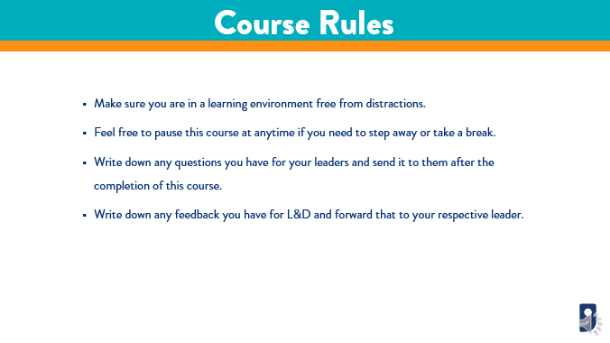

***Slide 5: Course Rules***

***Estimated duration:***

***Participant Guide Page:***

***Notes:***

**Slide Title: Who we are**

**Say:** Before we dive right in to the content I want to cover with you today, I want to take a moment and have you watch a short video. This video talks about who we are, and how we serve our community.

**Discuss:** As you’re watching this video, be sure to listen closely to the stories begin shared, and how our mission and vision touch the lives of those we serve. Think about other ways this might show up, maybe in your professional or personal lives. The key is to understand what Goodwill represents and how we serve others.

**Say:** When you are ready, click play on the video and watch it in its entirety. When you are finished, be sure to return to the training video.

**Say:** Go ahead and watch the video now. We will debrief after you complete the video.

**Say:** Welcome back! I hope you enjoyed the video you just watched. I want to take some time to talk about it.

**Ask:** What are 3 key takeaways you gained from the video? I encourage you to use your participant guide to write these down. Remember, there is not right or wrong answer, I just want to gain a better understanding of your perception and biggest takeaways from the video.

**Say:** Now that we have a better understanding of who we are, let’s talk more about our mission on the next slide.

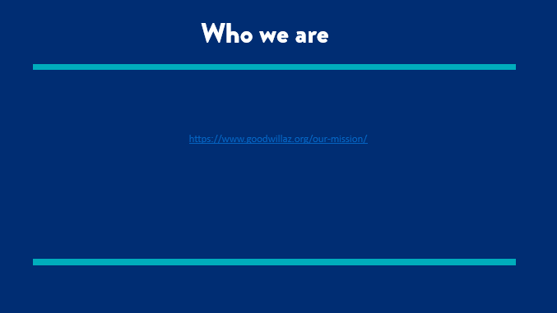

***Slide 6: Who we are***

***Estimated duration:***

***Participant Guide Page:***

***Notes:***

**Slide Title: Our Mission**

**Say:** Let’s talk about our mission. Off the top of your head, can you tell me what our mission is? In your own words, I want you to write down what our mission is in your workbook.

**Say:** Now, let’s go through this in more detail, so we can be certain of our understanding of what our mission is. Goodwill's mission falls into 3 categories. These categories include:

* Empowering Individuals
* Strengthening Families
* Building Stronger Communities

**Say:** Let’s talk a little about each one and discuss examples of how we meet our mission every day.

First, **Empowering Individuals** means that we motivate and educate our customers to improve their unique situations. Customers seek out Goodwill for various reasons, and as an organization we strive to meet the needs of everyone who reaches out to us. So how do we accomplish this? An example of how we accomplish this is by offering support through career services, job training, and upskilling in our career centers.

Next, we focus on Strengthening Families. This means that when we work with customers who are seeking out Goodwill for help, these customers often have families they need to support. When you think about it from a larger scale, we touch the lives of many individuals and their families or even friends and collogues they recommend our services to. We have an innate opportunity to enhance the lives of our customers, which in turn strengthens their families. An example of how we do this by providing valuable work opportunities within Goodwill and other employers in the community. When customers can secure meaningful employment, it paves a road for financial stability and encourages them to build a strong home life for their families.

Lastly, we build **Stronger Communities**. Building stronger communities helps us ensure that the people we serve will have many valuable resources at their fingertips to help them continue to live a meaningful and self-sustaining life. An example of how we accomplish this is by partnering with local hiring employers to build upon our local workforce and offer a pathway to securing a job.

**Say:** Our mission is what derives who we are and what we do as an organization. It is important that as a member of the Goodwill family, you have a thorough understanding of our mission and what it represents.

**Say:** Now that we have taken some time to review our mission, let’s talk about our vision.

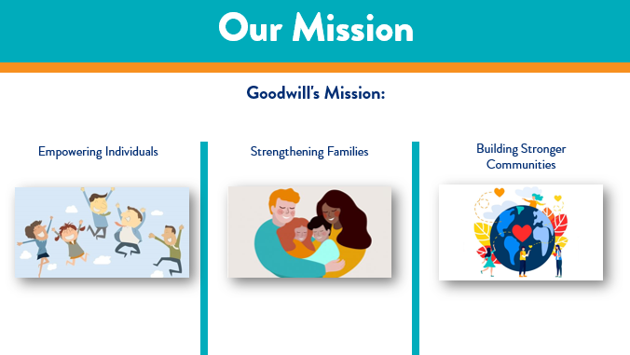

***Slide 7: Our Mission***

***Estimated duration:***

***Participant Guide Page:***

***Notes:***

**Slide Title: Our Vision**

Our vision is Ending Poverty Through the Power of Work.

**Say:** GCNA/GIMV is a 501(c)(3) non-profit organization dedicated to ending poverty through the power of work. Goodwill takes a holistic approach to employment by providing job seekers the tools to feel confident, purpose driven, and successful. Goodwill empowers individuals, strengthens families, and builds stronger communities. Donating or shopping at Goodwill supports our no-cost career services, which are available to anyone looking for a new job, education, or training. Goodwill diverts millions of pounds of material from Arizona landfills, giving them second life through reuse or recycling.

**Explain:** So, you’re probably wondering how we accomplish this? Let’s talk about that a little more in detail now. When you think of Goodwill, you are probably thinking we are just a bunch of stores who sell thrift clothing and goods, but, did you know that we offer so much more? Our organization is a pillar in the community, offering access to affordable necessities that families need and offering career and employment services for our active jobseekers. We offer these services through a variety of modalities, such as:

* **Traditional Career Centers:** We have career center locations throughout Arizona and a self-service center in Maryland.
* **www.Mycareeradvisor.com:** This is an online platform that has a global reach, and provides all of our career services virtually. You can create a resume, cover letter, take training classes, and even search for jobs in your local areas. Additionally, we offer an online chat function in the event you needed some assistance navigating the site.
* **Community Partnerships:** We have a specialized team in Mission that works closely with community partners to bring career services to their organizations. This modality allows us to reach a bigger audience and help even more people secure meaningful and sustain employment.

**Say:** Through this work, we foster the following concepts:

* We offer a hand-up, not a hand-out: When you think of charity, you probably think of food boxes, donation boxes of household items or free toiletries. Goodwill takes this further and offers no-cost career services that will upskill a person and help them secure meaningful employment. It is through that employment they receive a steady income and they are able to provide for themselves and their family.
* We offer a chance, not charity. There is a huge respect that society fosters for charity; however, at Goodwill, we take additional steps to enhance this by giving jobseekers a chance. We do this through learning experiences, certification programs, and career planning. These services give families in the community a chance to better themselves and to become more prepared for the demands of our current workforce.
* It’s not just a donation, it’s making a difference. Most people associate Goodwill as a place you can just drop off your unwanted goods or donations. Which we definitely are, but did you know that .90 cents of every dollar is placed back into our Mission Services? This means that your donations generate the funds we need to help enhance the lives of our jobseekers every day. It is through your valuable donations that we are making a difference in the lives of the people we serve.

**Say:** As you can see, our vision is our guiding force behind the work Goodwill does in our local communities. What’s even more amazing is that you will play a crucial role in working closely with our community members and helping them access the services we offer that will help change their lives. Let’s move onto the next slide where we will talk about our core values.

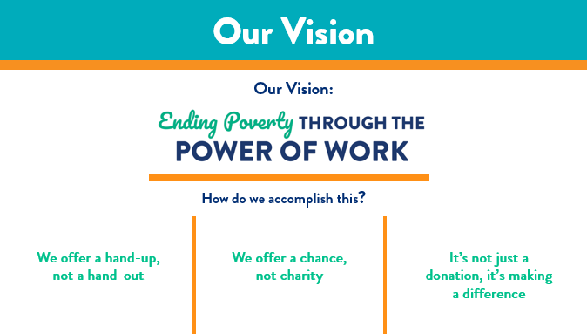

***Slide 8: Our Vision***

***Estimated duration:***

***Participant Guide Page:***

***Notes:***

**Slide Title: Our Core Values**

**Say:** Goodwill’s mission and vision are also guided by its core values. Let’s take some time to discuss the 5 core values that guide who we are and what we do.

* **Trust:** Make relationships as important as results. Do the right thing even when no one is looking. Do what we say we will do. Have the courage to resolve differences. Respect the uniqueness of every individual.
* **Collaboration:** Engage in unfiltered conflict around ideas. Apologize when appropriate. Take care of each other and the business. Achieve greatness as One Goodwill. Partner with our communities to serve our customers.
* **Engagement:** Value attitude and aptitude. Be an ambassador of Goodwill. Go above and beyond. Have fun and celebrate successes. Make life better for those around us.
* **Ownership:** Lead by example. Drive operational excellence. Hold one another accountable. Make Goodwill better every day. Take responsibility to initiate solutions.
* **Innovation:** Encourage continuous learning. Be willing to take risks. Transform from common to exceptional. Promote breakthrough thinking. Embrace change.

**Say:** Now that we have reviewed Goodwill's core values, let’s complete a brief activity to help us reinforce the content we just covered. Please locate the Core Values activity in workbook. Go ahead and pause the video and complete the activity. When you are finished, come back to the video and we will review the activity together.

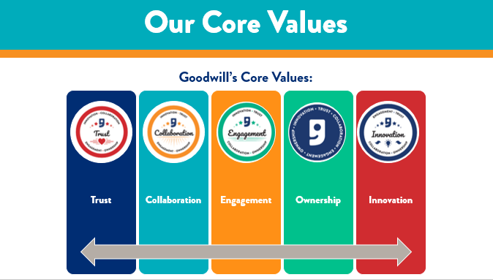

***Slide 9: Our Core Values***

***Estimated duration:***

***Participant Guide Page:***

***Notes:***

**Slide Title: Core Values**

**Say:** Welcome back! How do you think you did on that activity? Well, let’s take some time to review the answers together and see how well you did with learning and identifying Goodwill’s core values. Go ahead and make sure your completed activity is in front of you. Are you ready? Alright, let’s go!

**Discuss:**

**1. Engagement:** Value attitude and aptitude. Be an ambassador of Goodwill. Go above and beyond. Have fun and celebrate successes. Make life better for those around us.

**2. Trust:** Make relationships as important as results. Do the right thing even when no one is looking. Do what we say we will do. Have the courage to resolve differences. Respect the uniqueness of every individual.

**3. Innovation:** Encourage continuous learning. Be willing to take risks. Transform from common to exceptional. Promote breakthrough thinking. Embrace change.

**4. Collaboration:** Engage in unfiltered conflict around ideas. Apologize when appropriate. Take care of each other and the business. Achieve greatness as One Goodwill. Partner with our communities to serve our customers.

**5. Ownership:** Lead by example. Drive operational excellence. Hold one another accountable. Make Goodwill better every day. Take responsibility to initiate solutions.

**Ask:** So how did you do? If you aced this activity then kudos to you! If you didn’t, don’t worry, the whole idea of reviewing the core values with you is to learn about each one and become more familiar with who we are as an organization. Also, I want to challenge you to think of examples or ways each of the core values shows up in your role when you come to work every day. Maybe you experience these same values in your personal life. I want to encourage you to visualize how these show up and the steps you take to implement them into your everyday routines.

Next, let’s take some time to talk about our Trust Pledge.

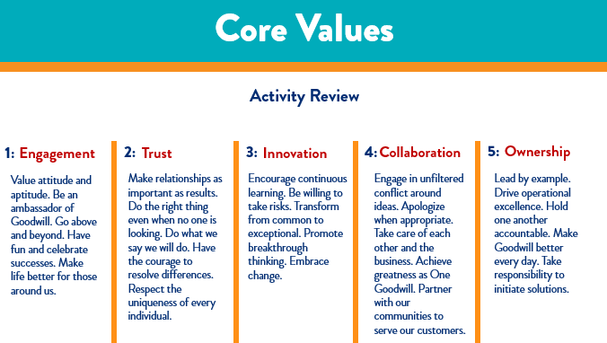

***Slide 10: Core Values***

***Estimated duration:***

***Participant Guide Page:***

***Notes:***

**Slide Title: Our Trust Pledge**

**Say:** Goodwill is guided by what we like to refer to as the Trust Pledge. The Trust Pledge empowers each member of the team to foster a culture of inclusiveness and honor. As we look at the pledge on screen, you see that we position the pledge in two ways.

**Say:** First, we are guided by a pledge that outlines how we agree to conduct ourselves when trust is compromised. Let’s take a moment to review that now.

* Recognize the impact
* Make it my responsibility to talk with others
* Move forward
* Talk about issues
* Apologize
* Renew commitment
* Hold each other accountable
* Agree to next steps

Now, the other part of our trust pledge includes how we build and foster a culture of trust within the organization. When it comes to building and maintaining trust, we are guided by the following:

* Communicate expectations clearly
* Believe in your best interest
* Reach out to you first
* Respect differences
* Get to know you before drawing conclusions
* Have the courage to stop the gossip
* Not contribute to gossip
* Expect you to help me look at myself

**Say:** In order for our team and organization to build a culture of trust, we have to recognize and own that it begins with us. We hold the key to making the decision each day to conduct ourselves by these guidelines. Also, it’s important to remember that if we see a colleague that might be struggling to have those Trust Pledge conversations, that we try to help each other out, or reach out to a leader to bring some awareness to that situation.

**Ask:** Can you think of some instances or examples of when you might need to have a Trust Pledge conversation? *(provide an example)*

Take a moment to write your examples down in your workbook in the space provided. I encourage you to keep you notes and examples in a safe place, that way you always have access to refer back to them.

**Say:** Now that we have covered our organization’s Trust Pledge, let’s move on to the next slide where we will review our knowledge check for this course.

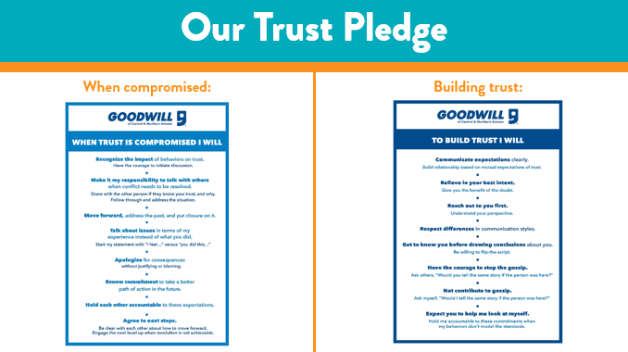

***Slide 11: Our Trust Pledge***

***Estimated duration:***

***Participant Guide Page***

***Notes:***

**Slide Title: Knowledge Check**

**Say:** The next part of this course is to designed to check your understanding of the content that was presented today. In your participant guide, you will find a knowledge check worksheet. Pause this video when I give you the prompt. I want you to take about 10 minutes to review and answer these knowledge check questions. Once you are finished, click Play on the video to finish the session.

**Say:** Remember, when you are finished with the course, provide your leader with your knowledge check worksheet, as this will ensure you are given credit for participating and completing the Core Values course today. If you have any further questions, please be sure to speak with your leader.

**Say:** Alright, go ahead and pause the video now and begin your knowledge check.

**Return:**

**Say:** Welcome back! I hope you enjoyed completing your knowledge check. Let’s move forward and discuss next steps as we wrap up this session.

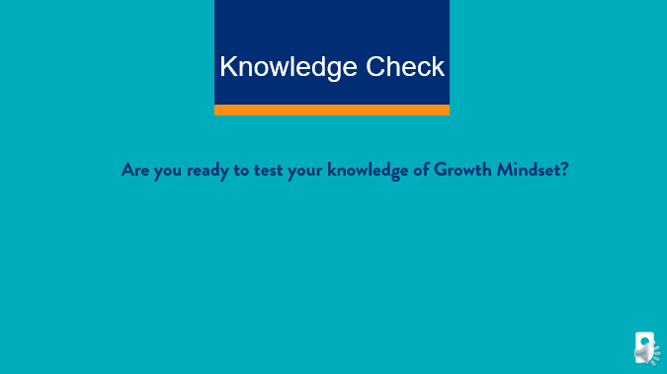

***Slide 12: Knowledge Check***

***Estimated duration:***

***Participant Guide Page:***

***Notes:***

**Slide Title: Next Steps**

**Say:** Some next steps I want to cover include:

* Be sure to pass your feedback and questions to your respective leaders.
* Make sure you pass on your knowledge check activity from this course to your leader as this is what will confirm your completion of this course.
* And lastly, work with your manager to schedule time to complete the other Core Courses that have been released this quarter.

**Say:** It is important to keep your upskilling and training at the forefront of everything you do.

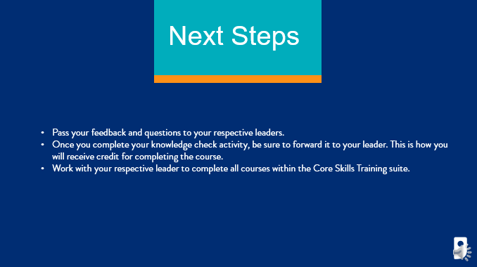

***Slide 13: Next Steps***

***Estimated duration:***

***Participant Guide Page:***

***Notes:***

**Slide Title: Questions**

**Say:** In the beginning of this course, I asked you to write down questions as you moved through the session. If you have any questions written down, or if you have questions that have crossed your mind now, I encourage you to write those down and schedule time with your leader to work through them and get answers.

**Say:** If you have feedback for the Learning and Development team on this training, we encourage you to reach out to LearningandDevelopment@goodwillaz.org. I am always happy to jump in and help when I can. Please be sure to forward your feedback to your leader first, then you can send it to the team.

**Close:** I want to take the opportunity to thank you for completing this course today. As a member of this team, I want to thank you for all the hard work and dedication you provide our jobseekers and community every day. It is because of you, we were able to provide career and employment services to our communities and help strengthen families in the communities we serve. Thank you for all you do! I appreciate your time today and I hope you gained a little more knowledge on an unfamiliar topic. I encourage you to continue to ask questions and take the information you have learned and leverage it with your colleagues and jobseekers. Have a wonderful day!

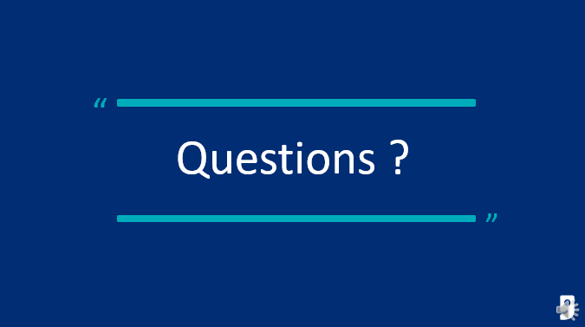

***Slide 14: Questions***

***Estimated duration:***

***Participant Guide Page:***

***Notes:***

**Slide Title: References**

**Say:** In an effort to give credit when credit is due, we have included a reference page to call out the resources used to create this content here for you today.

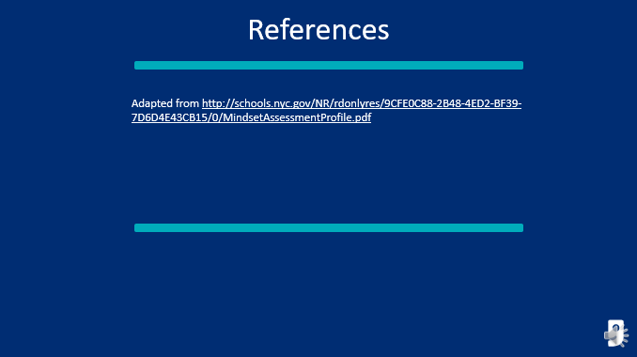

***Slide 15: References***

***Estimated duration:***

***Participant Guide Page:***

***Notes:***

Core Values Matching Activity Answer Key

**Directions:** Read each description and draw a line to the correct core value.

1. Value attitude and aptitude. Be an ambassador of Goodwill. Go above and beyond. Have fun and celebrate successes. Make life better for those around us.

2. Make relationships as important as results. Do the right thing even when no one is looking. Do what we say we will do. Have the courage to resolve differences. Respect the uniqueness of every individual.

3.Encourage continuous learning. Be willing to take risks. Transform from common to exceptional. Promote breakthrough thinking. Embrace change.

4. Engage in unfiltered conflict around ideas. Apologize when appropriate. Take care of each other and the business. Achieve greatness as One Goodwill. Partner with our communities to serve our customers.

5. Lead by example. Drive operational excellence. Hold one another accountable. Make Goodwill better every day. Take responsibility to  
initiate solutions.

|  |  |
| --- | --- |
|  |  |
| Trust | Make relationships as important as results. Do the right thing even when no one is looking. Do what we say we will do. Have the courage to resolve differences. Respect the uniqueness of every individual. |
| Collaboration | Engage in unfiltered conflict around ideas. Apologize when appropriate. Take care of each other and the business. Achieve greatness as One Goodwill. Partner with our communities to serve our customers. |
| Ownership | Lead by example. Drive operational excellence. Hold one another accountable. Make Goodwill better every day. Take responsibility to initiate solutions. |
| Innovation | Encourage continuous learning. Be willing to take risks. Transform from common to exceptional. Promote breakthrough thinking. Embrace change. |
| Engagement | Value attitude and aptitude. Be an ambassador of Goodwill. Go above and beyond. Have fun and celebrate successes. Make life better for those around us. |

Knowledge Check Answer Key

**Question:** *Goodwill’s Mission includes the following: Strengthen Families, Building Stronger Communities and _______________?*

1. Identify Family Needs
2. Empower Individuals
3. Leverage Community Partnerships

**Question:** *Complete our vision statement. ________________ Through the Power of Work.*

1. Empowering Jobseekers
2. Creating Jobs
3. Ending Poverty

**Question:** *Complete the following statements:*

*1. It’s not just a________, it’s making a difference.*

*2. We offer a ________, not a hand-out.*

*3. We offer a _________, not charity.*

1. Chance (3)
2. Hand-up (2)
3. Donation (1)

**Question:** *Select the correct Core Value.* *Encourage continuous learning. Be willing to take risks. Transform from common to exceptional. Promote breakthrough thinking. Embrace change.*

1. Innovation
2. Ownership
3. Trust

**Question:** *Select the correct Core Value. Value attitude and aptitude. Be an ambassador of Goodwill. Go above and beyond. Have fun and celebrate successes. Make life better for those around us.*

1. Engagement
2. Collaboration
3. Ownership

**Question:** *Select the correct Core Value. Engage in unfiltered conflict around ideas. Apologize when appropriate. Take care of each other and the business. Achieve greatness as One Goodwill. Partner with our communities to serve our customers.*

1. Innovation
2. Engagement
3. Collaboration

**Question:** *Identify the missing word in the Trust Pledge. When trust is _____________ I will…*

1. Established
2. Broken
3. Compromised

**Question:** *Identify the missing word in the Trust Pledge. To ________ trust I will…*

1. Grow
2. Build
3. Cultivate

**Question:** *Identify the correct steps within the Building Trust section of the Trust Pledge.*

1. Communicate expectations, Apologize, Respect differences
2. Agree to next steps, Respect differences, Believe in your best intent
3. Respect Difference, Communicate expectations, Believe in your best intent

**Question:** *Scenario 1: You overhear a colleague at work gossiping about another co-worker in your center. This colleague is pointing out some recent absences, and saying that the co-worker who was missing work wasn’t really out sick. What is the best way to handle this?*

1. Mention the Trust Pledge to the co-worker and hold them accountable for the workplace gossip
2. Join in on the gossip
3. Go straight to your manager and report them