Leading Change

Participant Guide

Goodwill of Central and Northern Arizona

Welcome to Leading Change, the next course in your journey as a leader at Goodwill of Central and Northern Arizona.

Learning Objectives

Our goals for today are:

- Differentiate change from transition
- Explore how change and transition affects people
- Identify how to effectively lead through times of change

Attitudes towards change

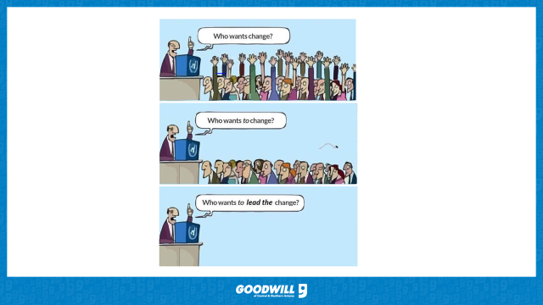
Which change illustration stood out to you and why?
________________________________________________________________________
________________________________________________________________________
________________________________________________________________________
________________________________________________________________________

Overview
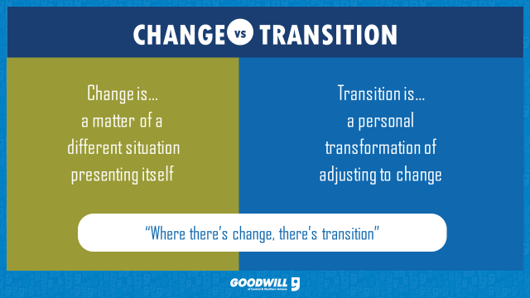
Notes:
________________________________________________________________________
________________________________________________________________________
________________________________________________________________________
________________________________________________________________________

Video
Notes:
________________________________________________________________________
________________________________________________________________________
________________________________________________________________________
________________________________________________________________________

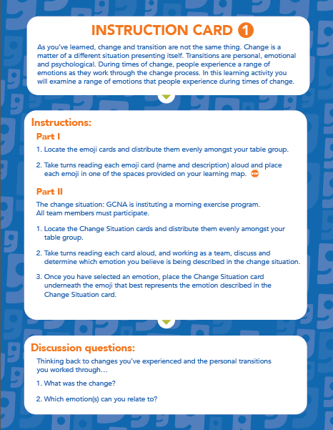 | Notes:
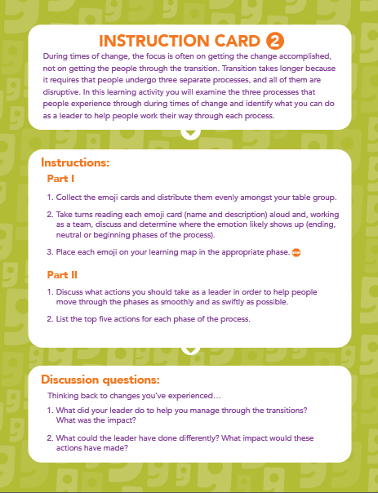 | Notes:
The Transition Model (William Bridges)

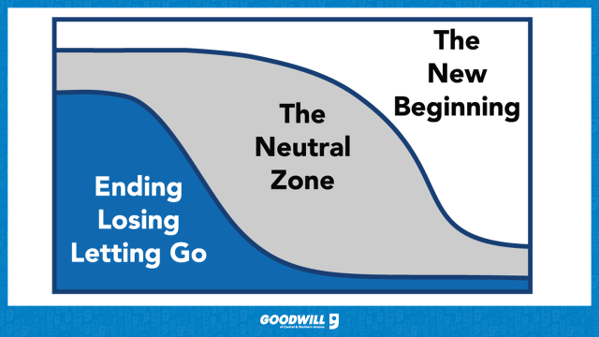

Ending, Losing, Letting Go
________________________________________________________________________
________________________________________________________________________
________________________________________________________________________
Neutral Zone
________________________________________________________________________
________________________________________________________________________
________________________________________________________________________
New Beginning
________________________________________________________________________
________________________________________________________________________
________________________________________________________________________

Transition Model (Emotions)

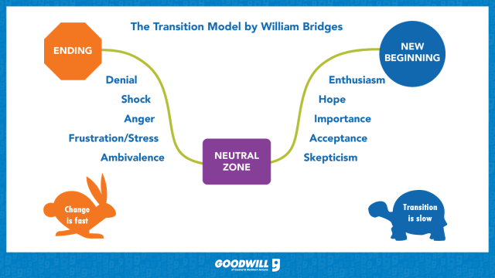
Notes:
________________________________________________________________________
________________________________________________________________________
________________________________________________________________________
________________________________________________________________________

The 4 P’s

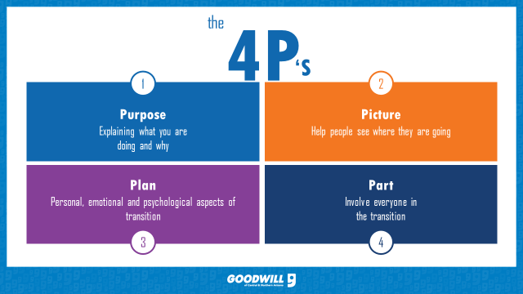
Notes:
________________________________________________________________________
________________________________________________________________________
________________________________________________________________________
________________________________________________________________________
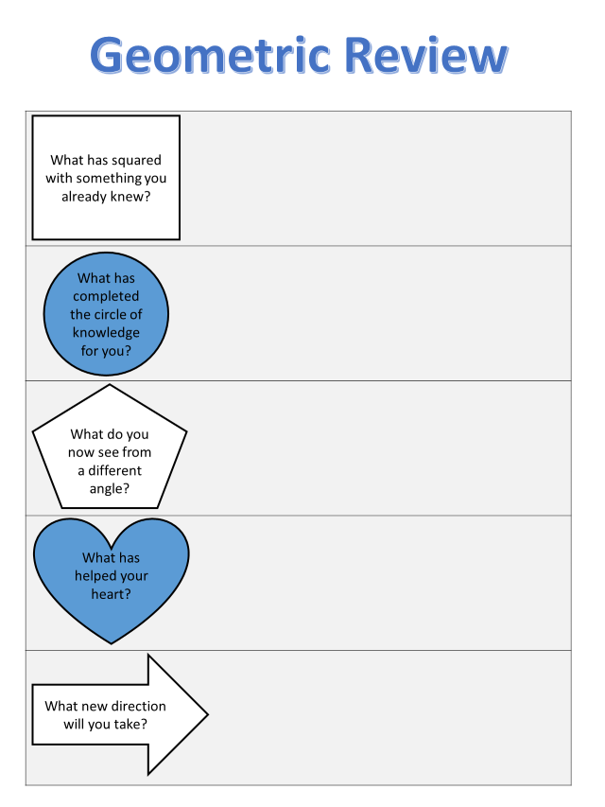

References

Bridges, W. (1980). Transitions: Making sense of life's changes. Reading, Mass: Addison-Wesley.
Bridges, W and Mitchell, S (2002) Leading transition: a new model for change, in On Leading Change, ed F Hesselbein and R Johnston, pp 47–59, Jossey-Bass, New York

