Leadership Styles

Participant Guide

Goodwill of Central and Northern Arizona

Welcome to Leadership Styles, the next course in your journey as a leader at Goodwill of Central and Northern Arizona.

Learning Objectives

Our goals for today are:

- Understand the 3 foundational leadership styles
- Discuss the effectiveness of each style
- Examine your leadership style

Skyscraper Challenge
Notes
________________________________________________________________________
________________________________________________________________________
________________________________________________________________________
________________________________________________________________________
________________________________________________________________________
________________________________________________________________________
________________________________________________________________________
________________________________________________________________________

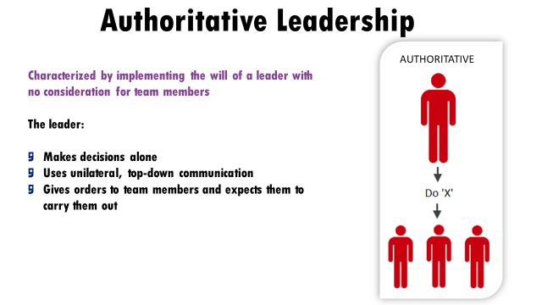
__
Definition:
_______________________________________________________________________
________________________________________________________________________
Notes:
________________________________________________________________________
________________________________________________________________________
________________________________________________________________________
________________________________________________________________________
How does this style relate to our core values?
________________________________________________________________________
________________________________________________________________________
________________________________________________________________________

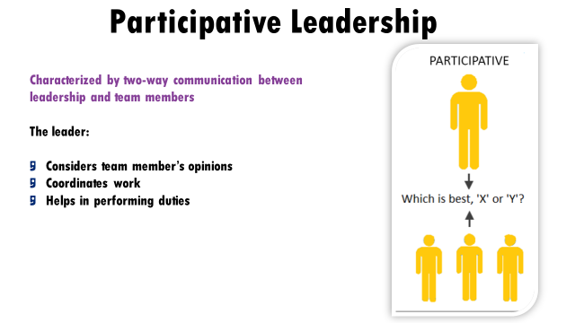

Definition:
_______________________________________________________________________
________________________________________________________________________
Notes:
________________________________________________________________________
________________________________________________________________________
________________________________________________________________________
________________________________________________________________________
How does this style relate to our core values?
________________________________________________________________________
________________________________________________________________________
________________________________________________________________________

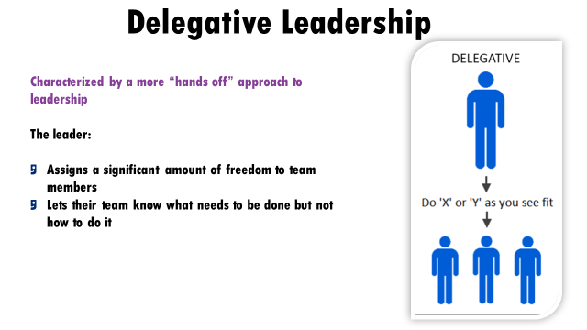

Definition:
_______________________________________________________________________
________________________________________________________________________
Notes:
________________________________________________________________________
________________________________________________________________________
________________________________________________________________________
________________________________________________________________________
How does this style relate to our core values?
________________________________________________________________________
________________________________________________________________________
________________________________________________________________________

Which leadership styles did you see in the video examples?

Video 1
________________________________________________________________________
________________________________________________________________________
Video 2
________________________________________________________________________
________________________________________________________________________
Video 3
________________________________________________________________________
________________________________________________________________________

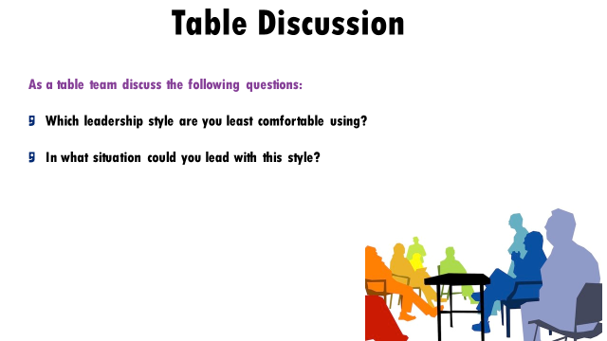

Which leadership style are you least comfortable using?
________________________________________________________________________
________________________________________________________________________
________________________________________________________________________
________________________________________________________________________
In what situation could you lead with this style?
________________________________________________________________________
________________________________________________________________________
________________________________________________________________________
________________________________________________________________________
