Introduction to Leadership

Participant Guide

Goodwill of Central and Northern Arizona

Welcome to Introduction to Leadership, the first course in your journey as a leader at Goodwill of Central and Northern Arizona.

Learning Objectives

Our goals for today are:

- Examine effective leader characteristics
- Describe the differences between leadership and management
- Define leadership

Leadership Shield

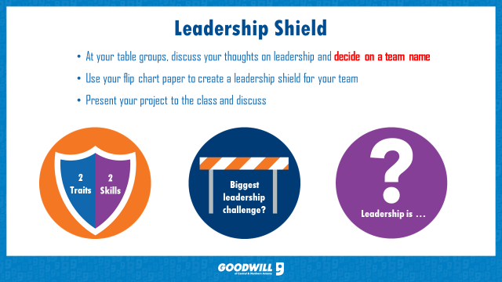
Traits:

Skills:

Challenges:

Leadership is……

Notes:
________________________________________________________________________
________________________________________________________________________
________________________________________________________________________
________________________________________________________________________
Effective Leadership Examples

Leaders that uplifted you

Have you had a leader in your past that uplifted or inspired you? What behaviors did they exhibit to make you remember them right now?

________________________________________________________________________
________________________________________________________________________
________________________________________________________________________
Bosses that pulled you down

What about a boss that pulled you down?

________________________________________________________________________
________________________________________________________________________
________________________________________________________________________

Influence
“The true measure of leadership is influence- nothing more, nothing less.” –John C. Maxwell.

What makes up your ability to influence others?
Self-Assessment
- __________ Who you are _____
- __________ Who you know _____
- __________ What you know _____
- __________ What you feel _____
- __________ Where you’ve been _____
- __________ What you’ve done _____
- __________ What you can do _____

What area do you need to improve most? _____________________

What will you do? ______________________________________________

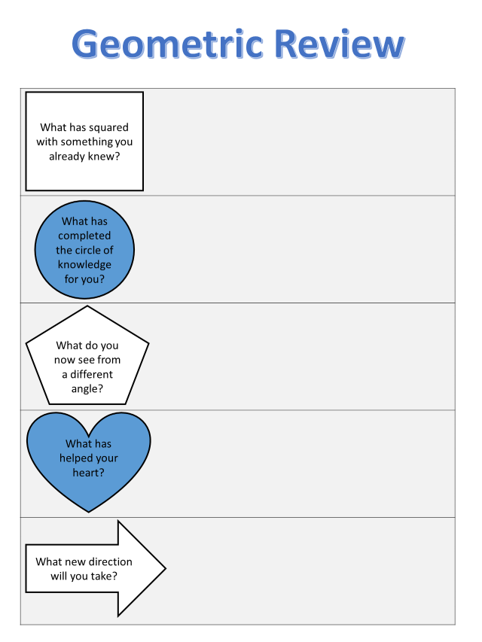

References

Maxwell, J. C. (2007). The 21 irrefutable laws of leadership. Nashville: Thomas Nelson.
Northouse, P. G. (2010). Leadership theory and practice. Thousand Oaks: Sage Publications.

