Notes:

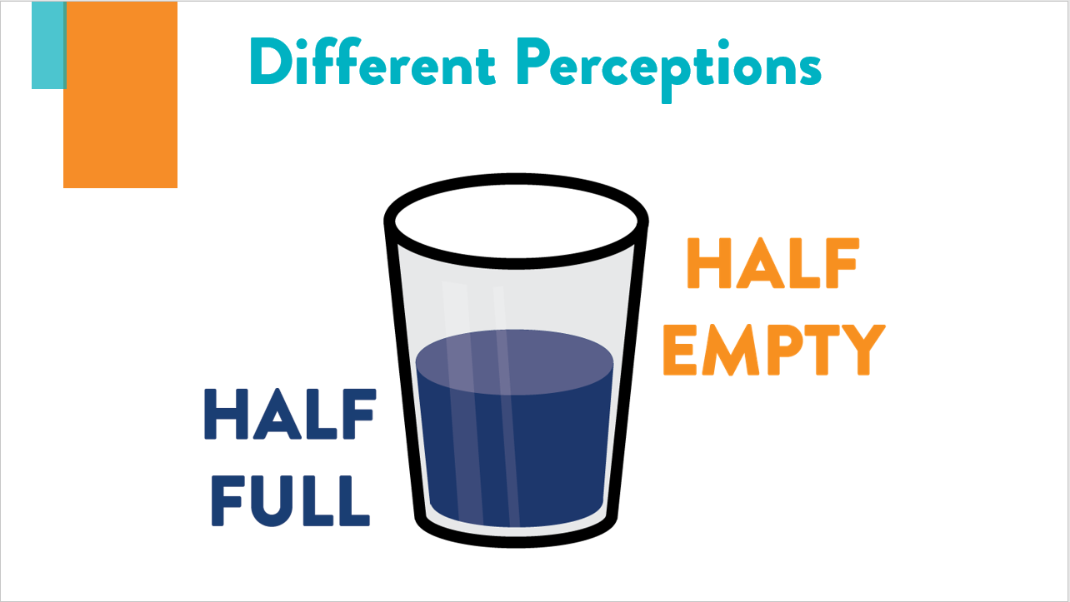

1: What word do you see?
2: What word do you see?
3: What do you see in the picture?
4: What word do you see?__
5: How many Fs did you count?
6: What word do you see?_________ ____
7: What do you see in the picture? ____
8: Which orange circle is larger?__ ____

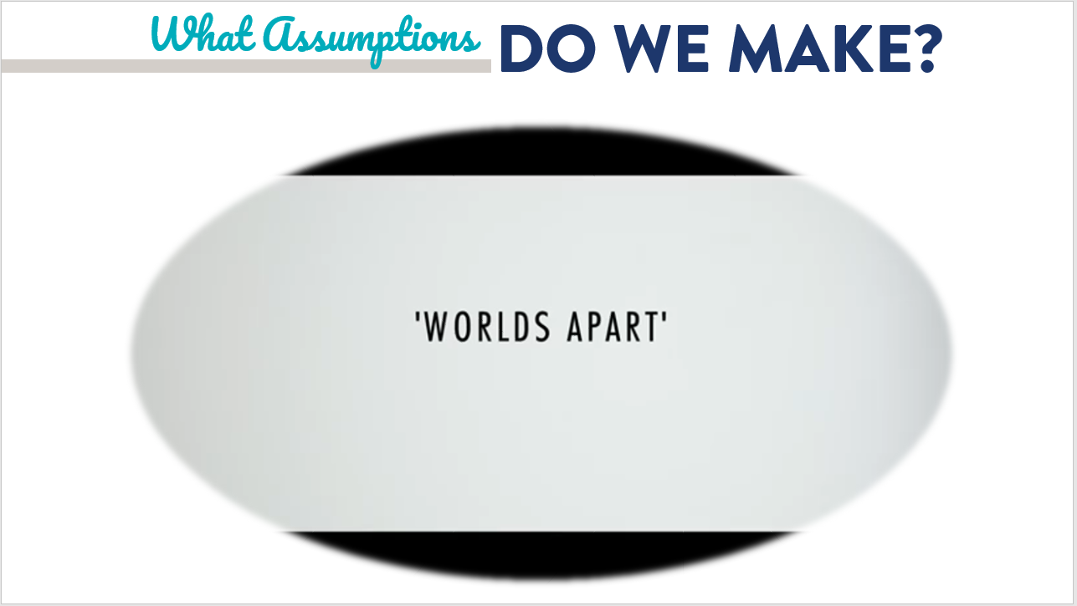

Notes:

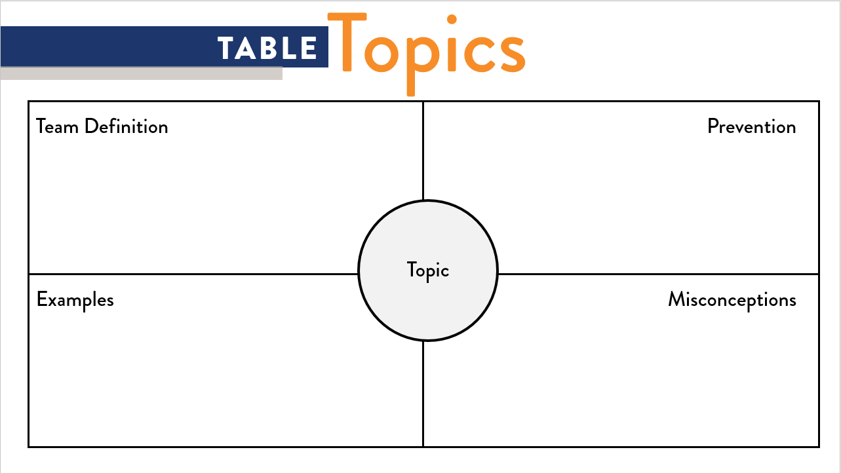
Topic:_

Definition:

Examples:

Prevention:

Misconceptions:

Notes:

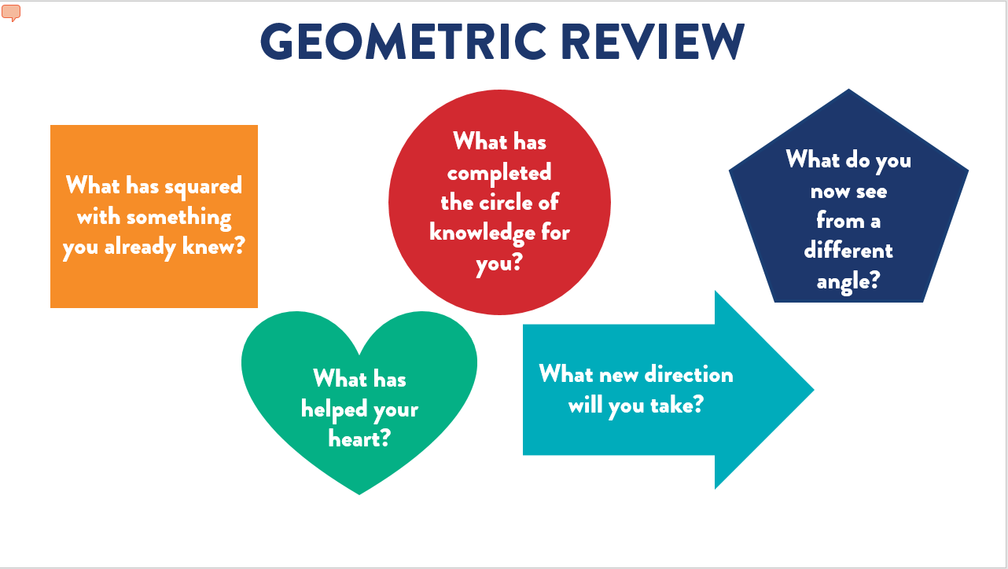
Notes:

