Difficult Conversations

Participant Guide

Goodwill of Central and Northern Arizona

Welcome to Difficult Conversations, the next course in your journey as a leader at Goodwill of Central and Northern Arizona.

Course Description
We tend take one of three actions when we are faced with having a difficult conversations. We avoid the conversation, we respond poorly or we respond well. This course focuses on the difficult conversations and how to positively address an array of issues and behaviors with team members, colleagues, customers and others in the workplace.
Learning Objectives

- Examine the structure of a difficult conversation
- Analyze difficult conversation avoidance
- Discuss difficult conversation preparation and positive outcome

________________________________________________________________________
________________________________________________________________________
________________________________________________________________________
________________________________________________________________________
________________________________________________________________________
________________________________________________________________________

“What I most regretted in my life were my silences. My silences had not protected me. Your silences will not protect you. We can learn to work and speak when we are afraid.”
Lorde, A. (Poet)

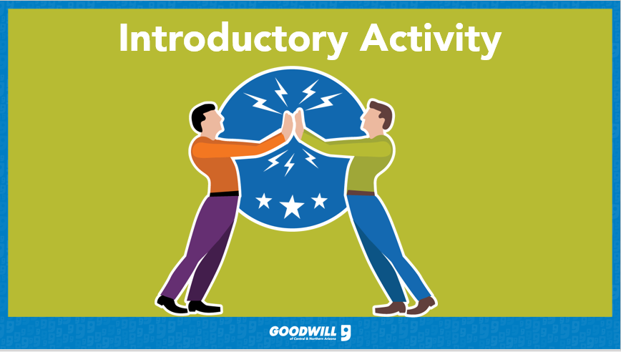

Key Take-Always from The Blind Side Activity
________________________________________________________________________
________________________________________________________________________
________________________________________________________________________
________________________________________________________________________
________________________________________________________________________
________________________________________________________________________

________________________________________________________________________
________________________________________________________________________
________________________________________________________________________
________________________________________________________________________
________________________________________________________________________
________________________________________________________________________

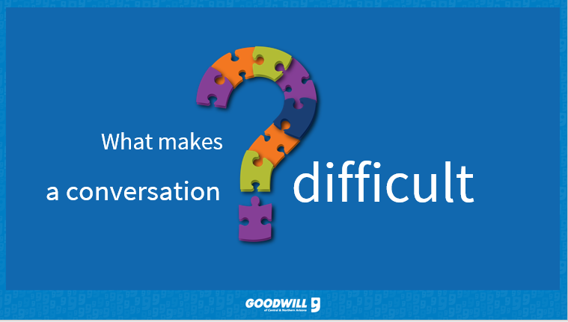

________________________________________________________________________
________________________________________________________________________
________________________________________________________________________
________________________________________________________________________
________________________________________________________________________
________________________________________________________________________
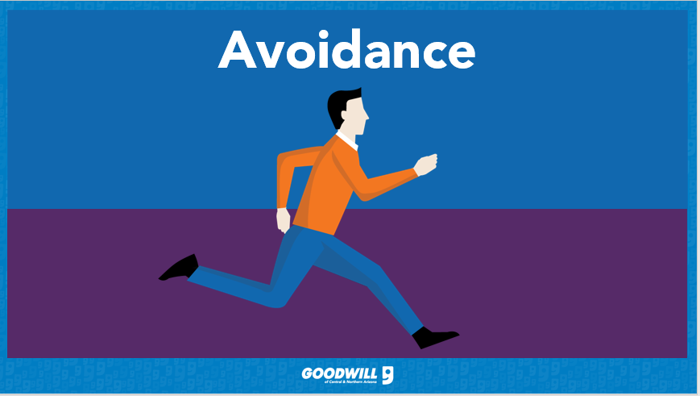
________________________________________________________________________
________________________________________________________________________
________________________________________________________________________
________________________________________________________________________
________________________________________________________________________
________________________________________________________________________

________________________________________________________________________
________________________________________________________________________
________________________________________________________________________
________________________________________________________________________
________________________________________________________________________
________________________________________________________________________

________________________________________________________________________
________________________________________________________________________
________________________________________________________________________
________________________________________________________________________
________________________________________________________________________
________________________________________________________________________

________________________________________________________________________
________________________________________________________________________
________________________________________________________________________
________________________________________________________________________
________________________________________________________________________
________________________________________________________________________

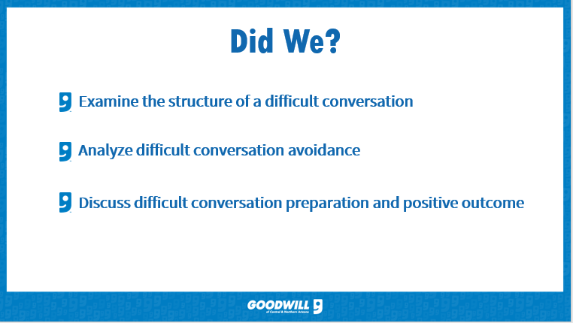
________________________________________________________________________
________________________________________________________________________
________________________________________________________________________
________________________________________________________________________
________________________________________________________________________
________________________________________________________________________

“In the end, we will remember not the words of our enemies, but the silence of our friends.” Martin Luther King Jr.

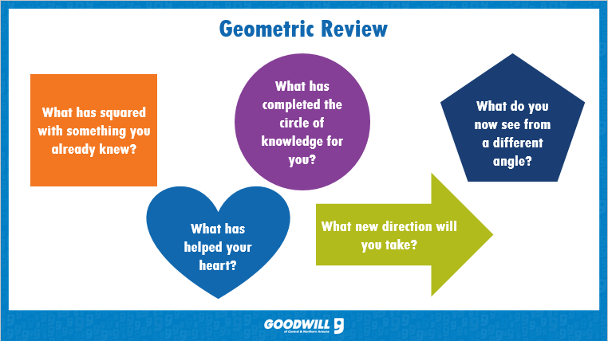

What is one thing from this course you will improve on in the next 30-days?
________________________________________________________________________
________________________________________________________________________
________________________________________________________________________
________________________________________________________________________
________________________________________________________________________
________________________________________________________________________

