Developing Vision

Participant Guide

Goodwill of Central and Northern Arizona

Welcome to Developing Vision, the final course in your journey through the Foundational Leader Academy.

Learning Objectives

Our goals for today are:

- Understand your why
- Discuss the difference between mission and vision
- Develop your team’s vision

Vision Impact Exercise
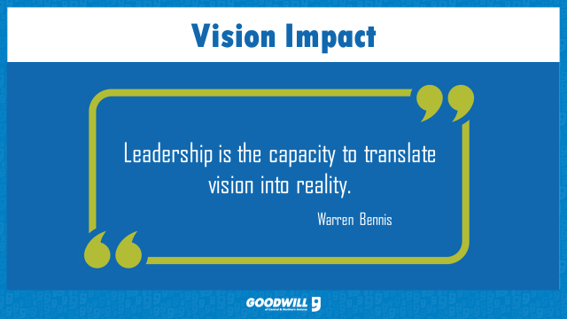

Write the number next to the company’s vision statement.

Amazon:
Ikea:
Goodwill:
McDonalds:
CVS:
Harley Davidson:
Disney:
Facebook:
Google:
Harvard:
Table Discussion
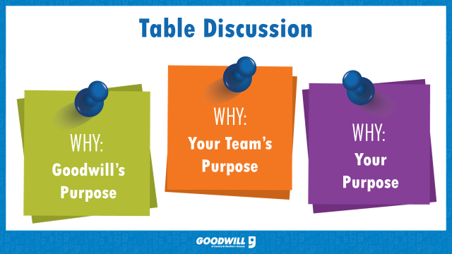

Goodwill:

Your Team:

You: _____

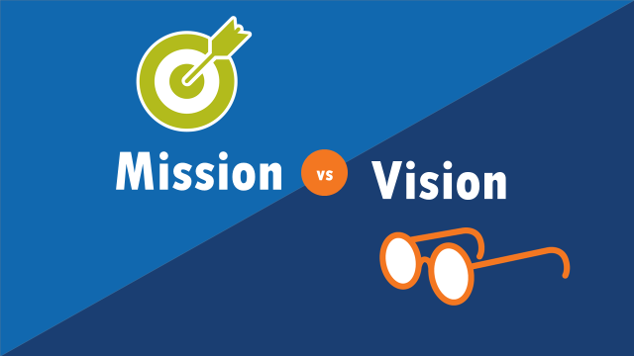
Notes:
________________________________________________________________________
________________________________________________________________________
________________________________________________________________________
________________________________________________________________________
________________________________________________________________________
________________________________________________________________________
________________________________________________________________________

VISION STATEMENT
A vision statement helps the collaborative group relate to the impact it will have if it succeeds in achieving its potential.
Vision Statement Examples
• “To produce frozen food that tastes as good as mom’s.”
• “That all seniors in Arizona have access to quality health care.”
• “That Kansas will be the #1 State in which to raise a child in 20 years.”
Vision Statements
• Tell the collaborative group’s “Ideal Hope”—the way it “ought” to be, both:
o for the collaborative group
o for those served
• Attract commitment
• Energize people
• Create meaning in group member’s lives
• Establish a standard of excellence
• Bridge the present and the future
• Show that different collaborative groups and organizations can have the same vision

VISION STATEMENT EXERCISE
Step 1:
Each person individually take a few minutes to think about the answer to the question listed below. Write that answer down on this sheet:
“If our success could be guaranteed, what would be the end result of our efforts?”
Step 2:
After writing your answer, discuss your ideal outcomes as a table group.
Please take about 10-15 minutes to do this exercise.
Step 3:
Discuss the similarities and differences that your group has. Use the common themes to brainstorm your team’s vision. We will share one vision statement per table with the class.

Notes:
________________________________________________________________________
________________________________________________________________________
________________________________________________________________________
________________________________________________________________________
________________________________________________________________________
________________________________________________________________________
________________________________________________________________________
________________________________________________________________________

