Communicating Effectively

Participant Guide

Goodwill of Central and Northern Arizona

Welcome to Communicating Effectively, the next course in your journey as a leader at Goodwill of Central and Northern Arizona.

Course Description
In this course, we will explore the basic principles of communication and learn how communicating effectively creates a positive work environment. We will summarize the barriers to effective communication and how to overcome these barriers as well as learn techniques to apply effective communication strategically.

Learning Objectives

- Examine basic elements of communication
- Identify and overcome barriers to effective communication
- Discuss strategic approaches to effective communication

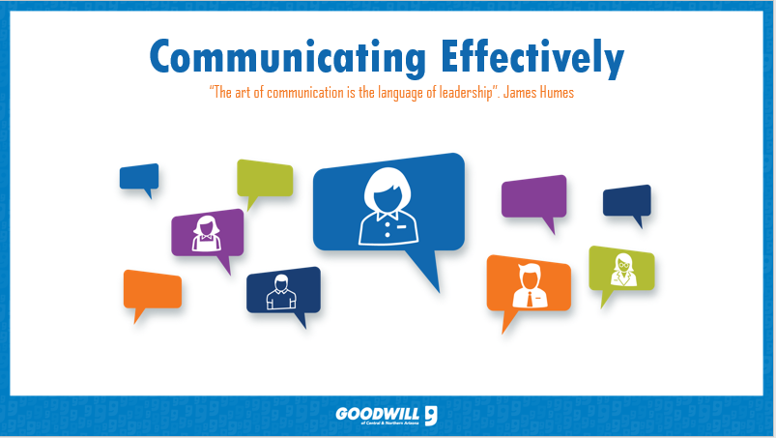
________________________________________________________________________
________________________________________________________________________
________________________________________________________________________
________________________________________________________________________
________________________________________________________________________
________________________________________________________________________

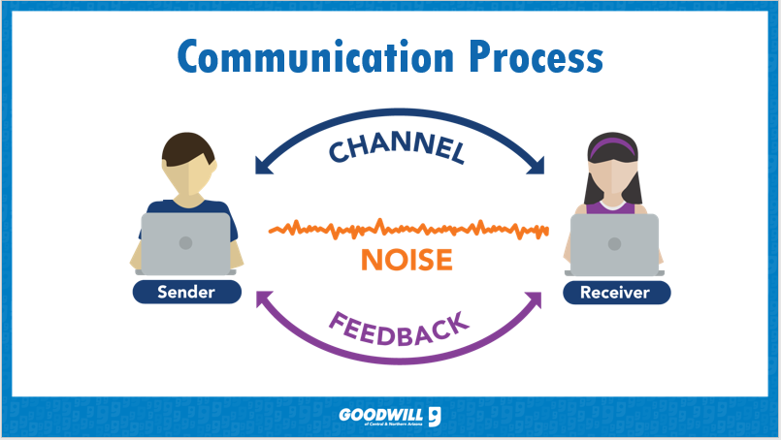
________________________________________________________________________
________________________________________________________________________
________________________________________________________________________
________________________________________________________________________
________________________________________________________________________
________________________________________________________________________

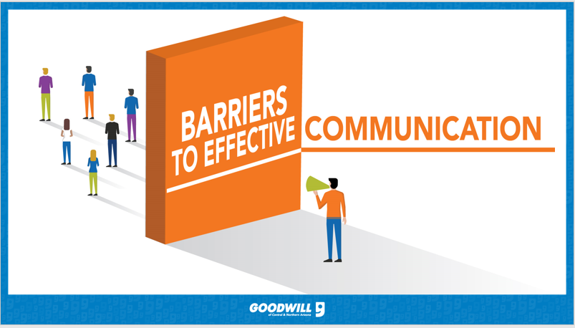

________________________________________________________________________
________________________________________________________________________
________________________________________________________________________
________________________________________________________________________
________________________________________________________________________
________________________________________________________________________

“Seek first to understand, then to be understood.” Steven Covey

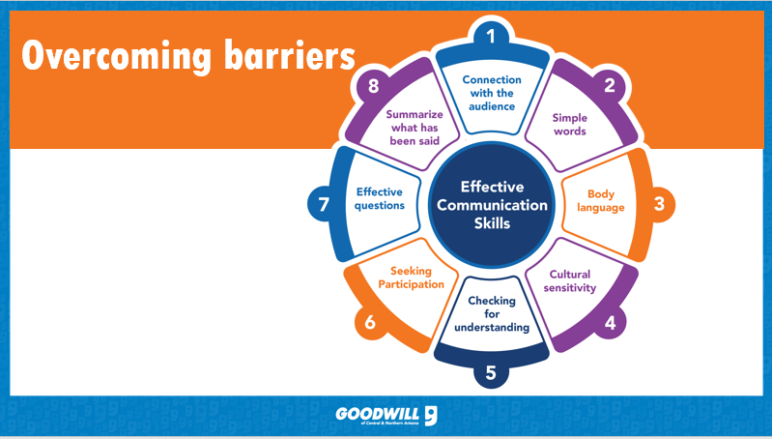
________________________________________________________________________
________________________________________________________________________
________________________________________________________________________
________________________________________________________________________
________________________________________________________________________
________________________________________________________________________

________________________________________________________________________
________________________________________________________________________
________________________________________________________________________
________________________________________________________________________
________________________________________________________________________
________________________________________________________________________

________________________________________________________________________
________________________________________________________________________
________________________________________________________________________
________________________________________________________________________
________________________________________________________________________
________________________________________________________________________

Do I use nonverbal communication? When and why? What will I do to ensure my nonverbal communication matches my verbal communication?
________________________________________________________________________
________________________________________________________________________
________________________________________________________________________
________________________________________________________________________
________________________________________________________________________
________________________________________________________________________

“The most important thing in communication is hearing what isn’t said.” Peter Drucker

How will I strategically apply effect communication in my workplace?
________________________________________________________________________
________________________________________________________________________
________________________________________________________________________
________________________________________________________________________
________________________________________________________________________
________________________________________________________________________

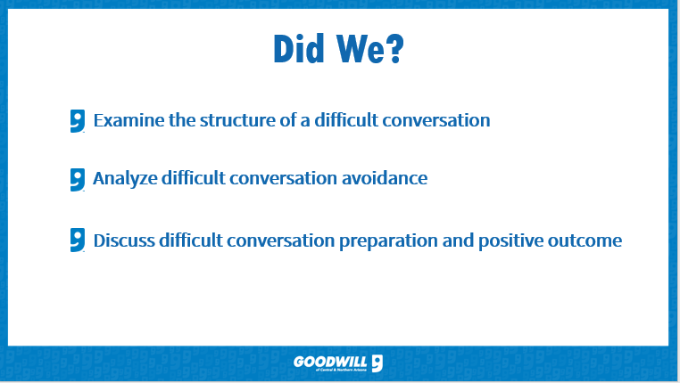
________________________________________________________________________
________________________________________________________________________
________________________________________________________________________
________________________________________________________________________
________________________________________________________________________
________________________________________________________________________

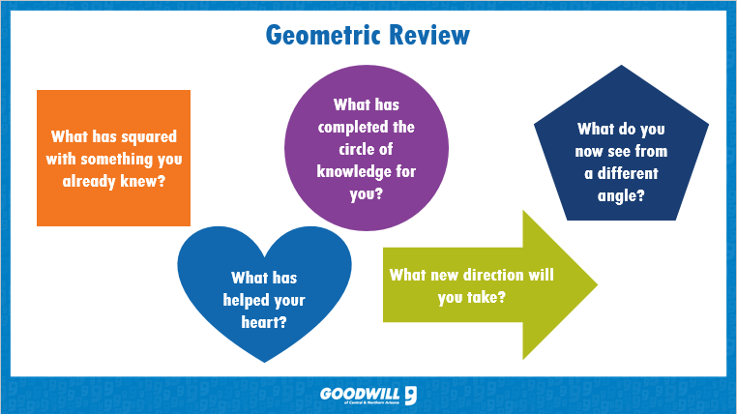
________________________________________________________________________
________________________________________________________________________
________________________________________________________________________
________________________________________________________________________
________________________________________________________________________
________________________________________________________________________

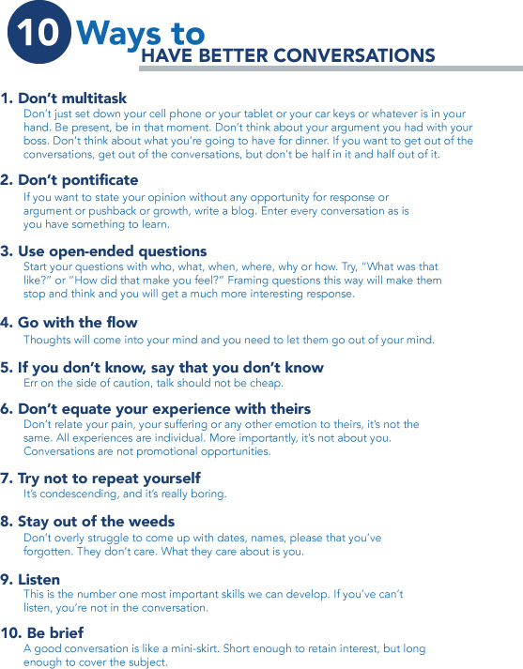

Facial Expressions/Body Language Activity
Use one term to describe the facial expression/body language in the picture. The pictures are numbered 1-10 but, are posted in random order.

Fear Surprise Happy Disgust Excited
Sad Love Tired Bored Nervous

1._____________________________________________________
2._____________________________________________________
3._____________________________________________________
4._____________________________________________________
5._____________________________________________________
6._____________________________________________________
7._____________________________________________________
8._____________________________________________________
9._____________________________________________________
10.____________________________________________________

