The 5 Levels of Leadership

Participant Guide

Goodwill of Central and Northern Arizona

Welcome to The 5 Levels of Leadership, the next course in your journey as a leader at Goodwill of Central and Northern Arizona.

Learning Objectives

Our goals for today are:

- Understand the 5 Levels of Leadership
- Describe the pros and cons of each level
- Determine the level you are operating on

Stand by your quote
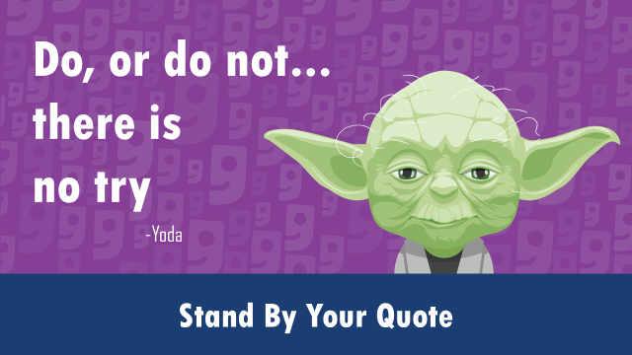

Which quote stood out to you and why:
________________________________________________________________________
________________________________________________________________________
________________________________________________________________________
________________________________________________________________________

Overview
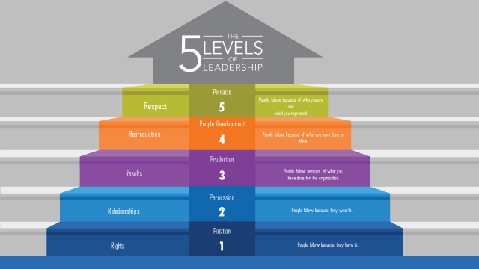
Level 1
________________________________________________________________________
________________________________________________________________________
________________________________________________________________________
________________________________________________________________________
Level 2
________________________________________________________________________
________________________________________________________________________
________________________________________________________________________
________________________________________________________________________

Level 3
________________________________________________________________________
________________________________________________________________________
________________________________________________________________________
________________________________________________________________________
Level 4
________________________________________________________________________
________________________________________________________________________
________________________________________________________________________
________________________________________________________________________
Level 5
________________________________________________________________________
________________________________________________________________________
________________________________________________________________________
________________________________________________________________________

Team Exercise
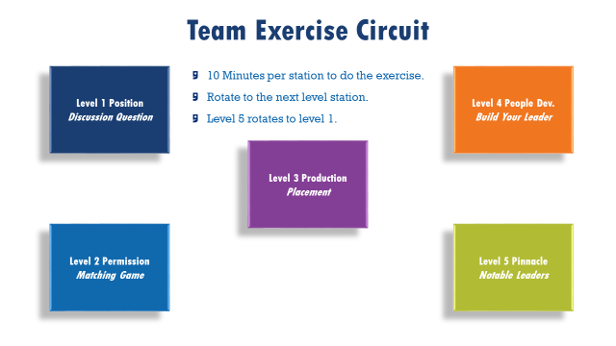

Level 1-Discussion Question
________________________________________________________________________
________________________________________________________________________
________________________________________________________________________
________________________________________________________________________
Level 2- Matching Game
________________________________________________________________________
________________________________________________________________________
________________________________________________________________________
________________________________________________________________________

Level 3- Placement Practice
________________________________________________________________________
________________________________________________________________________
________________________________________________________________________
________________________________________________________________________
Level 4- Build Your Leader
________________________________________________________________________
________________________________________________________________________
________________________________________________________________________
________________________________________________________________________

Final Project

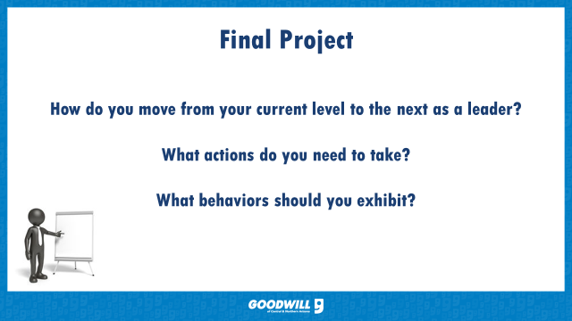

How do you move from your current level to the next?
________________________________________________________________________
________________________________________________________________________
________________________________________________________________________
What actions do you need to take?
________________________________________________________________________
________________________________________________________________________
What behaviors should you exhibit?
________________________________________________________________________
________________________________________________________________________

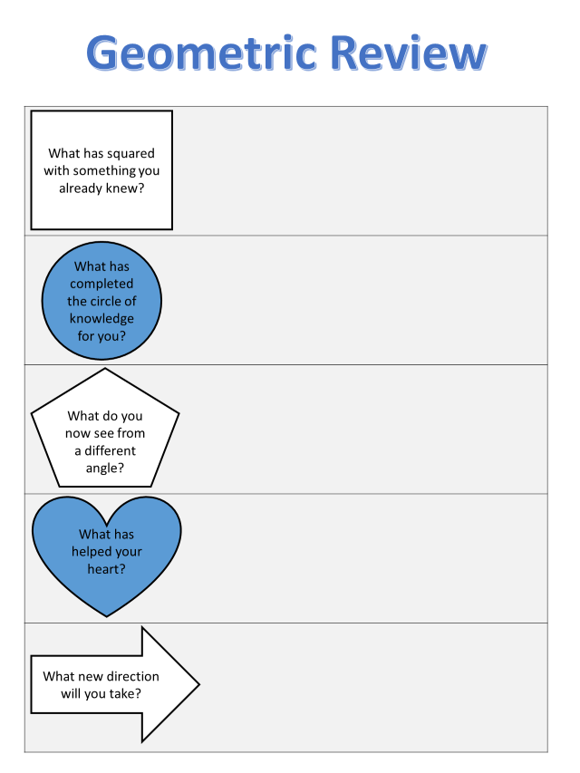

References

Maxwell, J. C. (2007). The 21 irrefutable laws of leadership. Nashville: Thomas Nelson.
Maxwell, J.C. (2011). The 5 levels of leadership. Nashville: Thomas Nelson.

